Source and basin effects on rotational ground motions: comparison with translations

Haijiang Wang¹, Heiner Igel¹, František Gallovič²
¹ Department of Earth and Environmental Studies, Section Geophysics, Ludwig-Maximilians-University München, Germany
² Department of Geophysics, Faculty Of Mathematics And Physics, Charles University, Czech
ABSTRACT: Recently, instruments (e.g., ring laser) are capable to accurately record the rotational motions induced by earthquakes. In order to investigate source and structure-dependent variations of rotational motions, we simulate several M7 earthquakes with different source scenarios on the Newport-Inglewood (NI) fault embedded in the 3D Los Angeles basin. We use data base with several hundred numerical Green’s functions for a discretized model of the NI fault that allows arbitrary finite-fault scenarios to be synthesized by their superposition. We investigate source and basin effects on the rotational part of ground motion (e.g., peak ground rotation rates and their variation, or horizontal gradients) and compare with translations. Our conclusions are: the fault parallel component of rotation rate is affected more by the source and less by the structure than the other two components; the pure-strike slip source mechanism leads to much larger rotation rates around the vertical axis than the horizontal axes; variation of hypocenter introduces more scatter on ground rotation rate than variation of slip history; there is waveform similarity between the horizontal accelerations and the vertical rotation rates in the considered frequency range; the co-processing of these two motion types might suggest a new method for basin detection; accelerations (horizontal component) decay, similarly, with the distance as rotation rates (vertical component).

Version: 0.6 28/02/2008

Introduction
In conventional earthquake engineering, seismic loads on structures are formulated only in terms of the three translational ground motion components. Nevertheless, each site on the surface can be subjected to six kinds of motion: three translations along x-, y- and z-axes as well as three rotations about these axes. While the building response subjected to translational motions has been long investigated, studies on the building response to rotational motions are just at the beginning. The engineering importance of rotational components of seismic strong ground motion was noted during the late sixties and early seventies of the last century (e.g., Newmark and Hall, 1969; Newmark and Rosenblueth, 1971). There are many reports about rotations of tombstones and stone lanterns during large earthquakes (e.g., Yamaguchi and Odaka, 1974). Zembaty (2006) also pointed out that the rotation effects become especially important in the case of high buildings. Different studies have shown that torsional and rocking excitations can be significant and with combinations of structural and soil properties are important (e.g., Gupta and Trifunac, 1987, 1989, 1988, 1990, 1991). For example, rocking excitation becomes important for tall structures supported by soft soil while torsional excitations can dominate the response of long and stiff structures supported by soft soils (Zembaty and Boffi, 1994). These buildings are very sensitive to angular momentum carried by rotation waves.
Recent theoretical studies (e.g., Teisseyre, 2004; Boratynski and Teisseyre, 2004) and observational results (e.g., Nigbor, 1994; Spudich et al., 1995; McLeod et al., 1998; Spillman et al., 1998; Takeo, 1998) observed rotational motions excited by a distant seismic source. A first contribution in this field was a simulation study of rotational effects in layered media and near-field excitations by Bouchon and Aki (1982). They simulated rotational ground motions near earthquake faults buried in layered media for strike-slip and dip-slip fault models, and obtained a maximum rotational velocity of 1.5x10⁻³ rad/s produced by a buried 30 km long strike-slip fault with slip of 1 m (seismic moment of 8x10¹⁸ Nm). Such small rotational motions are difficult to be measured. Deployment of strong motion accelerographs in many seismic areas of the world during the past decades has produced data on translational components of motion during many strong earthquakes. This data describes strong motion in three orthogonal directions (two horizontal and one vertical), but because the spacing of the recording sites is much larger than the wavelengths of the recorded motions, little is known today about the accompanying differential and rotational motions in most areas of the world except some studies (e.g., Spudich et al., 1995; Huang, 2003).
In recent decades ring laser technology succeeded in detecting weak rotational motions radiated by earthquakes (McLeod et al., 1998; Pancha et al., 2000; Cochard et al., 2006; Igel et al., 2005, 2006). At teleseismic distances the seismic wave field can be well approximated by plane waves. Under this assumption, a direct comparison between rotation rate around a vertical axis and transverse acceleration (recorded by a standard seismograph) is possible – translations and rotations are in phase and their amplitudes scaled by twice the horizontal phase velocity. Igel et al. (2005) studied similarity between the collocated translations and rotations recorded by ring laser. Their observations showed over a very broad frequency range (1–150 sec) that the waveforms have the expected similarity and the amplitude ratios allow an accurate estimate of horizontal phase velocities (see also Igel et al., 2005, 2006; Cochard et al., 2006). In the near source region, the fundamental assumption of the above mentioned study –plane wave propagation – does not hold. Nevertheless what the comparison between the translation and the rotation will reveal is still considered an interesting topic.
Translational and rotational components of strong motion radiated from an earthquake source are modified along the propagation path through interference, focusing, scattering, and diffraction. For the velocities, complex variations are observed in Wang et al. (2007a) and Wang et al. (2006) with respect to the varying hypocentre location and varying slip history. In this paper, how the ground rotation rates vary with these source and sub-surface parameters is investigated. The results are shown and analyzed.
In the first part, we briefly describe the “numerical Green’s function” (NGF) method and investigate the accuracy in terms of rotational motion. A large number of kinematic sources can be calculated with 3D media presented. Then, we present some observations on the following topics: (1) the possible ground rotation rates expected for scenario M7 earthquakes which are believed to happen on the Newport Inglewood fault embedded in the Los Angeles basin; (2) the structure and source complexity effect on the spatial distribution of rotation rates and what could be revealed when compared to translations; (3) the potentiality of joint processing of rotation rate and acceleration.
What should be pointed out is that we deliberately remain in the framework of classical elasticity, for which the stress and strain tensors are symmetric. The reason is that so far all observational studies suggest that this is justified.

Numerical Green’s Functions
In the following we describe the basic concept of the “numerical Green’s functions” (NGF) approach and verify it against high-resolution (“continuous”) finite-fault solutions. A target fault plane is divided into equally sized, rectangular sub-faults and for each of these sub-faults the corresponding ground response is denoted as NGF which is calculated using a double-couple source mechanism (here we restrict ourselves to pure strike-slip excitation). Afterwards, a finite-source scenario can be synthesized with appropriate pattern. More detailed information about this method can be found in Wang et al. (2007b, equation (1) to (4)).
We apply the NGF method to the Newport Inglewood (NI) fault system located in the Los Angeles basin (Fig. 1). An area of 96×87×25.5 km, in the two horizontal and vertical directions, is selected as study area, and rotated in order to have one horizontal grid axis parallel to the NI fault. The velocity model is based on the elastic part of the SCEC 3D velocity model for the Los Angeles (LA) basin (Version 3, Kohler et al., 2003). The depth of a shear wave velocity isosurface, 2.0 km/s, is shown in Fig. 2. To reduce the computational effort and the size of the data base, we truncate the seismic velocities at 1.4 km/s which gives a maximum frequency resolution of 0.56 Hz at a grid spacing of 0.3 km (Levander, 1988).
The NI fault is chosen for several reasons: it hosted the M6.4 Long Beach earthquake in 1933 (Hauksson and Gross, 1991), causing serious damage; and it is still considered the most probable source for a damaging M7.0 earthquake to the LA area (USGS); The near-vertical plane can be approximated by a vertical plane to first order in the numerical calculation and the predominant right-lateral slip can be approximated with a pure strike-slip mechanism (Grant and Shearer, 2004).
First, as what has been done for the velocity part of ground motion (Wang et al. 2007a, 2007b), we determine a fault discretization that will be sufficiently accurate. The computational setup and source parameters are given in Table 1. The fault length L and width W are specifically chosen to be 36 km and 18 km, respectively, with the aim to get uniform sub-fault discretizations with size of 5x5 and 6x6 (in grid points, considering the total number of grid points that the fault plane occupies being 120x60). The quasi-dynamic rupture process adopted is calculated with the method published in Guatteri et al. (2004), with 2D Gaussian auto-correlation function used and an isotropic correlation-length of 5 km for both the strike and dip directions. The final slip distribution is shown in the inlet of Fig. 1. An M7 finite fault earthquake scenario is first simulated with sub-faults of side-length 0.3 km (treated as the “continuous” solution, corresponding to the finest grid distance). The ground rotation rates for the two larger solutions are compared to those for the “continuous” solution.
Fig. 3 shows the results of the verification. The z-component of rotation rate has much larger amplitude (and error) than the other two components because of the pure-strike slip source mechanism, and thus is used to illustrate the results. The peak ground rotation rates (PGRRs) covering frequencies up to 0.5 Hz from different solutions are compared over the entire study area. The ratio – the PGRR difference between one discretized solution (sub-fault size of 1.8 km) and the “continuous” solution, divided by the PGRR of the “continuous” solution – is shown in Fig. 3a. The largest relative difference is 18% in the position of P1. The waveforms from different solutions are almost identical in the profile shown in Fig. 3c with lowest peak correlation coefficient value of 0.991. This can also be seen from the waveform comparison (Fig. 3b) for one single station where the biggest relative PGRR difference is observed (point P1, Fig. 3a). Thus we conclude that solutions with 1.5 km sub-fault side-length are accurate enough for scenarios to be investigated.

Earthquake Scenario Simulations
The NGF data base calculated allows us - within the limits of the method (e.g., reliable frequency range) - to synthesize ground motions from arbitrary strike-slip histories on the NI fault for the complete study area. How variations of the source parameters (e.g., hypocenter location, slip distributions) influences the shaking for a scenario earthquake has been revealed to be considerably relevant to estimates of seismic hazard (Wang, et al., 2006, 2007b). This is the question we will focus on in this study. We assume the existence of a scenario M7 earthquake on the NI fault section. The fault parameters (geometry, location, and moment) are the same as adopt in the former section. For this earthquake, we synthesize ground motions for varying hypocentre locations while the slip distribution is fixed. We also investigate the case of fixed hypocentre location but varying slip distributions. The same process as in the former section is adopted to produce the needed quasi-dynamic rupture processes (Guatteri et al., 2004).

Effect due to Hypocentre Location
In this section we investigate how the variations of the hypocentre location, for a given final slip distribution, influence the ground rotation rate, during a scenario earthquake of a given magnitude. We assume the existence of scenario M7 earthquakes on the entire NI fault. A 4x6 grid of hypocentres in the seismogenic zone (5 - 15 km depth) as indicated in the inlet of Fig. 1 is designed. For these hypocenters the ground rotation rates are synthesized and analyzed.
In Fig. 4 we show the statistic properties of ground rotation rate variations due to varying hypocentre location. The maximum values are shown to describe how fast a station could rotate during these scenario M7 earthquakes. Two ratios are calculated and shown to characterize the variations: RSD – standard deviation relative to the mean value, and Rmax – the maximum value divided by the mean value. Rmax is shown to characterize the possible largest rotation rate in the future earthquakes.
The maximum rotation rate over the entire study area is observed close to the fault trace (inside region A), but at different places for different components. And this value of the z-component is about 8 times larger than the x-component and 5 times larger than the y-component. This phenomenon could be explained with the source mechanism (pure strike slip).
In the region A (surrounding the fault trace), for the x-component (Fig. 4 top, left), the maximum PGRR distribution is symmetrical about the middle of the fault trace in the x direction. That symmetry is not observed for the other two components (Fig. 4 middle and bottom, left). For these two components, larger rotation rates are observed in the left part of region A (around the left tip of the fault trace) where the neighbouring basin is deeper, than in the right part. For y- and z-components, there are larger rotation rates inside the small basin (region B, Fig. 4) when compared to the neighbouring area. Whereas, for the x-component, this amplification is quite weak. This observation suggests that in our model the fault parallel component of rotation rate is more affected by the source and less affected by the 3D structure than the other two components.
The ground motion variation due to varying hypocentres is illustrated also by showing the spatial distribution of ratio R_{SD} (Fig. 4 middle). We take two example regions, B and C where substantial basin depth variations are located, to illustrate the 3D effect on the rotations. For the x-component, there is no noticeably high R_{SD} observed (Fig. 4 top, middle) inside these two regions. However for the y-component (Fig. 4 middle, middle) and the z-component (Fig. 4 bottom, middle), large R_{SD} is observed, when compared to the neighbouring area. The largest R_{SD} of the whole study area, 75% for the y-component and 72% for the z-component, are all located inside region C. Right on the fault trace, the ratio R_{SD} for the x-component (Fig. 4 top, middle) is similar to the neighbouring regions, but not for the other two components (Fig. 4 middle and bottom, middle). For all three components, especially for the z-component, there are large R_{SD} found in the regions off both tips of the fault trace.
The distributions in terms of ratio R_{max} are shown in Fig. 4 (right) for different components. For the y- and z-components (Fig. 4 middle and bottom, right), the spatial distributions of this ratio are quite similar to those of R_{SD} (Fig. 4 middle and bottom, middle). The largest R_{max} over the entire study area is at the same station (P1 for y-component and P2 for z-component). Larger values of R_{max} are observed in the small basin (region B). Smaller values are observed in the fault plane projection regions (region A) when compared to the neighbouring area. However, for the x-component, the difference between spatial distributions of R_{max} and R_{SD} is much larger. The largest R_{max} is at station P3 whereas the largest R_{SD} is at station P4. The spatial distributions of ratio R_{max} are more localized than those of the ratio R_{SD} or more affected by the 3D structure (e.g., in region B). To sum up, at the basin edge, the rotation rates can be about 2.8, 3.2 and 3.1 times larger than the mean rotation rate, with components x, y and z.

Effect due to Slip History
Huge variation of strong ground motion observed in the near-source is associated with several phenomena like directivity, near-source effect, and static offsets, etc., which are strongly affected by the geometrical and dynamic characteristics of the faulting. In order to quantify the associated uncertainties, how the ground motion varies with many different slip histories is worthy of an investigation.
We design 20 randomly generated slip histories (hypocentre fixed), for which ground rotation rates are synthesized. The slip histories and the calculation set ups (e.g., hypocentre location) are described in Wang et al. (2006). The aim is to investigate the composite effect of the 3D structure and the source complexity on the ground rotation rates, and to provide a possible range of the ground rotation rates that might be introduced by M7 earthquake on the Newport Inglewood fault. The results are shown and analyzed in the following section.
In Fig. 5, we illustrate how the ground rotation rate varies when different slip histories are employed (applying the same characteristics as above, ie., Maximum, R_{SD} and R_{max}) for different components. The largest rotation rate of the entire study area for the vertical component is 4.5 times larger than those of the x-component and 6 times larger than those of the y-component. These largest rotation rates are located either right above (x- and z-component, Fig. 5 top and bottom, left) or very close to the fault trace (y-component, Fig. 5 middle, left). For the vertical component, very large rotation rate gradients are observed across the fault trace. For the y-component, the largest rotation rate happens around the epicentre while those for the other two components are located further from the epicentre (right on the fault trace, close to the far end of the fault trace). Further from the fault trace, e.g., at area D, there are still large values for the y-component (Fig. 5, middle left) which are comparable to those on the fault trace. But for the x- and z-components, the rotation rates here are quite small compared to those on the fault trace. This observation suggests that the fault parallel component of rotational motion (x-component) is more affected by the structure while the other two components are more affected by the source.
The spatial distributions of R_{SD} of all 20 simulations are shown in Fig. 5 (middle column) to characterize the variations in a relative sense. The largest R_{SD} of the entire study area is 42% for the x-component, 50% for the y-component and 45% for the vertical component, respectively. The difference is where it happens. For the x-component, R_{SD} is very large inside the region F which is around the epicentre. For the other two components, the high ratios are restricted inside region A (banded region right perpendicular to the fault trace). At point G (basin edge), higher ratios are found for the y- and z-components, but not for the x-component when compared to those areas around the fault trace (region F). Source variations will introduce more variations on the fault parallel (x-) component of rotation rate than the other two components. And 3D structure does contribute to the variations of the rotational rate parallel to the fault, too (e.g., at station G).
The spatial distributions of the ratio R_{max} are shown in Fig. 5 (right). These distributions are quite similar to those of R_{SD}: the largest values of the entire study area are observed in the same areas. Around the epicentre, large R_{max} are observed for the x-component but not for the other two components for which large values of R_{max} are mostly restricted to region A (banded region perpendicular to the fault trace). High R_{max} are observed at point G (basin edge) for the y- and z-components. The spatial distributions R_{max} are more localized than R_{SD}.
Finally, comparing the results shown in Fig. 4 and Fig. 5, it can be seen that in the regions off both tips of the fault trace, varying hypocentre plus the 3D structure will lead to more variations on the ground rotational motions than the varying source process does. When we focus very close to the fault trace, the source process will take control of the ground rotational motion variations. Also it is concluded that the 3D structure has comparable effect on the variations as the source for y- and z-components (Fig. 5, middle) and can boost the variations in distant locations.

Comparison with Translations
With the assumption of plane wave incidence, Igel et al. (2005, 2006) theoretically presented the strong relation between the horizontal accelerations and the vertical rotation rates -- identical waveforms scaled by a factor related to the phase velocity. They also observed that phenomena in the global earthquake. In the following, the vertical rotation rates are compared with the horizontal accelerations. The possible hints mainly concern about what could be revealed with the joint processing of these two groups of motions.

Waveform
First, the waveforms are shown on three seismogram profiles, OR, PS and QT (Fig. 5 bottom, right). All the seismograms are synthesized with the hypocentre H3 (Fig. 1 inlet). The rotation rate seismograms on these profiles are plotted in Fig. 6 for the two horizontal accelerations and the vertical rotation rate. These two different seismogram components are all scaled to unit amplitude 1. On the profile OR, both the acceleration and the rotation rate attenuate faster with the increase of y (distance from the fault) than the other two profiles. In the range of y < 26 km, the major parts of the waveforms are similar between the y-component of acceleration and the rotation rate, but not for the x-component of acceleration. On the profile PS, the x-component of acceleration and rotation rate seismograms are almost identical when y is larger than 22 km while the y-component of accelerations are different from the rotation rates. For stations y < 16 km the waveforms of these two motions (x-component of acceleration and vertical rotation rate) are similar, but in an anti-correlated way. On the profile QT, for stations y > 25 km, the accelerations (x-component) and the rotation rates are almost identical in waveform while this similarity is not observed for the y-component of acceleration. Right on the fault trace, the waveform between the y-component of acceleration and vertical rotation rate are the same but anti-correlated.
To measure and illustrate the waveform similarity of the entire study area, the zero-lag correlation coefficient (ZLCC) between two seismograms (one horizontal acceleration and vertical rotation rate) at a station is calculated and the results are shown in Fig. 7. The higher the ZLCC, the more similar are the waveforms. ZLCC equal 1 means that two seismograms are identical (without considering the absolute amplitude difference). For the x-component of acceleration (Fig. 7 left), in most region, the ZLCCs are larger than 0.75. The highest ZLCC is found in the region right above the epicentre. Also large ZLCCs are found right below the epicentre, namely in region x$∈$[35, 55] and y$∈$[5, 20]. Small ZLCCs are found in the four lobes to the epicentre.
For the y-component of acceleration (Fig. 7 right), in the regions off both tips of the fault trace, ZLCCs are larger than 0.75. The ZLCC changes very fast between the major region of low ZLCCs (y$∈$[30, 63]) and the regions of high ZLCCs (off the two tips of the fault trace). The points, where big gradients of ZLCC are found, are roughly aligned in an angle of 45° to the fault trace from the epicentre. In contrast to the x-component, large ZLCCs are found right inside one region surrounding the fault trace except for a very narrow zone (concentrated with the epicentre and perpendicular to the fault trace). Roughly speaking, the regions with large ZLCCs (>0.85) for the y-component, plus those for the x-component cover the entire study area, with an exception of the epicentral area. This fundamental conclusion, about the waveform similarity, activates the next step of this study, namely the co-processing of translational and rotational motions. In areas above and under the fault trace where shear wave dislocation is predicted mainly in x-direction from the radiation pattern (Aki and Richards, 2002), this component of acceleration is quite similar to the vertical rotation rate. Same conclusion can be reached for the y-component of acceleration. To sum up, over the entire study area, the translations are quite similar to the rotations with respect to the waveform.

Amplitude Ratio and Medium Parameter
Since in most of the study area, the horizontal accelerations are quite similar to the vertical rotation rates, it should be insightful to show the amplitude ratios between the accelerations and the rotation rates as has been carried by Igel et al. (2005, 2006). Based on the plane wave propagation, the amplitude ratio between the horizontal acceleration and the vertical rotation rate at a station is theoretically derived to be 2 times the phase velocity (Igel et al., 2005). In Fig. 8, we plot out that ratio over the study area together with the basin depth (iso-surface of the shear wave velocity at 2 km/s), for both the case of varying hypocentre and varying slip history.
For each point on the surface, the mean value of the peak ground accelerations is denoted as $M_{\text{PGAx}}$ for the x-component and $M_{\text{PGAy}}$ for the y-component, respectively. And the mean value of the peak ground rotation rates of the vertical rotation rate is denoted as $M_{\text{PGRRz}}$. The ratios between them, ${M_{\text{PGAx}}}/{M_{\text{PGRRz}}}$ and ${M_{\text{PGAy}}}/{M_{\text{PGRRz}}}$, are shown in Fig. 8 (top and middle), respectively. The results from the varying hypocentre case are shown in the left column and the results from the varying slip history case are shown in the right column (Fig. 8).
Inside the basin and far from the fault trace, for the x-component of acceleration (Fig. 8 top), the ratio is small, less than 2000 m/s. Outside of the basin, except for the region A, the media parameters are getting larger, the ratio is also getting larger than 3000 m/s. But in the region A, the ratio is still low (close to 1000 m/s). This region is right to the fault trace where directivity effect dominates the ground motion. In the regions around the left tip of the fault trace, for both the case of varying hypocentre and the varying slip history, the ratio is distinctly larger than 4000 m/s and not comparable to those in the neighbouring areas (Fig. 8 top).
For the y-component of acceleration, in the region B (outside the basin and thus large velocity is used), the ratio between the acceleration and the vertical rotation rate is less than 1700 m/s for the varying hypocentre case (Fig. 8 middle left). No strong relation between the amplitude ratio and the basin structure exists any more. But for the varying slip history case (Fig. 8 middle right), the forward mentioned ratios are comparable to those inside region A (outside the basin and to the right of the fault trace). In the band region C (surrounding the fault trace and right in front of the rupture propagation direction for the case of fixed hypocentre), the ratio are obviously higher than the case of varying hypocentre.
The simple average between those two ratios, $(M_{\text{PGAx}}+M_{\text{PGAy}})/2⋅M_{\text{PGRRz}}$ is shown in (Fig. 8 bottom) for both varying hypocentre and varying slip history. A strong relation is observed over the entire study area between the amplitude ratio and the local media parameter (Fig. 8 bottom) for both the varying hypocentre case and the varying slip history cases, except for the regions around the two tips of the fault trace. The compatibility between the ratio and the local media parameter holds over almost the entire study area.

Decay with Distance
In Fig. 9, we pick up the maximum amplitude of both the y-component of acceleration and vertical rotation rates synthesized with the varying hypocentre and plot them against the fault distance. Larger values are observed for both the rotation rates and the accelerations in the range A (fault distance between 25 and 53 km) which covers the small basin depicted as region B in Fig. 4. The rotation rates are similarly amplified by this small basin as the accelerations. Both the acceleration and the rotation rate saturate in the region of fault distance less than 10 km. It is also seen that the mean rotation rate decreases with the fault distance similarly to the acceleration in the range of fault distance larger than 10 km. In the log-log coordinates, the rotation rate linearly decreases with to the fault distance just as the acceleration. This suggests that the same form could be adopted for the distance term when developing the attenuation relationship for rotational motions.

Conclusions and Discussions
We investigate how different parameters including the source and 3D structure affect the ground rotation rates. In the region surrounding the fault trace, the vertical component of rotation rates is several times larger than the other two horizontal components. The pure-strike slip source mechanism dominates the ground rotation rates in this region.
The variation in hypocentre location will lead to large variations to the ground rotation rates. The fault perpendicular and the vertical rotation rates are elevated by both the medium and the slip asperity. However, there are no obvious effect on the fault parallel component due to the medium and the slip asperity. This component is dominated by the directivity effect. The medium amplification is, also, observed in terms of the variation -- the largest variations are located at the edge of the basin. The variations are small, whereas, in the regions of large rotation rates (normally the region surrounding the fault trace). The hypocentre location variation and the media control the variations.
For the varying slip history case, directivity effect dominates the fault parallel component in terms of absolute values and relative variations. Smaller variations are introduced, in this case, with respect to the varying hypocentre. The media effect is mainly on the fault-perpendicular component when considering the absolute value. For the y- and z-component, the media can amplify the rotation rates to the same level in the source neighboring area.
The rotation rates are compared to the accelerations as has been done for the global scale (Igel et al., 2005). The varying hypocentre case is taken as example. For each individual acceleration component, areas with strong waveform similarity to the vertical rotation rates are coincident with shear-wave radiation pattern (double-couple point source). To sum up (w.r.t. two horizontal acceleration components), strong waveform similarity are observed over the entire study area which provides the basement for co-processing them. The amplitude ratios between the horizontal accelerations and the vertical rotation rate are compared to the medium parameter. Except for the very small region surrounding the fault trace, this amplitude ratio does have a strong relationship with the medium parameters and might suggest a new tool for basin edge detection. Finally, the vertical rotation rates are found to follow the same form to decay with the distance as the acceleration.
Acknowledgements
This work was partially funded by the International Quality Network - Georisk (German Academic Exchange Service), and the Elite Graduate College THESIS (elite.geophysik.uni-muenchen.de). We also acknowledge support from the European Human Resources Mobility Programme (Research Training Network SPICE, www.spice-rtn.org) and the provision of computational resources through the Leibniz Computing Centre Munich.

References
Boratynski, W. and R. Teisseyre (2004), Generalized continuum with defects and asymmetric stresses. Acta Geophys Pol, 52, 185–195.
Bouchon, M. and K. Aki (1982), Strain, tilt, and rotation associated with strong ground motion in the vicinity of earthquake faults. Bull. Seism. Soc. Am., 72, 1717–1738.
Cochard, A., H. Igel, A. Flaws, B. Schuberth, J. Wassermann, and W. Suryanto (2006), Rotational motions in seismology, in: Earthquake source asymmetry, structural media and rotation effects, edited by Teisseyre et al., Springer Verlag.
Grant, L. B., and P. M. Shearer (2004), Activity of the offshore Newport - Inglewood Rose Canyon fault zone, coastal Southern California, from relocated microseismicity, Bull. Seism. Soc. Am., 94, 747-752.
Guatteri, M., P. M. Mai, and G. C. Beroza (2004), A pseudo-dynamic approximation to dynamic rupture models for strong ground motion prediction. Bull. Seism. Soc. Am., 94, 2051–2063.
Gupta, I. D. and M. D. Trifunac (1987), Statistical analysis of response spectra method in earthquake engineering. Dept Civil Eng, Univ Southern California, Los Angeles CA, report.
Gupta, I. D. and M. D. Trifunac (1988), A note on computing the contribution of rocking excitation to earthquake response of simple buildings. Bull Indian Soc Earthq Tech, 25:2, 73–89.
Gupta, I. D. and M. D. Trifunac (1990), Probabilistic spectrum superposition for response analysis including the effects of soil-structure interaction. J Probabilistic Eng Mech, 5, 9–18.
Gupta, V. K. and M. D. Trifunac (1989), Investigation of building response to translational and rotational earthquake excitations. Dept Civil Eng, Univ Southern California, Los Angeles CA, Report.
Gupta, V. K. and M. D. Trifunac (1991), Effects of ground rocking on dynamic response of multistoried buildings during earthquakes. Struct Eng/Earthq Eng (JSCE), 8:2, 43–50.
Hauksson, E., and S. Gross (1991), Source parameters of the 1933 Long Beach earthquake, Bull. Seism. Soc. Am., 81, 81-98.
Huang, B. S. (2003), Ground rotational motions of the 1999 Chi-Chi, Taiwan earthquake as inferred from dense array observations. Geophys. Res. Lett., 30, 1307-1310.
Igel, H., U. Schreiber, A. Flaws, B. Schuberth, A. Velikoseltsev, and A. Cochard (2005), Rotational motions induced by the M8.1 Tokachi-oki earthquake, September 25, 2003. Geophys. Res. Lett., 32.
Igel, H., A. Cochard, J. Wassermann, A. Flaws, U. Schreiber, A. Velikoseltsev, and N. P. Dinh (2006), Broad-band observations of earthquake-induced rotational ground motions, Geophys. J. Int., 168, 182-197
Kohler, M., H. Magistrale, and R. Clayton (2003), Mantle heterogeneities and the SCEC three-dimensional seismic velocity model version 3, Bull. Seism. Soc. Am., 93, 757-774.
Levander, A. R. (1988), Fourth-order finite-difference P-SV seismograms. Geophysics, 53, 1425-1436.
McLeod, D. P., G. E. Stedman, T. H. Webb, and U. Schreiber (1998), Comparison of standard and ring laser rotational seismograms. Bull. Seism. Soc. Am., 88, 1495-1503.
Newmark, N. M. and H. J. Hall (1969), Seismic design criteria for nuclear reactor facilities. Proc. Fourth World conf Earthq Engrg. Santiago, Chile.
Newmark, N. M. and E. Rosenblueth (1971), Fundamentals of earthquake engineering Prentice-Hall, Englewood Cliffs.
Nigbor, R. L. (1994), Sic-degree-of-freedom ground-motion measurement. Bull. Seism. Soc. Am., 84, 1665–1669.
Pancha, A., T. H. Webb, G. E. Stedman, D. P. McLeod, and U. Schreiber (2000), Ring laser detection of rotations from teleseismic waves, Geophys. Res. Lett., 27, 3553-3556.
Spillman, W. B., D. R. Huston, and J. Wu (1998), Very long gauge length fiber optic seismic event detectors. Proceedings of the SPIE, 3555, 311–321.
Spudich, P., L. K. Stek, M. Hellweg, J. B. Fletcher, and L. M. Baker (1995), Transient stresses at Parkfield, California, produced by the M 7.4 Landers earthquake of June 28, 1992: Observations from the UPSAR dense seismograph array. Journal of Geophysical Research, 100, 675–690.
Stedman, G. E., Z. Li, and H. R. Bilger (1995), Sideband analysis and seismic detection in a large ring laser. Applied Optics, 34, 5375–5385.
Takeo, M. (1998), Ground rotational motions recorded in near-source region of earthquakes. Geophys. Res. Lett., 25, 789–792.
Teisseyre, R. (2004), Spin and twist motions in a homogeneous elastic continuum and crossband geometry of fracturing. Acta Geophys Pol, 52, 173–183.
Wang, H.J., H. Igel, A. Cochard, and M. Ewald (2006), Variations of peak ground motions due to slip histories: Application to the Newport Inglewood fault, Los Angeles Basin, 3, International Symposium on the Effects of Surface Geology on Seismic Motion, Grenoble, France.
Wang, H.J. (2007a), Source-dependent variations of M7 earthquakes in the Los Angeles Basin, Doctor thesis, Ludwig-Maximilian-University.
Wang, H.J., H. Igel, F. Gallovic, A. Cochard and M. Ewald (2007b), Numerical Green’s Functions in 3D medium: Application to the Newport-Inglewood Fault, Los Angeles Basin, to be submitted to Geophys. J. Int.
Yamaguchi, R. and T. Odaka (1974), Field study of the Izu-Hanto-oki earthquake of 1974. Special Bull Earthq Res Inst, Univ Tokyo, 14, 241–255.
Zembaty, Z. B. (2006), Deriving seismic surface rotations for engineering purposes. Earthquake source Asymmetry Structural Media and Rotation Effects, Springer Verlag.
Zembaty, Z. and G. Boffi (1994), Effect of rotational seismic ground motion on dynamic response of slender towers. Europ Earthquake Engng, 8, 3–11.

Table 1: Setup for the heterogeneous model in the Los Angeles basin
Spatial discretization (km) | 0.3
Time step (s) | 0.018
Lowest S-wave velocity (km/s) | 1.4
Simulation time (s) | 65
Number of cells | 320×350x100
PML Nodes | 15
Fault area (km²) | 18x36
Top depth (km) | 1.5

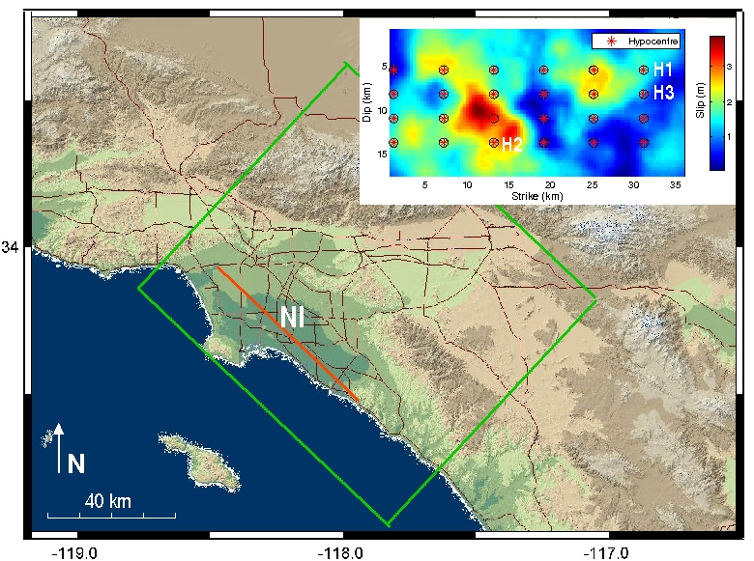

Figure 1: Los Angeles area with modelled region (green rectangle) and the idealized Newport-Inglewood fault (NI, red line). Inlet: Final slip distribution of an M7 earthquake on the vertical NI fault plane and hypocentre grid (red asterisks, for investigation of hypocentral effect on ground motion). H1, H2 and H3 show the two example hypocentre locations for more detailed exhibition of hypocentral effect on ground motion.
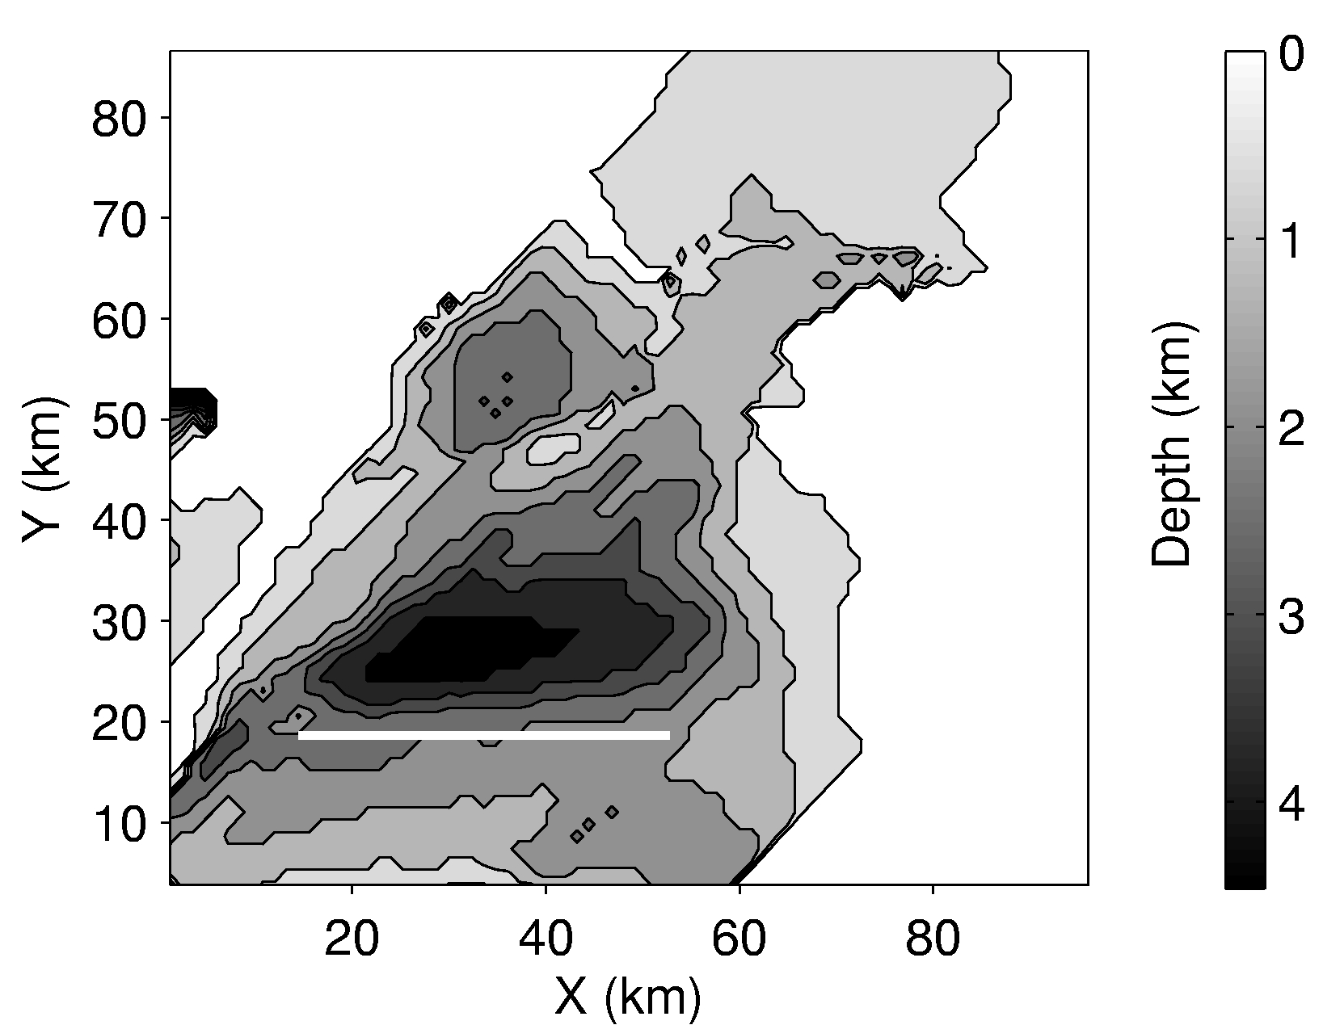
Figure 2: Depth of shear wave velocity isosurface at 2.0 km/s (grey scale). The thick white line marks the fault trace of the M7 earthquake.
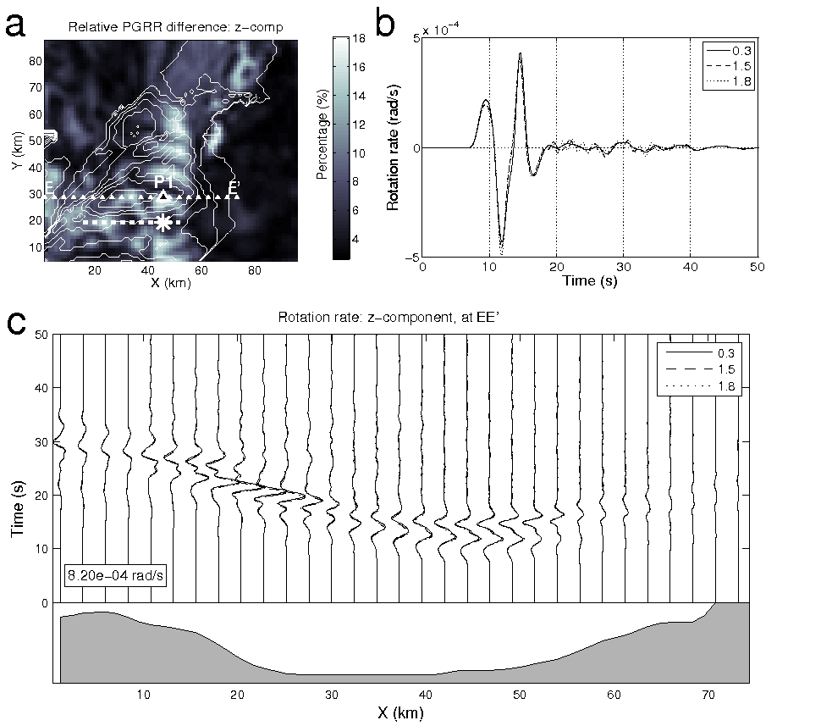
Figure 3: Effect of discretized sub-fault size on rotation rate. a. Relative PGRR difference (z-component) between the solution of 1.8 km and the “continuous” solution. The dashed thick white line marks the fault trace and the white asterisk shows the epicentre. b. Rotation rate seismograms (z-component) from different solutions (0.3 km, 1.5 km and 1.8 km) at receiver P1 (largest misfit). c. Rotation rate profile along EE’ (a) in which the depth of shear wave velocity isosurface at 2.0 km/s is shown at the bottom (gray scale). The largest rotation rate amplitude across this profile is shown (inlet).

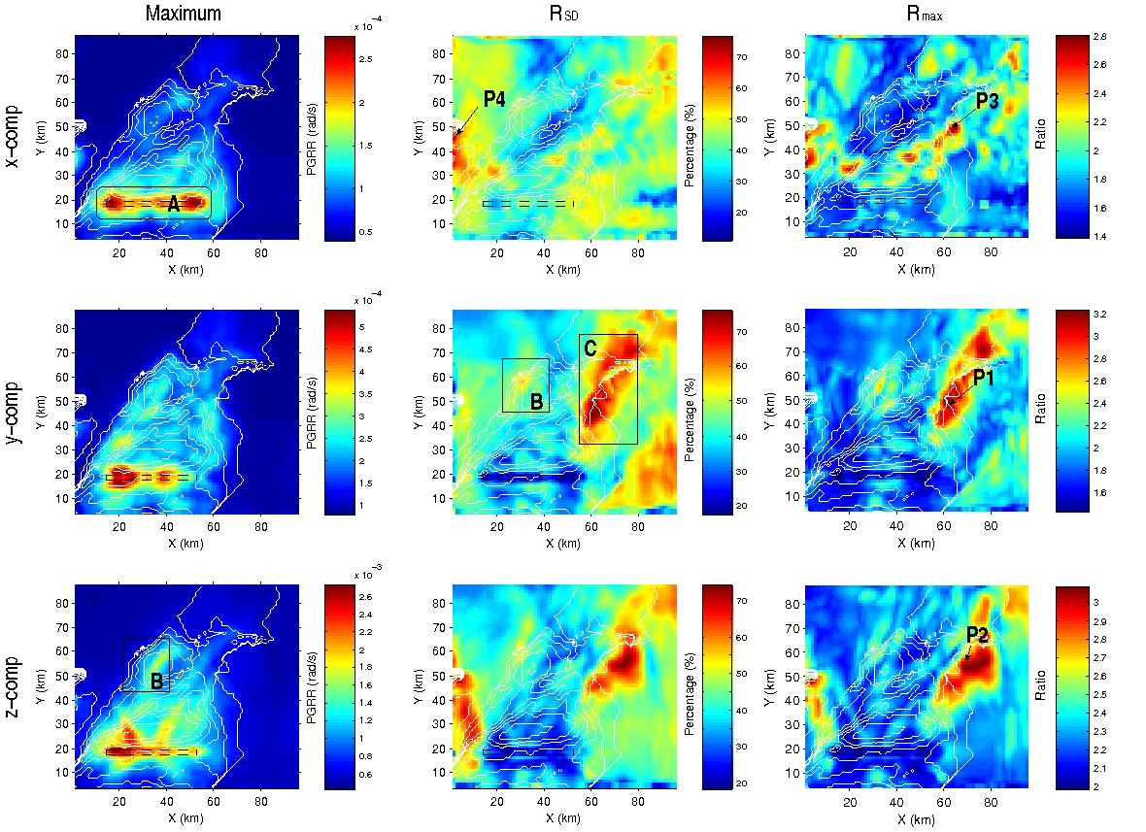

Figure 4: Statistics of the PGRR distributions due to varying hypocentre. Left. Maximum value. Middle. The ratio between the standard deviation and the mean PGRR value (combination of all 24 simulations) in percent. Right. The ratio between the maximum value and the mean value. From top to bottom are x-, y- and z-components, respectively. The black dashed rectangle is used to indicate the fault trace to avoid masking the high values on the fault trace. Thin white lines are contours of the shear velocity isosurface at 2.0 km/s. Region A, B and C, station P1, P2, P3 and P4 are denoted for more detailed discussion. Note the color scale difference.
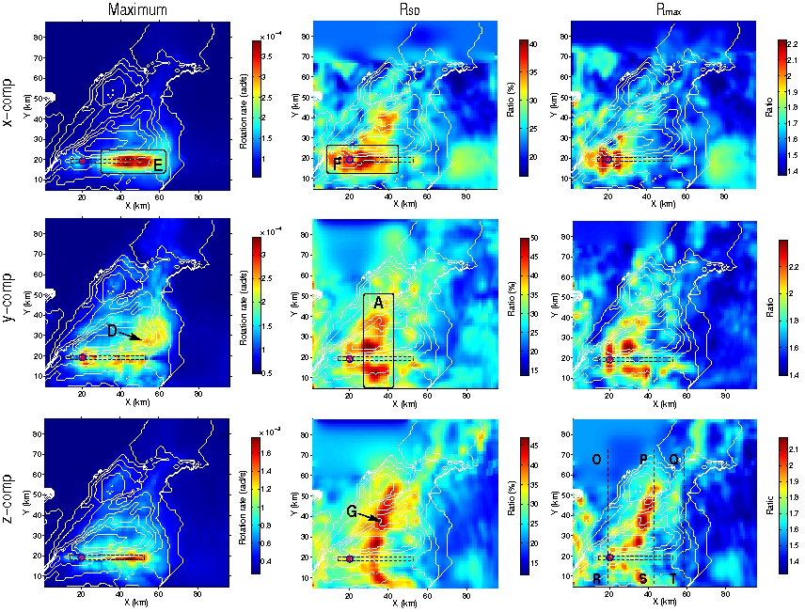

Figure 5: Peak ground rotation rate variations due to varying slip history – maximum and variations (measured by two ratios: R_{SD} and R_{max} see definition in the text). Left. Maximum value. Middle. R_{SD} in percent. Right. R_{max}. From top to bottom are the x-, y-, and z-components. Fault trace is marked as black dashed rectangle and epicentre is shown with red solid cycle. Thin white lines are the contours of the shear velocity isosurface at 2.0 km/s. Region A, E and F, station G, and profile OR, PS and QT are denoted for more detailed discussion. Note the color scale difference.

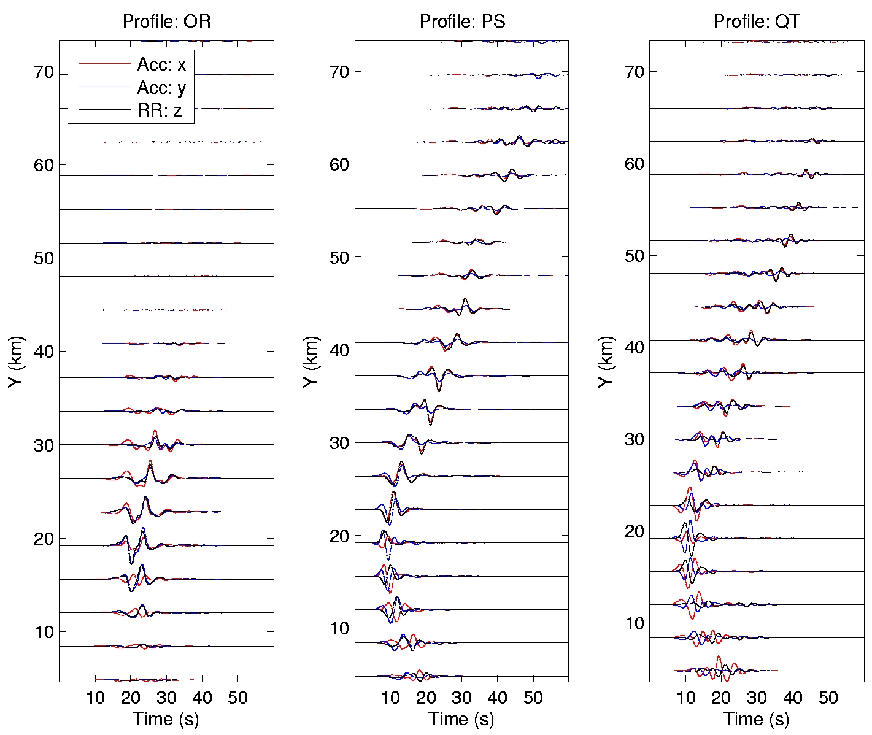

Figure 6: Acceleration (horizontal components) and rotation rate (z-component) profiles (Fig. 5 bottom right). The accelerations and rotation rates are scaled by the maximum amplitude of the corresponding profile, respectively.
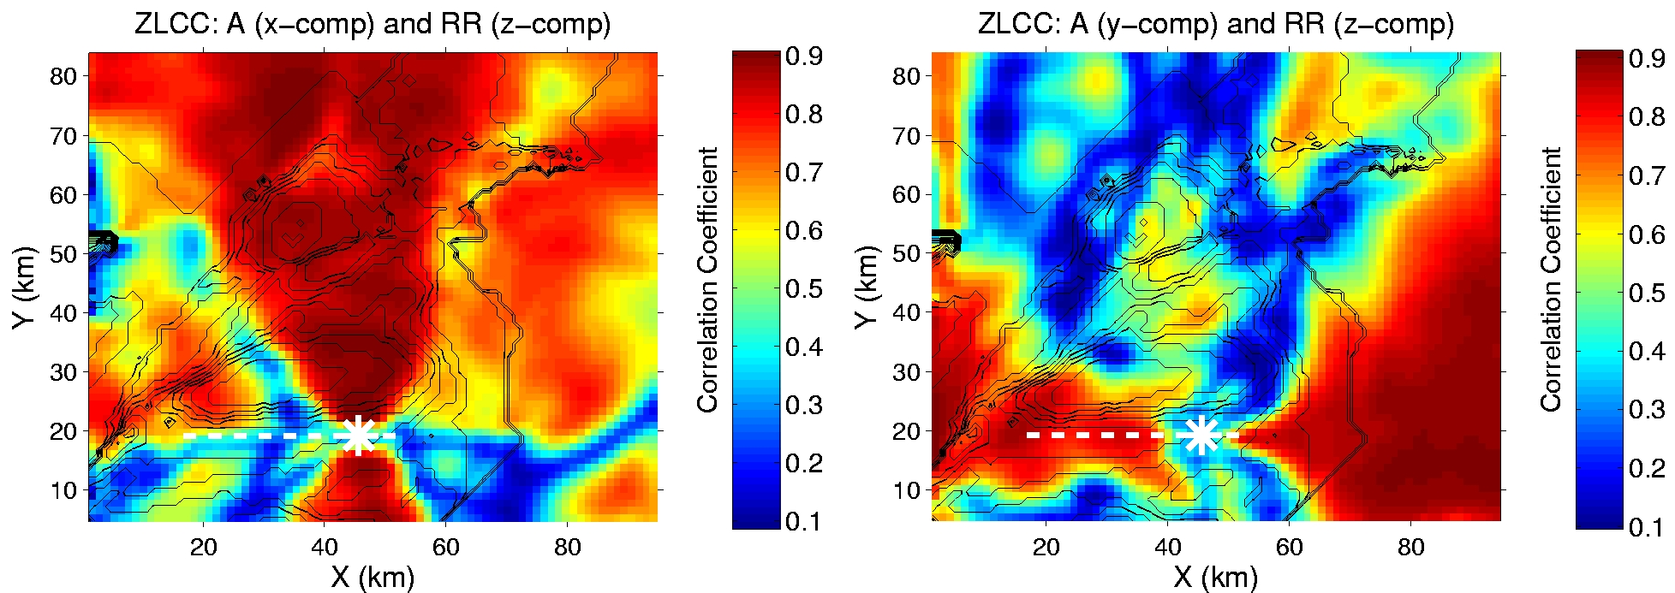

Figure 7: Waveform similarity between horizontal accelerations and vertical rotation rate. Zero-lag correlation coefficients (ZLCC) between the waveforms are illustrated over the entire study area for the hypocentre H3 (Fig. 1 inlet). Left. x-component of acceleration. Right. y-component of acceleration. The contours of the isosurface of shear wave velocity at 2.0 km/s are depicted with the thin black lines. The white thick dashed line marks the fault trace and the white asterisk marks the epicentre.

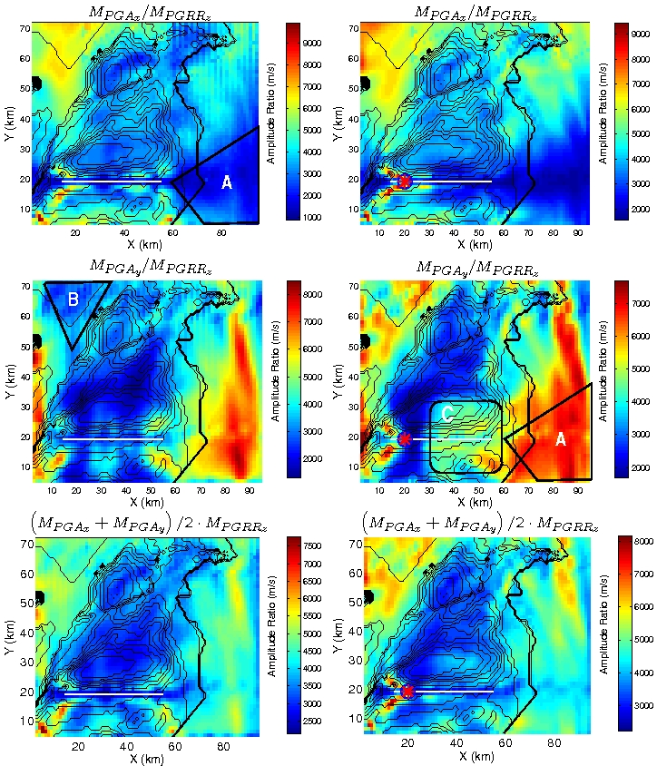

Figure 8: Ratio between peak acceleration and peak rotation rate (z-component). Left. Varying hypocentre. Right. Varying slip history. Top. Acceleration: x-component. Middle. Acceleration: y-component. Bottom. Geometric mean of the two horizontal accelerations. The ratio is represented with the color-scale. Black curved lines mark the contours of the shear-wave velocity isosurface at value of 2.0 km/s. The red asterisk marks the epicentre for the case of varying slip history. The white line marks the fault trace. Region A, B and C are denoted for illustrations. Note the color scale difference.
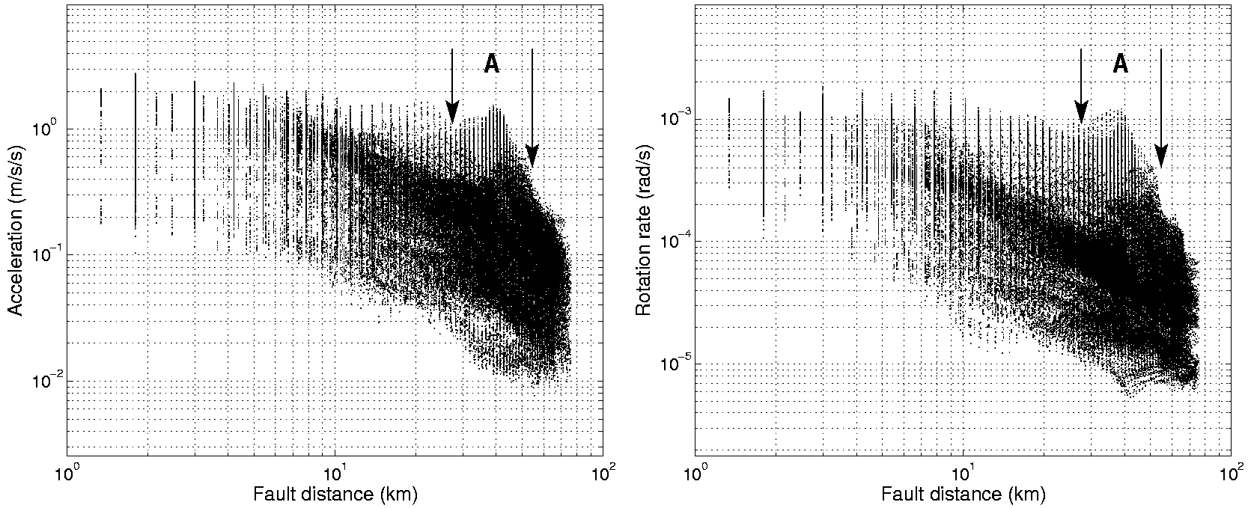

Figure 9: Peak ground accelerations (y-component) and Peak ground rotation rates (z-component) as a function of fault distance. Those results synthesized with the varying hypocentre location are shown. Left. y-component of acceleration. Right. z-component of rotation rate. Fault distance range of A is picked up for det

