Übungen Ergänzungen Angewandte Geophysik

Punktquelle – Scherdislokation

Berechnen Sie das maximale Verhältnis der Amplituden der P und S Wellen im Fernfeld (FP, FS). Berechnen Sie ein Verhältnis für λ = μ . Welche Konsequenzen für die Bodenbewegungen im Fernfeld, die auf Gebäude wirken? Max(A^{FX}) = 1.

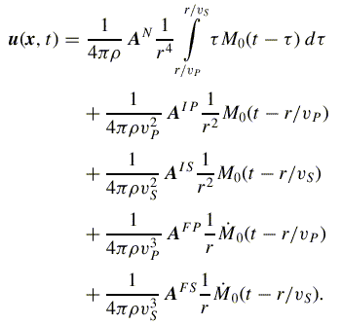

Bruchfläche – Bruchlänge

Zwischen der Oberflächenwellenmagnitude M_{S} und der Bruchfläche A gibt es einen empirischen Zusammenhang der Form

$\text{log}A=1\text{.}\text{02}M_{S}+6\text{.}0$

wobei A in cm² angegeben wird. Skizzieren Sie die Länge des Bruchs (in logarithmischer Form) als Funktion der Magnitude M_{S} unter der Annahme einer quadratischen Bruchfläche für das Magnitudenintervall [0,10] (Geradengleichung). Wie ändert sich diese Grafik wenn die maximale vertikale Bruchausdehnung 30km beträgt? Leiten Sie zuerst die entsprechende Geradengleichung her. Welchen Bruchlänge erhalten Sie für das Sumatrabeben mit M=9.3? Woran könnte es liegen, dass die Werte nicht übereinstimmen? Welche Magnitude hätte ein Beben, welches die Erde in zwei Hälften teilt (Bruchfläche wäre Ebene durch Erdmittelpunkt). Welche Magnitude hätte ein Beben welches die ganze Erdkruste entlang des Äquators bricht (Moho Tiefe 30km)?

Magnitude, seismic moment, displacement

Geologists observe the following features in the landscape around the San Andreas Fault, California. The areal photographs show that the river has been horizontally displaced over a considerable distance. Estimate the horizontal displacement from the top left figure.

The greater area around Wallace creek experiences an earthquake of a magnitude around M6 on average every 25 years. How long did it take the San Andreas fault to generate the observed displacement at Wallace Creek? What is the yearly horizontal displacement across the San Andreas Fault in this area?

Assume that over the same time period 1000 M3 earthquakes also happen on the same fault. How much of the total displacement would be attributed to such small events?

You will need the following information:

- The crustal shear velocity in that region is estimated at v_{s} = 2000m/s, the density ρ=2g/cm³
- The relation between rigidity, density and shear-velocity is $v_{s}=\sqrt{\frac{μ}{ρ}}$.
- The fault area moving during the typical M6 earthquake has a vertical extension of 10km and a horizontal extension of 15km.
- The seismic moment M₀ (in dyne-cm) is related to the Magnitude M by:
M = 2/3 (log₁₀M₀-16)
- The seismic moment M₀ is determined by the rock rigidity μ, the fault area A and the horizontal slip distance d by: M₀ = μ A d (in dyne-cm)
- The unit dyne is [g cm/s²], 10⁵ dyne = 1 N, N is [kg m/s²]
- A magnitude M3 earthquake is estimated to have a fault area of (200)²m².

Beachballs and tectonics

Using different colors for the different faulting types, circle five examples each of (a) normal faults, (b) reverse faults, and (c) strike–slip faults. Try to understand in the context of tectonic environment.

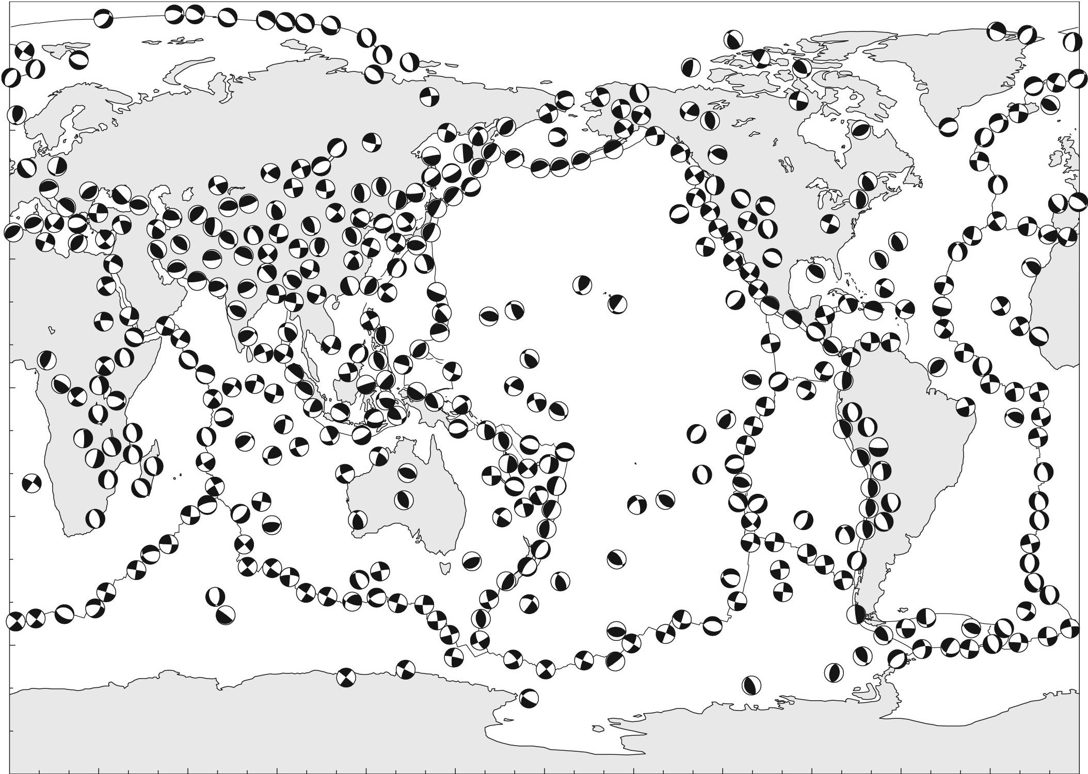

Earthquake spectra and stess drop

Your borehole seismic experiment obtains the P-wave spectra plotted in Figure 9.1 at a distance of 10 km from an earthquake. Using a ruler, crudely estimate Ω0 and fc from the plot. Assuming that the density is 2700 kg/m³, the P velocity is 6 km/s, and the S velocity is 3.46 km/s, compute the moment, M0, the moment magnitude, MW, the source radius, r, and the stress drop, Δσ, for this event. State any modeling assumptions that you make. Do not confuse the source radius r in Section 9.5 with the source-receiver distance r in Equation 9.27. The recording station is deep enough that you may assume that the effect of the free surface can be ignored and that the rock properties are uniform between the earthquake and the station. You may also assume that attenuation is negligible (or that the spectrum has already been corrected for attenuation) and that the radiation pattern term is simply its average P-wave value of 0.52.

You need the following relations:

Long-period spectral level and seismic moment (eq. 9.27)
$M_{0}=\frac{4\text{πρ}c^{3}Ω_{0}}{U_{\text{ΦΘ}}}$

And a relationship between Magnitude and M₀ (eq. 9.73)

$M_{w}=\frac{2}{3}\left[{\text{log}}_{\text{10}}M_{0}−9\text{.}1\right]$

Fault radius as a function of corner frequency (eq. 9.43)

$r=\frac{kβ}{f_{c}}\begin{matrix} & k=0\text{.}\text{32}\end{matrix}$

Stress drop (eq. 9.40)
$Δσ=\frac{7M_{0}}{\text{16}r^{3}}$

Stress drop and fault size

Calculate M₀ from the moment tensor of the Tohoku-oki earthquake March 11, 2011.
Estimate the stress drop in MPa using the relation from Knopoff (eqs. 9.8 and 9.41), w width 150km , L fault length 250km
$Δσ=\frac{2M_{0}}{π{\text{wL}}^{2}}$$M_{0}=\frac{1}{\sqrt{2}}{\left(\sum_{\text{ij}}{M_{{}_{\text{ij}}}^{2}}\right)}^{1/2}$

The moment tensor (Harvard CMT output)

Mechanism information
Exponent for moment tensor: 29 units: dyne-cm
Mrr Mtt Mpp Mrt Mrp Mtp
CMT 1.730 -0.281 -1.450 2.120 4.550 -0.657
Error 0.006 0.005 0.005 0.068 0.065 0.004

With these values of M₀ and area, estimate the slip assuming vs=4km/s and density ρ=2500 kg/m³

Magnitude

Suppose a fault existed completely around Earth’s equator to a depth of 30 km and ruptured in a single earthquake with 20 m of slip. Estimate MW for this event.

Rupture dimension and slip

Estimate the radius and average displacement of a circular fault for MW values ranging from −2 to 8 (make a table at unit increments). Use (9.40) and (9.73), a constant stress drop of 3 MPa, and a shear modulus, μ, of 30 GPa.

You need (r is fault radius), M₀ in Nm

$Δσ=\frac{7\text{πμ}D}{\text{16}r}=\frac{7M_{0}}{\text{16}r^{3}}$$M_{w}=\frac{2}{3}\left[{\text{log}}_{\text{10}}M_{0}−9\text{.}1\right]$

