XXX

An outlook on different meshing technique: the Grenoble benchmark.

Marco STUPAZZINI¹ , Heiner IGEL¹ , E. CASAROTTI² Jeroen TROMP²

Ludwig-Maximilians-Universitaet, Theresienstrasse 41, 80333, Muenchen, Germany

ABSTRACT - The spectral element method (SEM) is a powerful numerical technique naturally suited for seismic wave propagation analyses. A class of SEM has been widely used in the seismological field thanks to its capability of providing high accuracy and allowing the implementation of optimized parallel algorithms. The aim of this work is compare the results obtained with different meshing techniques. The set-up proposed by ESG2006 committee in the frame of the numerical benchmark of 3D ground motion simulation in the valley of Grenoble (French Alps).

1. Introduction

XXXX

2. SEM NUMERICAL TOOL: GeoELSE

The SE approach developed by Faccioli [1997], Komatitsch [1998] has been implemented in the computational code GeoELSE (GeoELasticity by Spectral Elements [Maggio 2001], [Stupazzini 2004]), for 2D/3D wave propagation analyses. The most recent version of the code includes: (i) the capability of dealing with fully unstructured computational domains and (ii) the parallel architecture. While the former feature allows to treat problems involving complex geometries, the second is the natural approach for large scale applications. The spectral element method (SEM) is usually regarded as a generalization of the finite element method (FEM) based on the use of high order piecewise polynomial functions. The crucial aspect of the method is the capability of providing an arbitrary increase in accuracy simply enhancing the algebraic degree of these functions (the spectral degree SD). On practical ground, this operation is completely transparent for the users, who limit themselves to choose the spectral degree at runtime, leaving to the computational code the task of building up suitable quadrature points and new degrees of freedom. Obviously, the increasing spectral degree implies the raise the computational effort of the problem.
On the other hand, one can also play on the grid refinement to improve the accuracy of the numerical solution, thus following the standard finite element approach. Spectral elements are therefore a so-called "h-p" method [Faccioli 1996], where "h" refers to the grid size and "p" to the degree of polynomials.
Referring to Faccioli [1997] for further details, we briefly remind in the sequel the key features of the spectral element method adopted. We start from the wave equation:

(1)

where is the time, the material density, a known body force distribution and the stress tensor. Introducing the Hooke's law:

(2)

where

(3)

is the small strain tensor, and are the Lamé elastic coefficients, and is the Kronecker symbol, i.e. if and , otherwise.

As in the FEM approach, the dynamic equilibrium problem for the medium can be stated in the weak, or variational form, through the principle of virtual work (Zienckiewicz 1989), and, through a suitable discretization procedure that depends on the numerical approach adopted, can be written as an ordinary differential equations system with respect to time:

(4)

where matrices and , respectively the mass and the stiffness matrix, vectors and are due to the contributions of external forces and tractions conditions, respectively. In our SE approach, denotes the displacement vector at the Legendre-Gauss-Lobatto (LGL) nodes, that correspond to the zeroes of the first derivatives of Legendre polynomial of degree N [Abramowitz 1966]. The advancement of numerical solution in time is provided by the explicit 2nd order leap-frog scheme (LF2-LF2) [Maggio 1994].

This scheme is conditionally stable and must satisfy the well known Courant-Friedrichs-Levy (CFL) condition:

(5)

3. The 3D numerical simulation

3.1. Plane wave

3.3. Valley of Grenoble

The SEM has been formulated as proposed by Faccioli [1997] and Komatitsch [1998]. The computational domain is decomposed into a family of non overlapping hexahedrals in 3D. The aim of this work is compare the results obtained with different meshing techniques. We adopt the set-up proposed by ESG2006 committee in the frame of the numerical benchmark of 3D ground motion simulation in the valley of Grenoble (French Alps). The participants to the benchmark received the task to compute the simulation of two strong motion earthquake (“strong1” and “strong2”) on the basis of the following data:
- the topography of the area (DEM with 250 m spacing);
- the shape of the alluvial basin (DEM with 250 m spacing);
- the mechanical properties, varying inside the alluvial basin proportionally to the depth.

Obviously a 3D simulation should take into account all these information, but in order to accurately and efficiently reproduce the features listed above, it is necessary to provide a 3D unstructured mesh.
While 3D unstructured tetrahedral meshes can be achieved quite easily with commercial or non commercial software, the creation of a 3D non structured hexahedral mesh is still recognized as a challenging problem. The personal experience developed throughout the different study cases already analyzed [Stupazzini 2004] [Maggio et al., 2005] suggests that one of the most promising software capable of meshing complex 3D domain is the commercial software CUBIT (http://cubit.sandia.gov/) that incorporates a set of powerful and advanced meshing scheme developed to automatically handle the unstructured meshing problem.
Nevertheless, it is worth noting that the meshing of a large domain (compared to the minimum element size) like the valley of Grenoble seems not to be feasible with just a "push-button" procedure, due to the complex shape of the basin and to the wide rage of element size, going from 100m up to 1km.
We propose the comparison between two different techniques:

First strategy: “Honoring”

The strategy here presented subdivides the computational domain in small (many kilometers) hexahedral chunks (Figure 3). Each sub-volume was meshed with a quite standard scheme (e.g.: “pave” mesh scheme is applied on one of the surface and then a sweeping is performed along the other direction). This technique obviously worsens the quality of the resulting mesh and increases the total number of elements but, on the other hand, allow to perform the splitting into hexahedras of the area under exams strictly honoring the given geometry
The final mesh is depicted in Figure 3 and Figure 4 and consists of 216972 elements that range from a minimum size of 21 m (alluvial area) up to 1000 m. The mesh is designed to propagate correctly up to 2.5 Hz with a spectral degree SD = 3, and up to around 3 Hz with SD = 4. The main characteristics of the numerical analyses are summarized in Table I. The computations have been performed with a Dell Linux cluster based on Intel Xeon, 3.06 GHz, 64 bit, Gigabit Ethernet connection (homer.stru.polimi.it) and with a Fujitsu siemens cluster (tethys.geophysik.uni-muenchen.de).
The partitioning of the global domain into subdomains is performed by the free METIS software (Karypis and Kumar 1998) and is completely independent from the kernel. In order to avoid confusion it is worth to underline the fact that the meshing and the partitioning of the domain are two completely independent issue; Figure 3 and 4 do not represent the partitioning of the domain but only the way to mesh the domain honoring the given geometry. Finally the communication between the processors is performed by the MPI (Message Passing Interface) libraries.

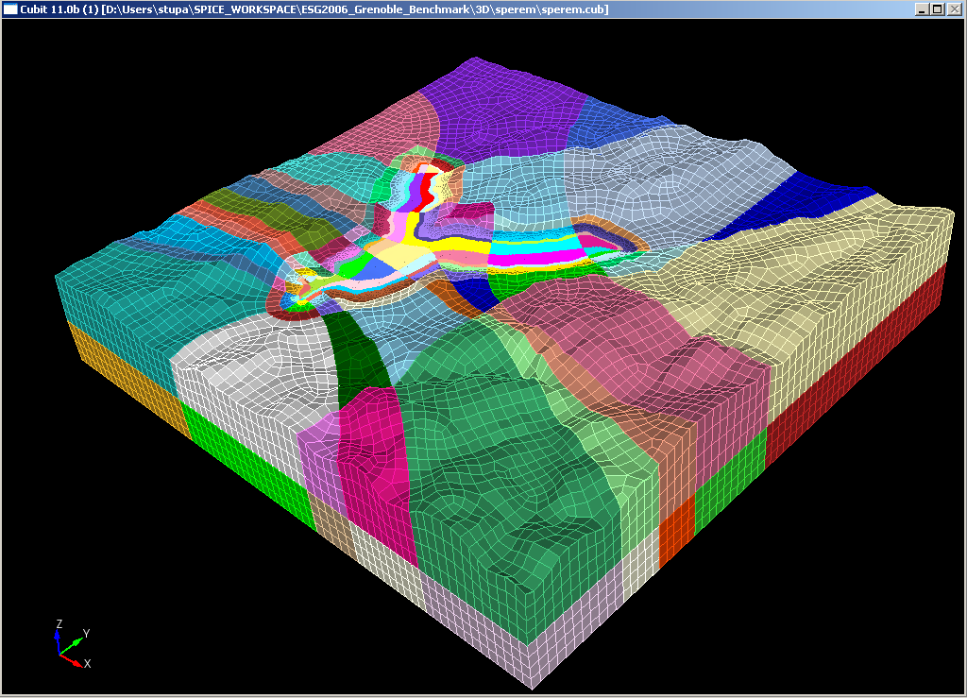

Figure 1. 3D numerical model used for the simulations (top view). The computational domain is subdivided into small chunks and each one is meshed starting from the alluvial basin down to the bedrock.. For simplicity only the spectral elements are shown without LGL nodes.

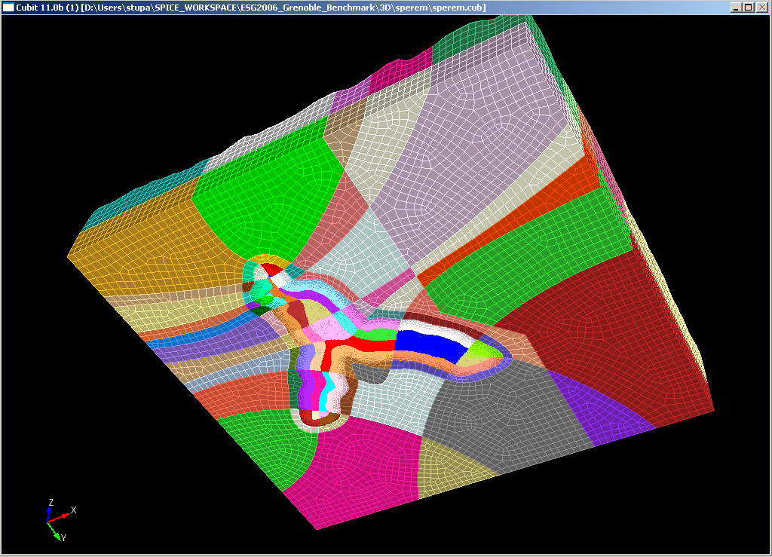

Figure 2. 3D numerical model used for the simulations (bottom view).

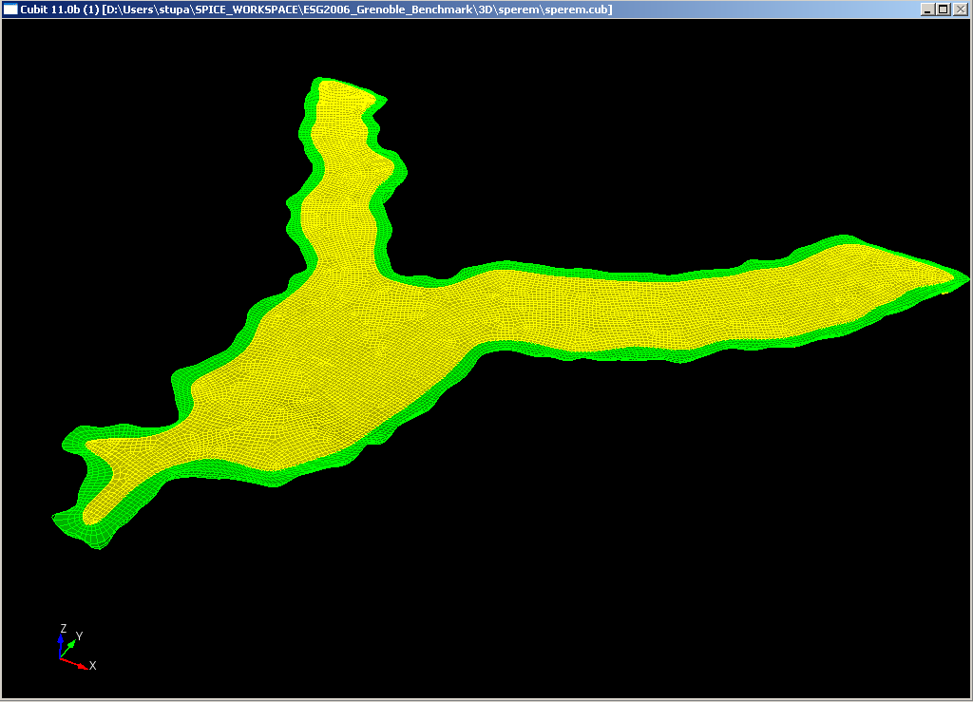
Figure 3. 3D numerical shape of the alluvial basin (top view).

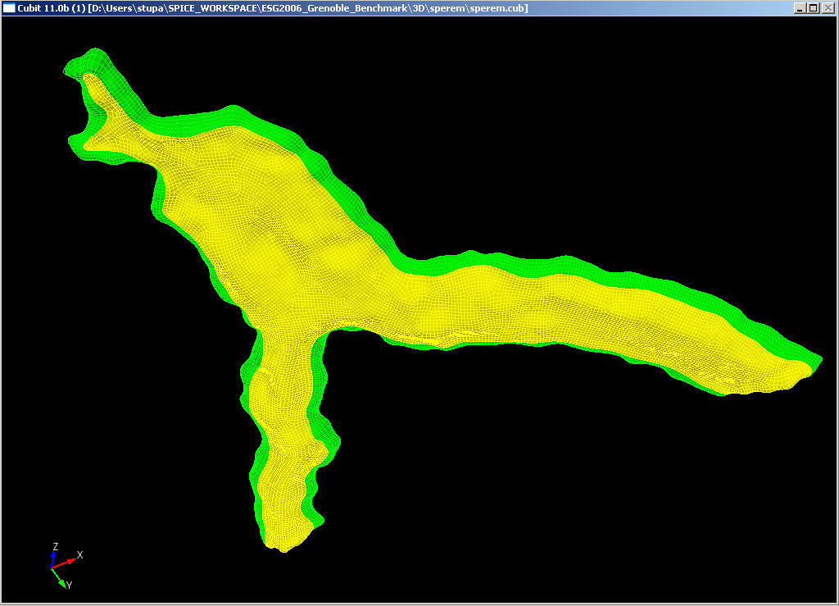
Figure 4. 3D numerical shape of the alluvial basin (top view).

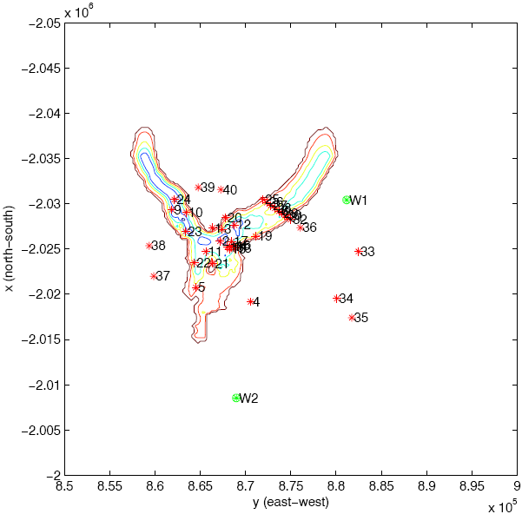
Receivers location along the valley
Comparison with 3 different numerical techniques:
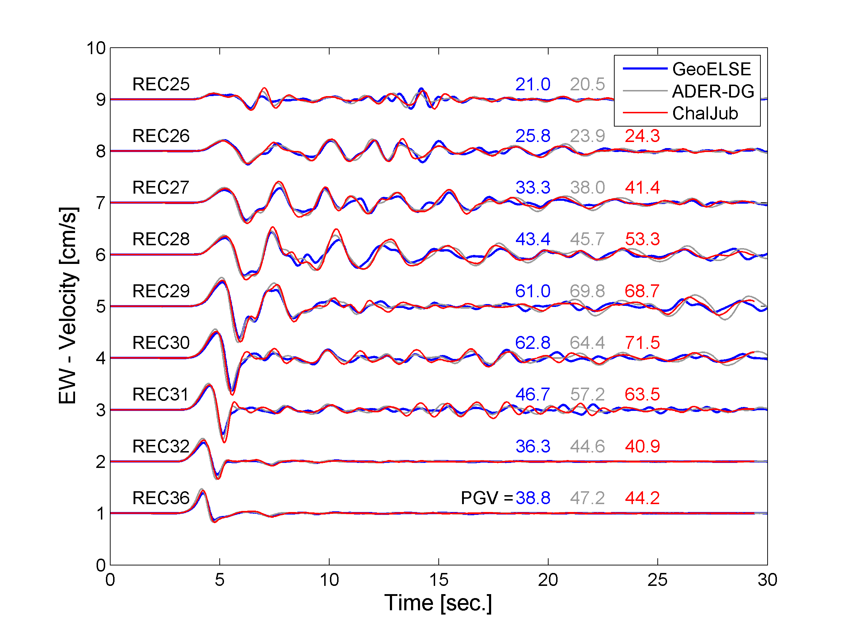
Figure 5. Synthetics of EW components obtained by the 3D numerical modelling with ADER-DG (grey line), “Honoring strategy” GeoELSE (Blue line) and ), Chaljub (Red line) excited by fault “strong 1” (M_{W} = 6). Receivers are recorded along the 2D Profile (R25, R26, R27, R28, R06, R29, R30, R31, R32 and 36).

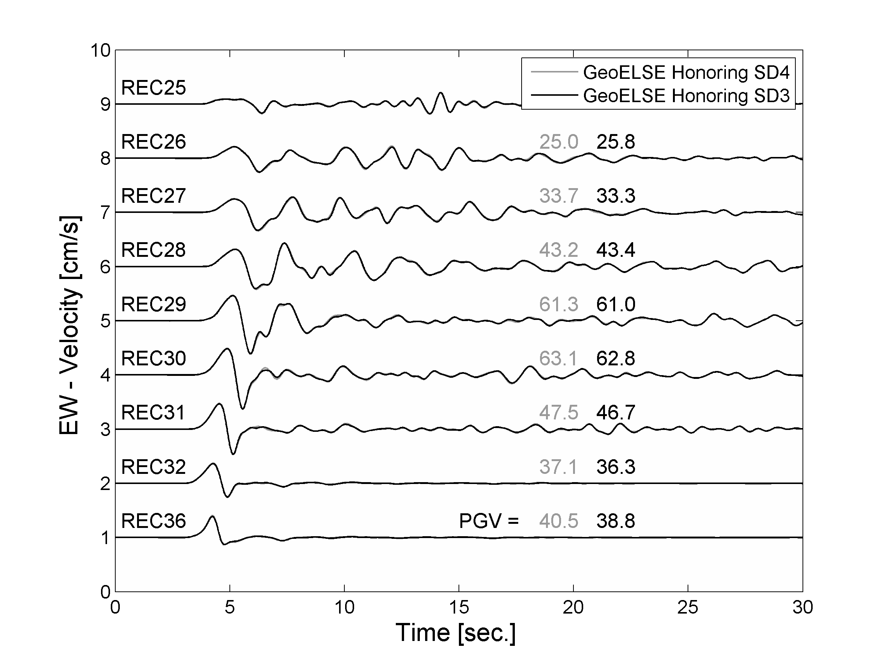
Figure 6. Synthetics of EW components obtained by the 3D numerical modelling with “Honoring strategy” GeoELSE at a SD = 3 and SD =4 excited by fault “strong 1” (M_{W} = 6). Receivers are recorded along the 2D Profile (R25, R26, R27, R28, R06, R29, R30, R31, R32 and 36).

Second strategy: “Not Honoring”

The “original mesh” is coarse and designed with element honouring only the topographical constrain. The top shape of the alluvial basin is given as a “soft” constrain: the green volume does not represent the shape of the alluvial basin but only a more simplified and larger version of that (Figure XXX). The “3 steps” procedure here described start with a mesh that is designed with elements of around 1000 m, compatible with a correct sampling of an f_{max} = 3Hz propagating inside the outcropping bedrock (V_{S} = 3200 m/s). The 2nd step refine surface 1 and 2 up to a certain depth. The algorithm adopted is the “1 to 3“ scheme already presented and adopted by many authors. One of the major difference of the one implemented inside CUBIT lies on the fact that it can be applied even to unstructured paved mesh with no particular matters around the resulting quality of the generated hexahedras. Finally the 3rd step refine only the surface 2, once again up to an imposed depth. The procedure basically drive the element size from 1000 m down to 100 m. This size is compatible with a correct sampling up to 3 Hz of the upper part of the alluvial deposit (Vs = 300 m/s).

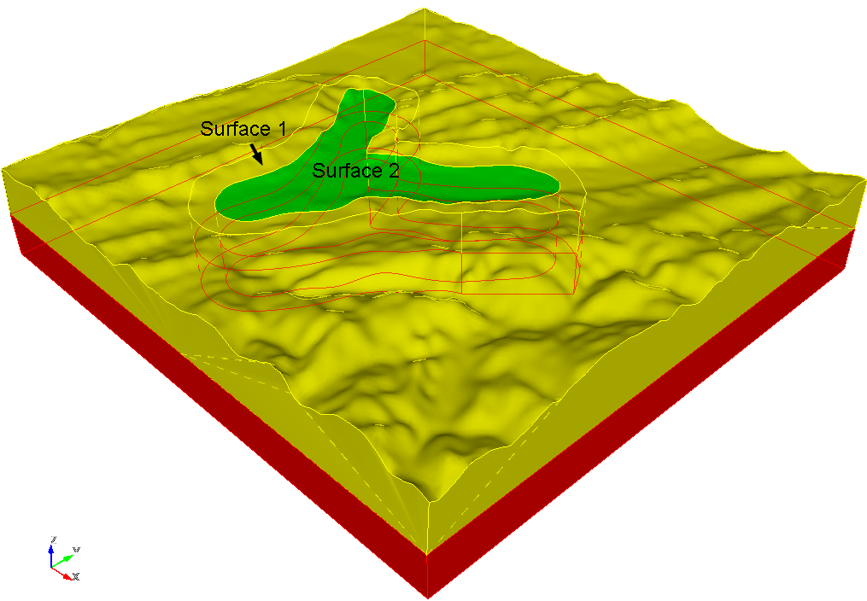

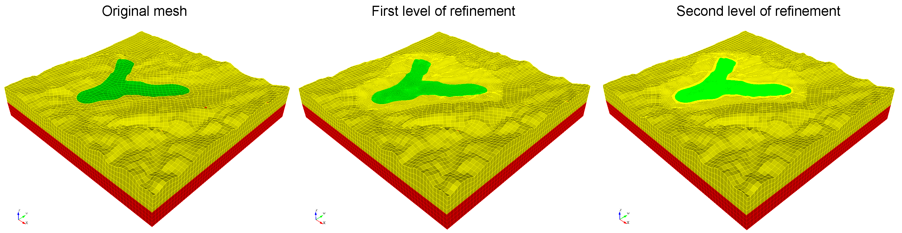
Figure 8. The “3 steps” procedure adopted for the creation of the fully unstructured mesh of Grenoble. The computational domain is subdivided into big chunks and each one is meshed with a pave scheme on the top and then swept down to the bottom. For simplicity only the spectral elements are shown without LGL nodes.

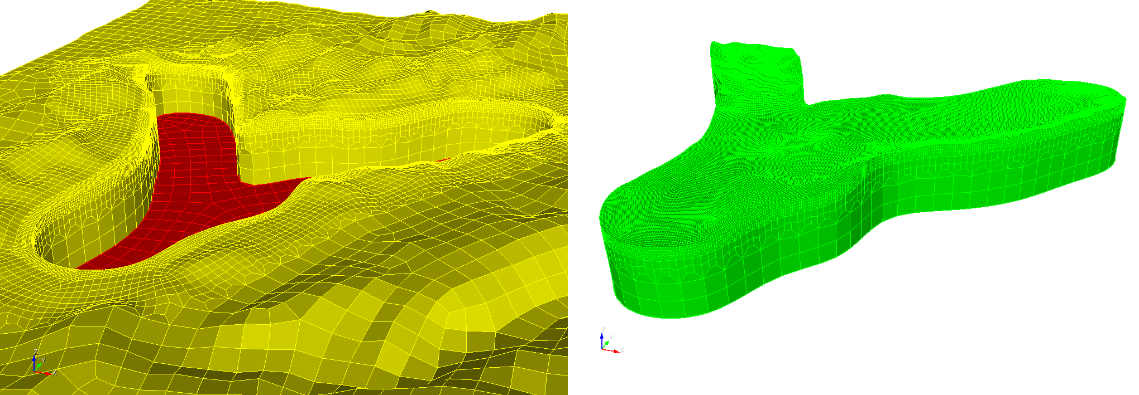
Figure 9. Final mesh obtained with the “3 steps”; the domain is fully unstructured. For simplicity only the spectral elements are shown without LGL nodes.

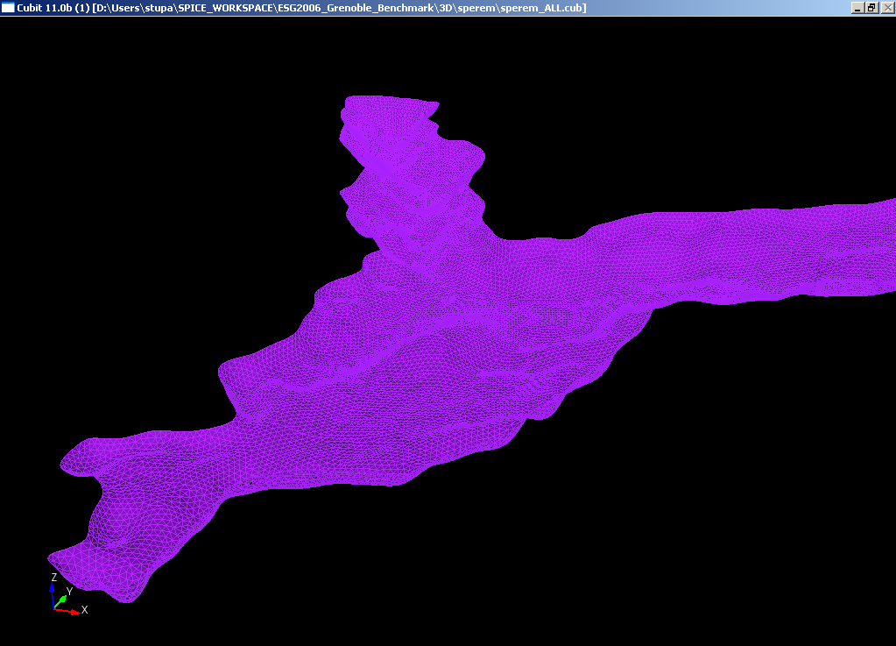
Figure 10. DEM of the alluvial basin

Table II. 3D numerical model size produced with the “3 steps” procedure
Name | Surface 1+2  Refinement up to Depth [elem] | Surface 1  Refinement up to Depth [elem] | # Elem. | SD | Nodes number | Δt_{simulation} [sec.] | time steps  #
NH1_SD3 | 1 | 1 | 171 056 | 3 | 4 793 368 | 0.000307876 | 97474
NH1_SD4 | 1 | 1 | 171 056 | 4 | 11 257 997 | 0.000307876 | 97474
NH2_SD3 | 1 | 2
NH3_SD3  (homer) | 2 | 2 | 296 161 | 3 | 8 185 294 | 0.000307876 | 97474

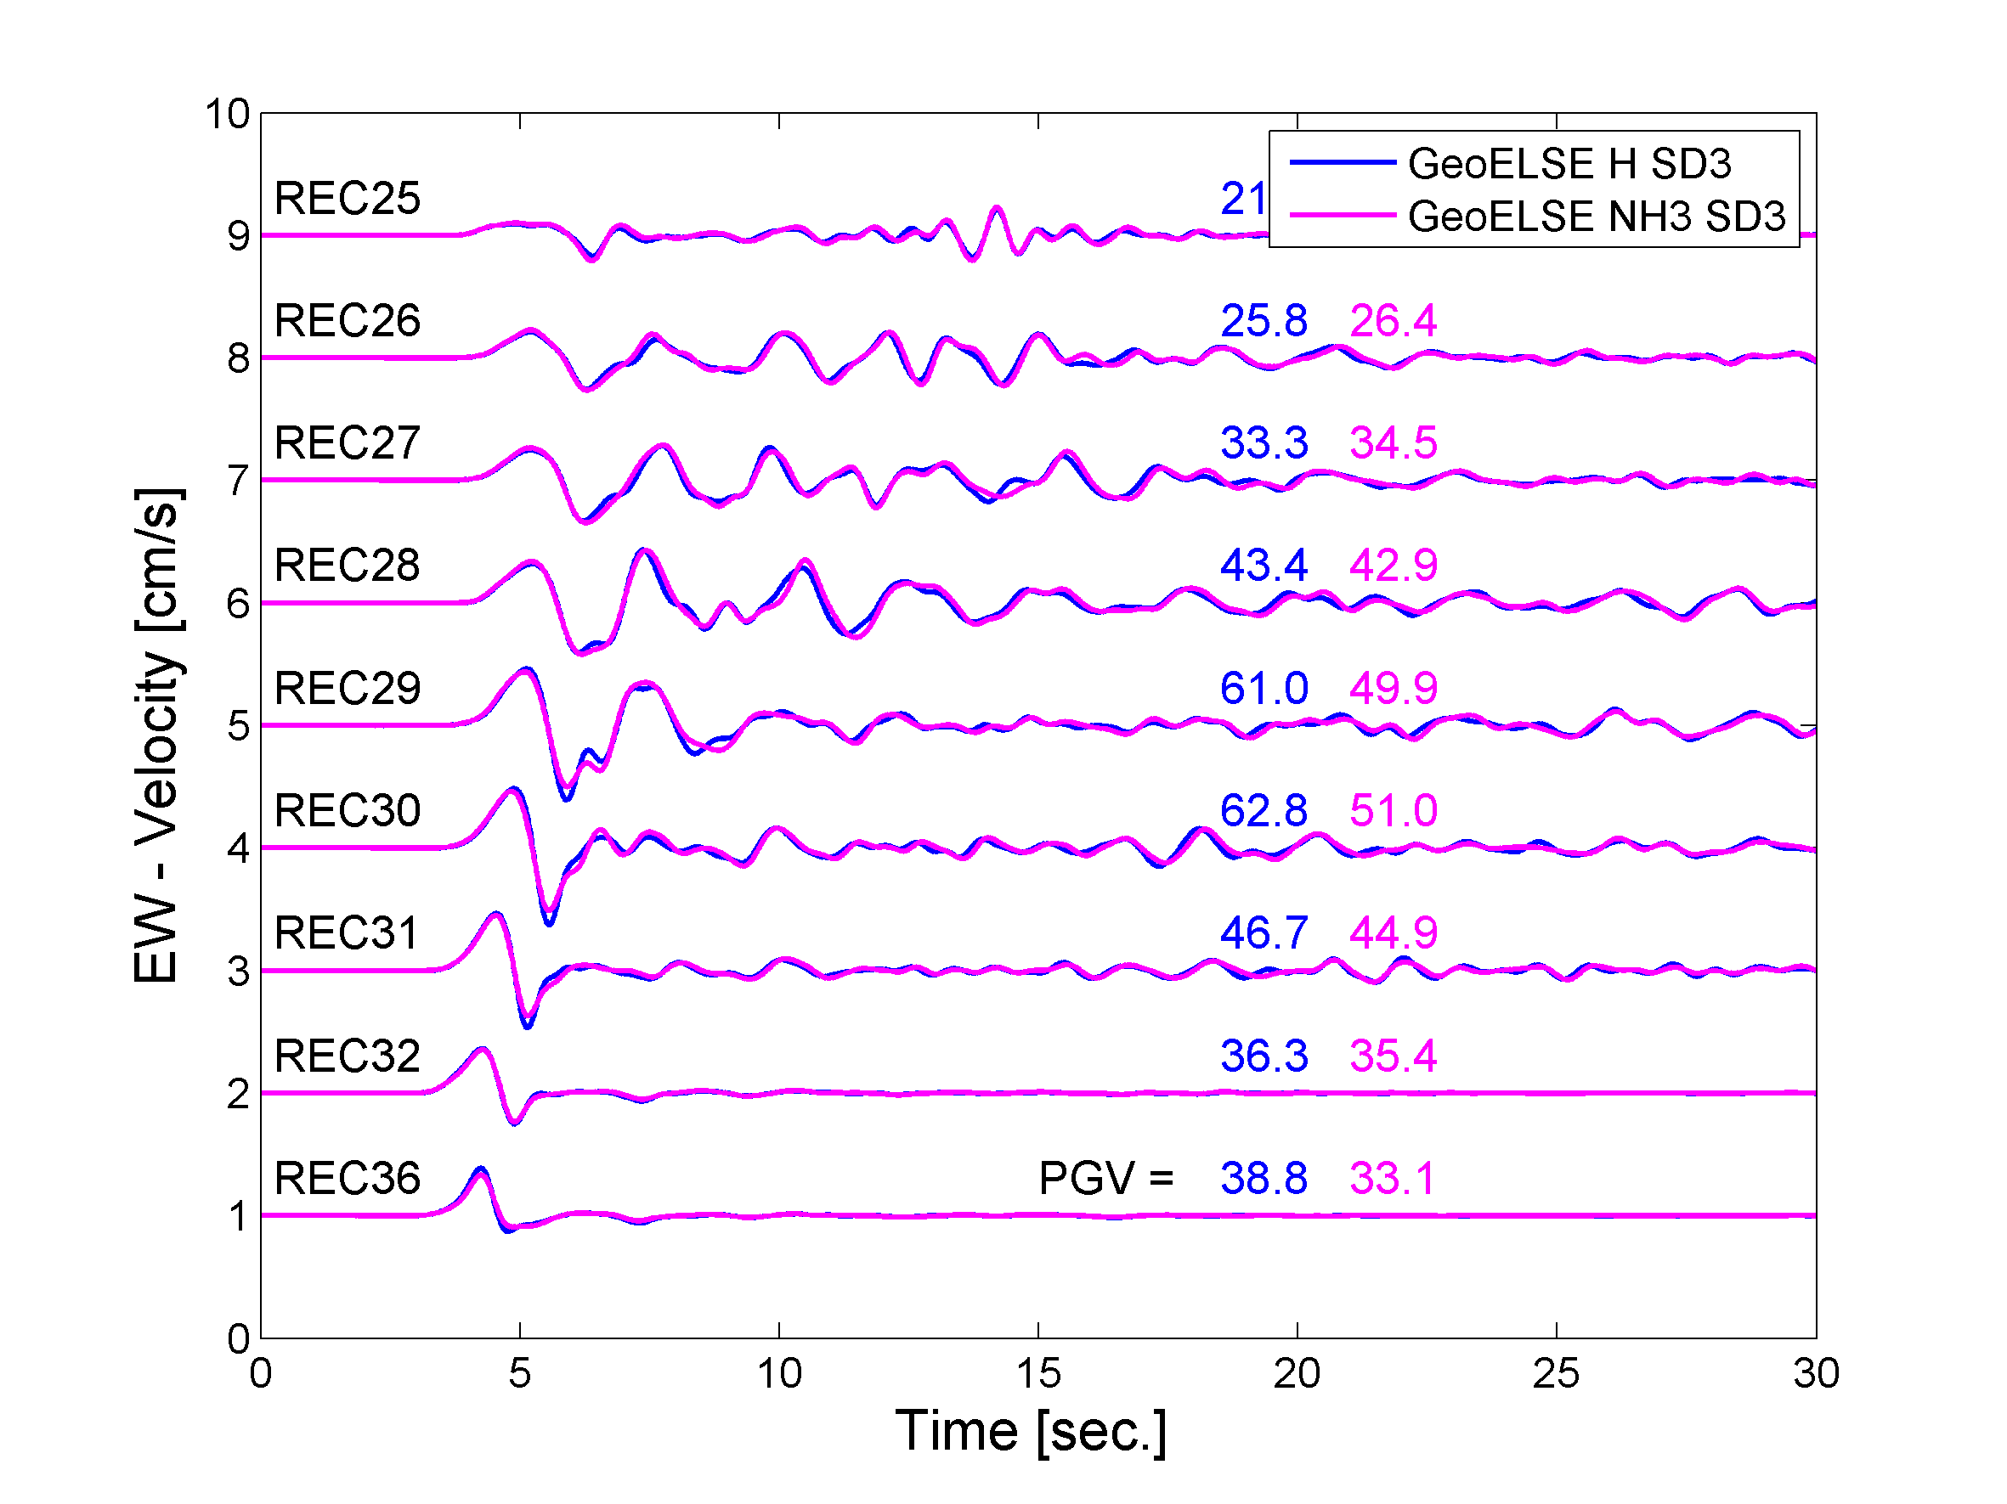 Figure 11. Synthetics of EW components obtained by the 3D numerical modelling with “Honoring” strategy (SD3) GeoELSE (blue line) and “NOT Honoring” strategy (SD3) GeoELSE (magenta line) excited by fault “strong 1” (M_{W} = 6). Receivers are recorded along the 2D Profile (R25, R26, R27, R28, R06, R29, R30, R31, R32 and 36).

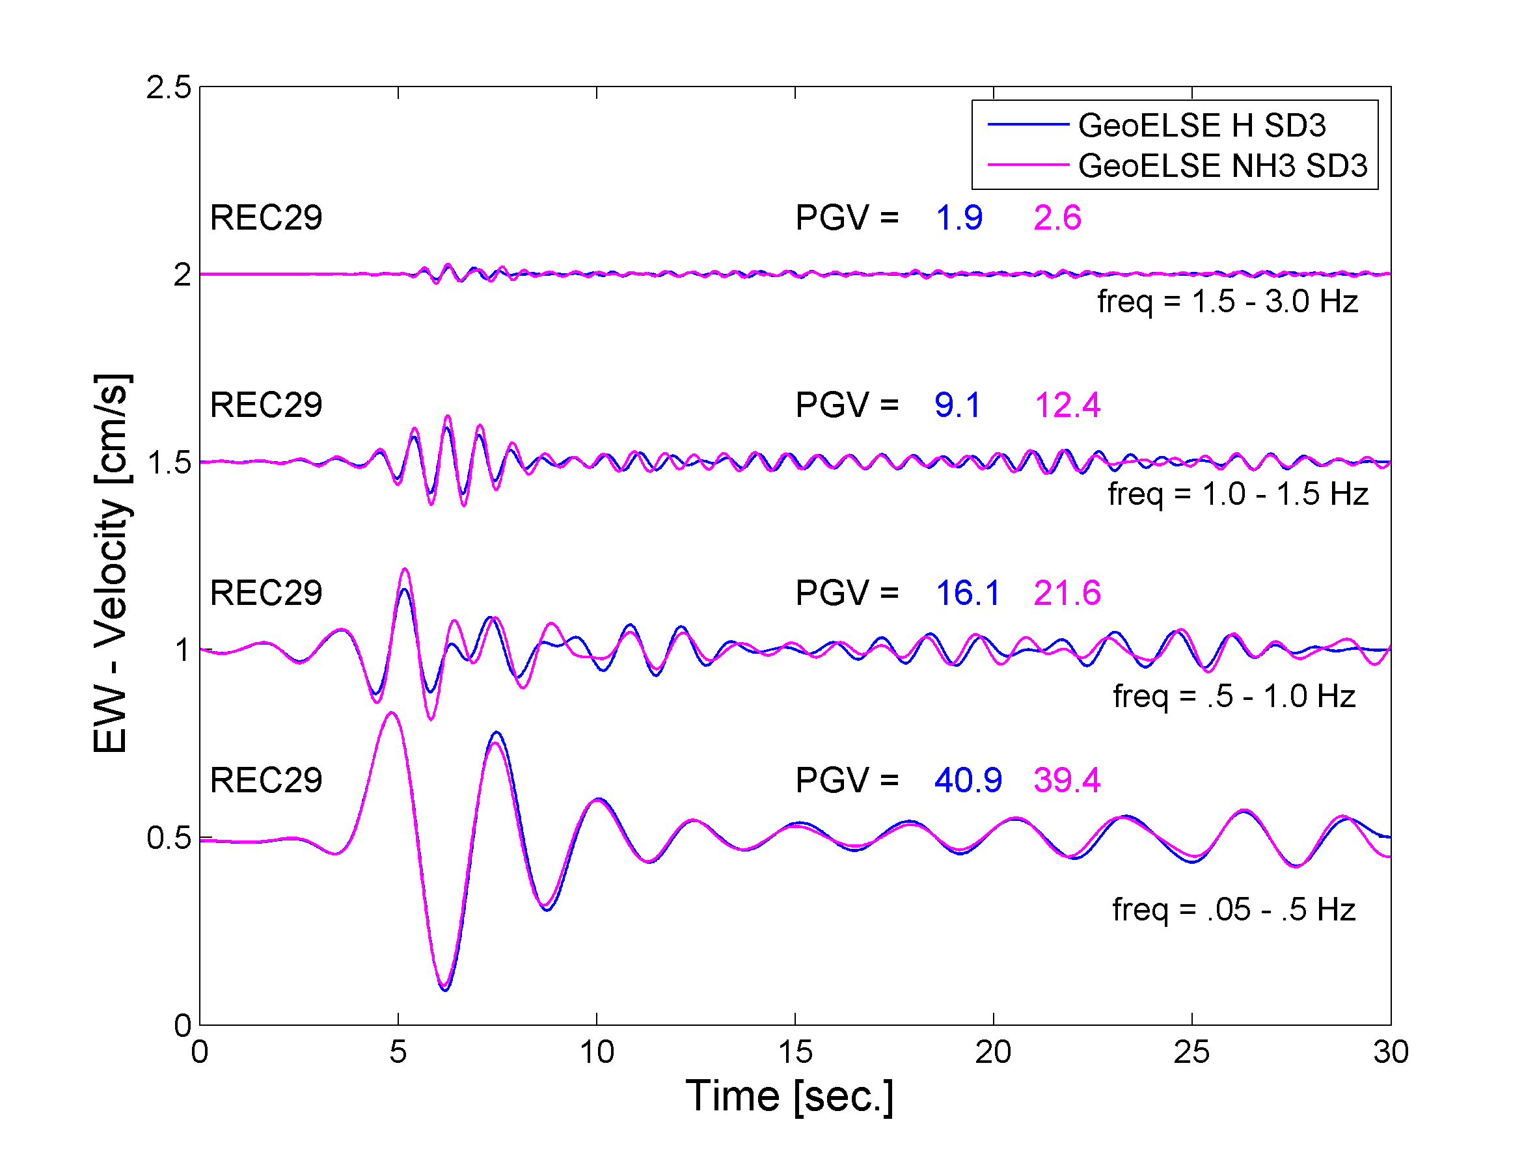
Figure 12. Synthetics of EW at receivers 29 filtered between the different range of frequencies. The components are obtained by the 3D numerical modelling with “Honoring” strategy (SD3) GeoELSE (blue line) and “NOT Honoring” strategy (SD3) GeoELSE (magenta line) excited by fault “strong 1” (M_{W} = 6).

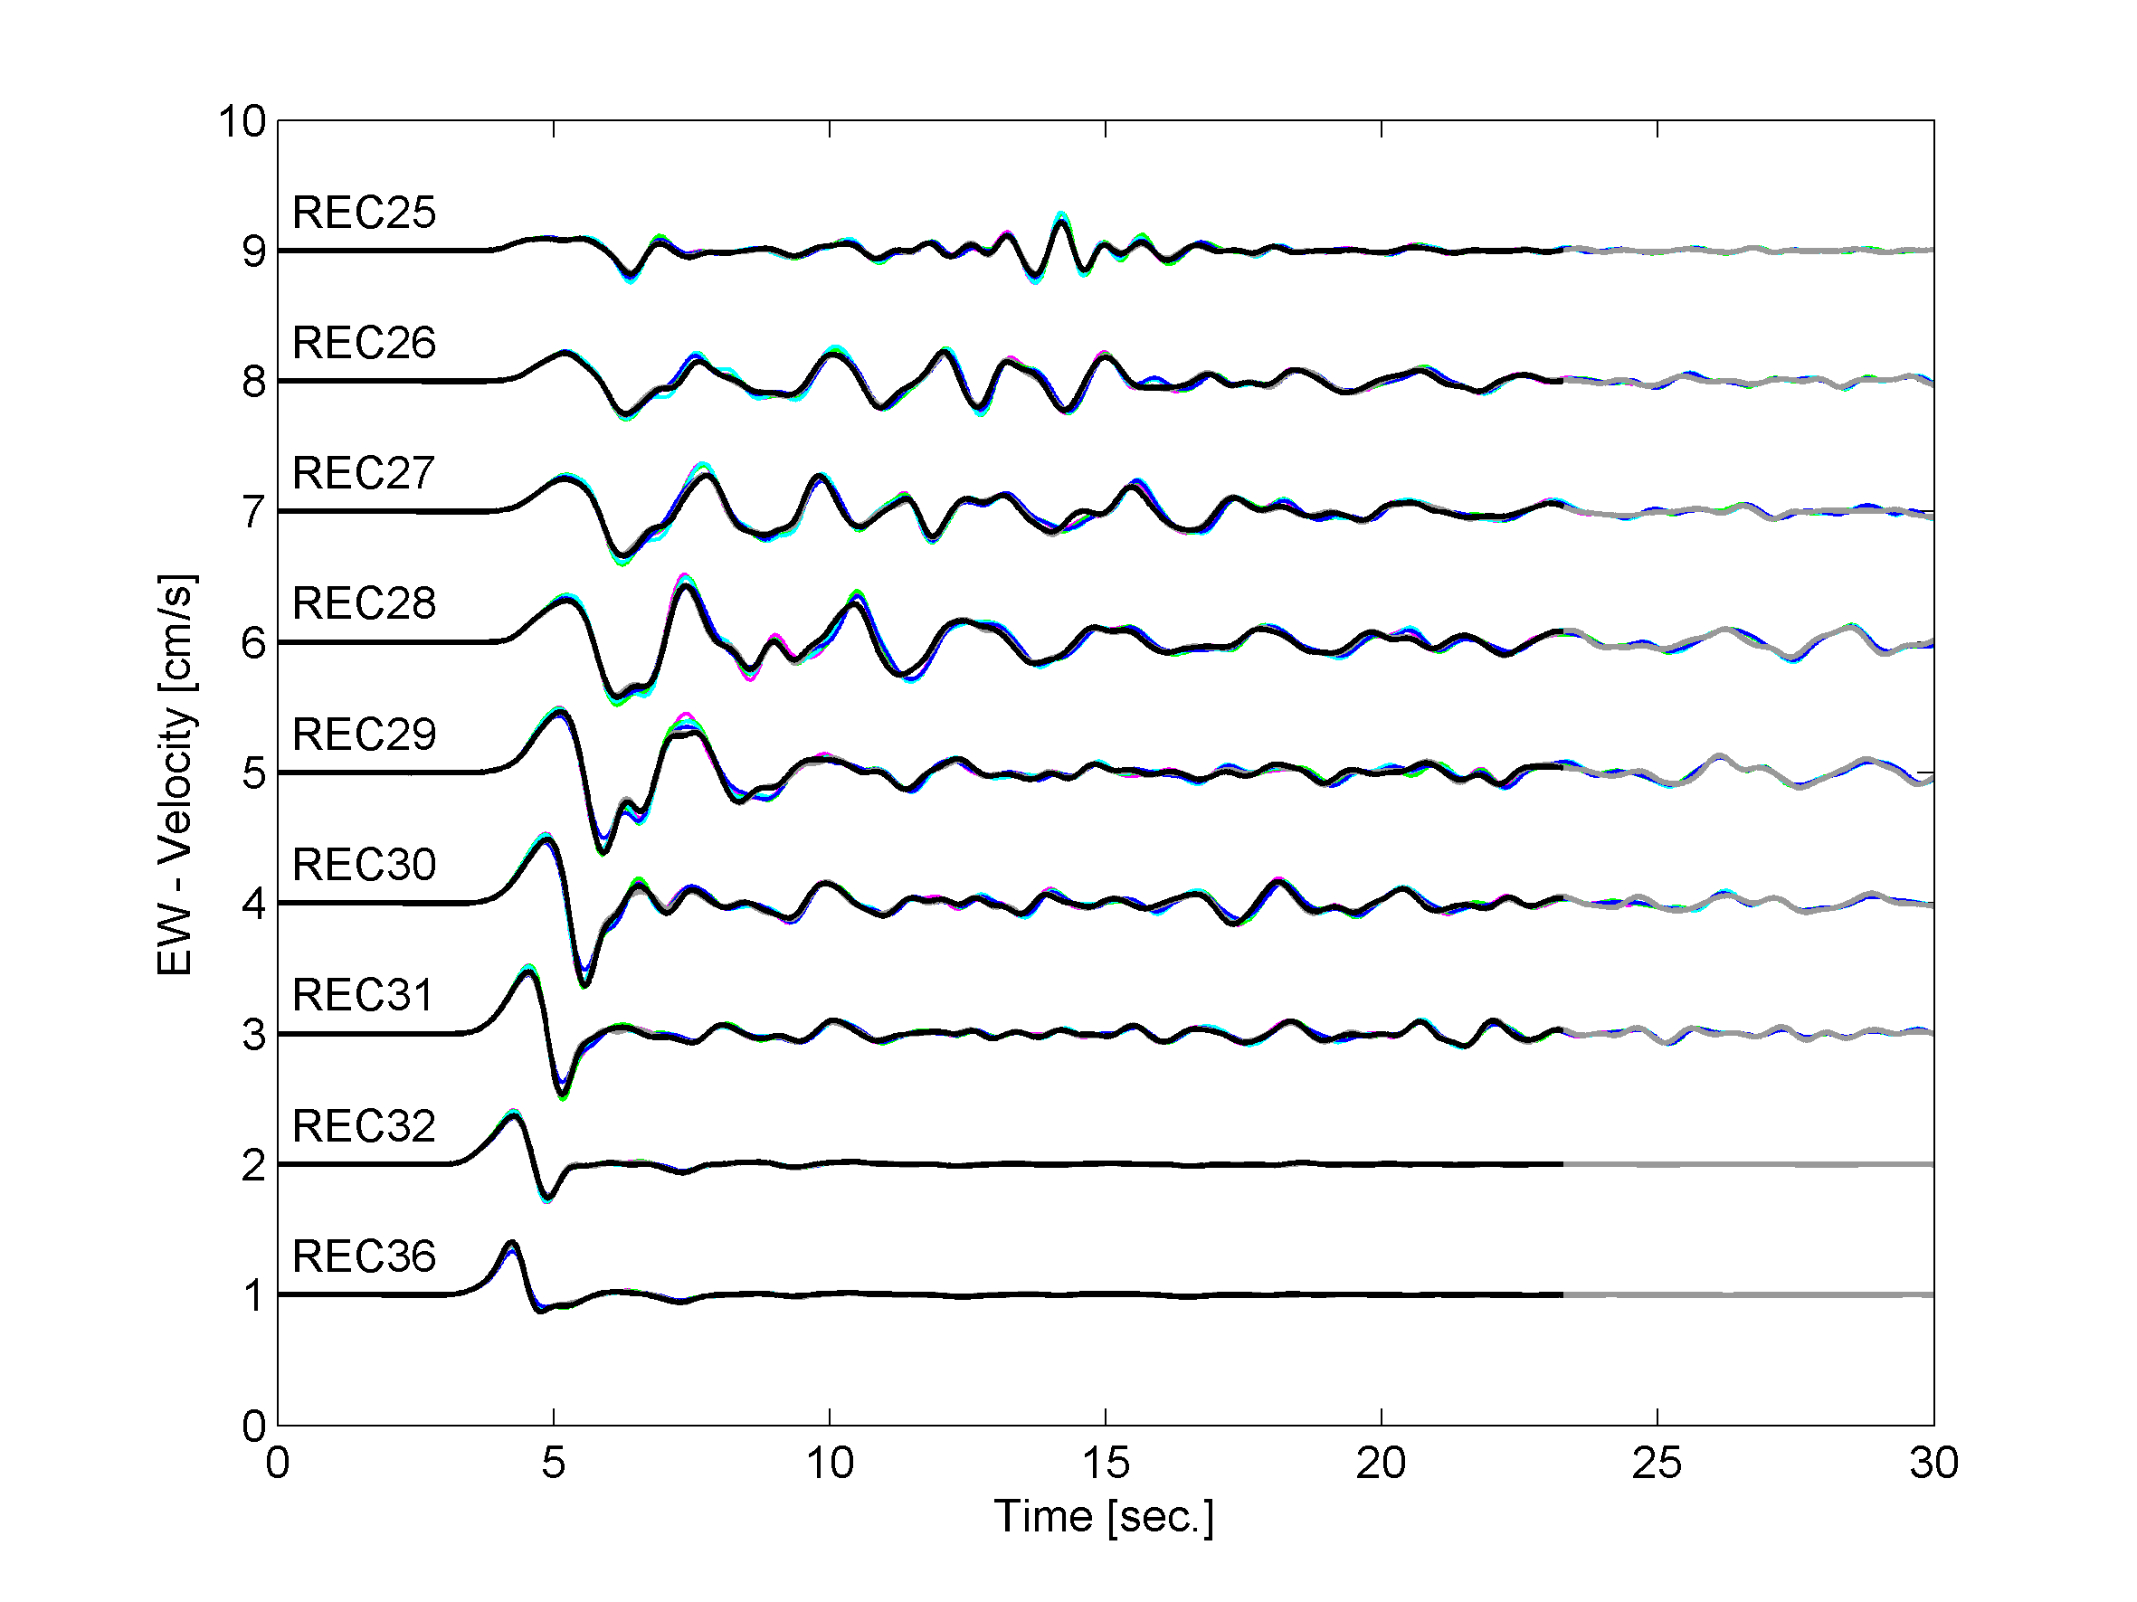
Figure 13. Synthetics of EW components obtained by the 3D numerical modelling with:
- “Honoring” strategy (SD3) GeoELSE (grey line)
- “Honoring” strategy (SD4) GeoELSE (black line)
- “NOT Honoring” strategy DEPTH 3 (SD3) GeoELSE (blue line)
- “NOT Honoring” strategy DEPTH 2 (SD3) GeoELSE (cyan line)
- “NOT Honoring” strategy DEPTH 1 (SD4) GeoELSE (green line)
- “NOT Honoring” strategy DEPTH 1 (SD3) GeoELSE (green line)
excited by fault “strong 1” (M_{W} = 6). Receivers are recorded along the 2D Profile (R25, R26, R27, R28, R06, R29, R30, R31, R32 and 36).

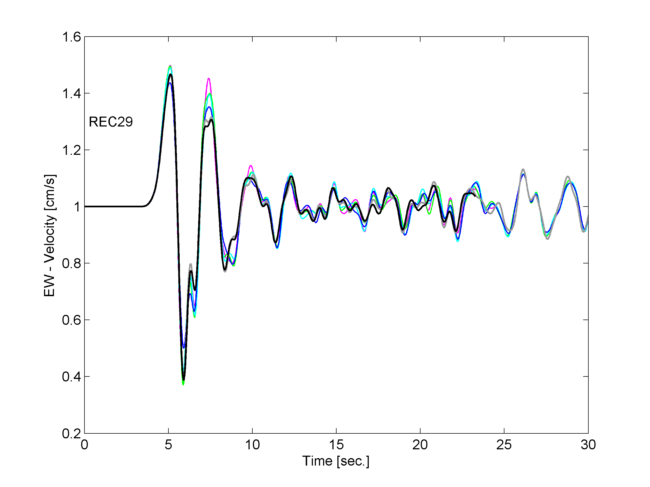
Figure 14. Receivers 29 (SOFT SOIL CLOSE THE FAULT). Synthetics of EW components obtained by the 3D numerical modelling with:
- “Honoring” strategy (SD3) GeoELSE (grey line)
- “Honoring” strategy (SD4) GeoELSE (black line)
- “NOT Honoring” strategy DEPTH 3 (SD3) GeoELSE (blue line)
- “NOT Honoring” strategy DEPTH 2 (SD3) GeoELSE (cyan line)
- “NOT Honoring” strategy DEPTH 1 (SD4) GeoELSE (green line)
- “NOT Honoring” strategy DEPTH 1 (SD3) GeoELSE (green line)
excited by fault “strong 1” (M_{W} = 6).

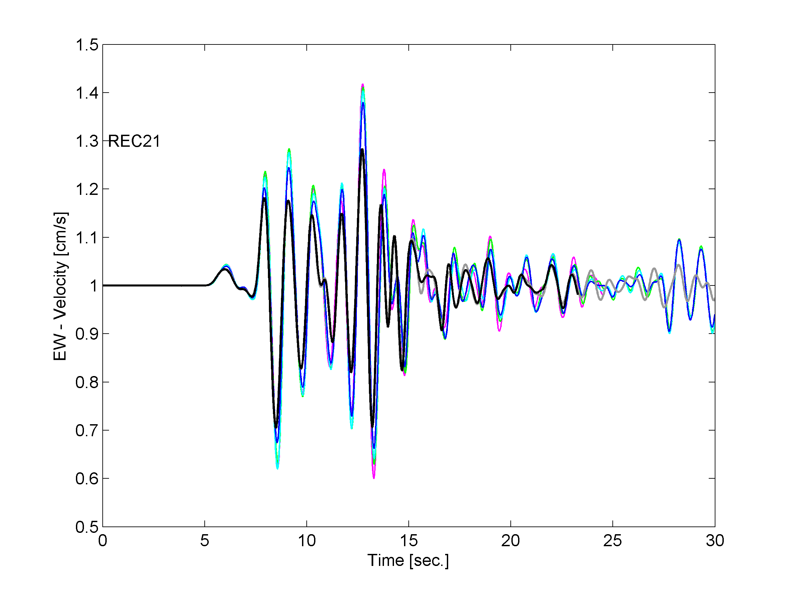
Figure 15. Receivers 21 (SOFT SOIL MIDDLE OF THE BASIN).. Synthetics of EW components obtained by the 3D numerical modelling with:
- “Honoring” strategy (SD3) GeoELSE (grey line)
- “Honoring” strategy (SD4) GeoELSE (black line)
- “NOT Honoring” strategy DEPTH 3 (SD3) GeoELSE (blue line)
- “NOT Honoring” strategy DEPTH 2 (SD3) GeoELSE (cyan line)
- “NOT Honoring” strategy DEPTH 1 (SD4) GeoELSE (green line)
- “NOT Honoring” strategy DEPTH 1 (SD3) GeoELSE (green line)
excited by fault “strong 1” (M_{W} = 6).

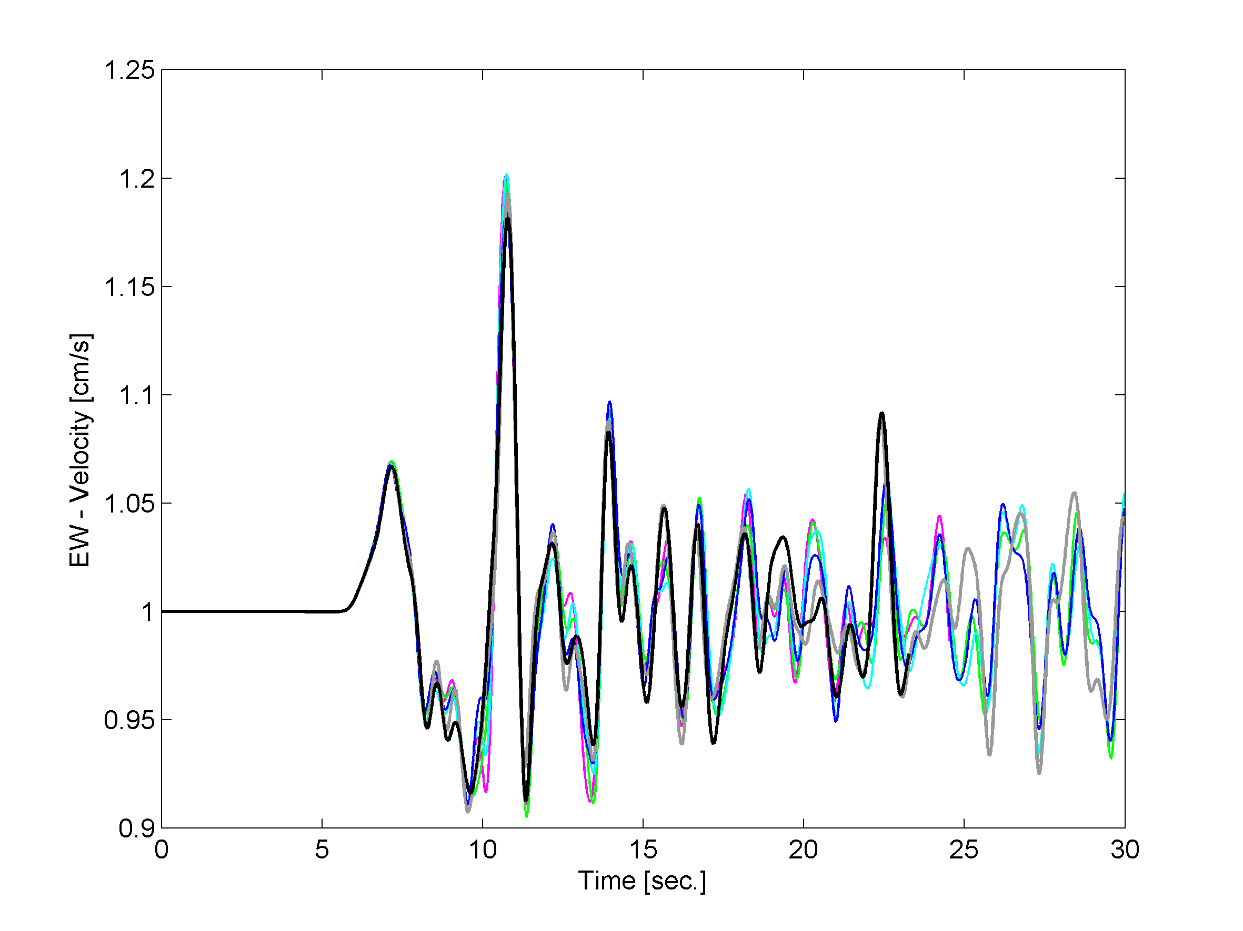
Figure 16. Receivers 24 (SOFT SOIL FAR FROM THE FAULT).. Synthetics of EW components obtained by the 3D numerical modelling with:
- “Honoring” strategy (SD3) GeoELSE (grey line)
- “Honoring” strategy (SD4) GeoELSE (black line)
- “NOT Honoring” strategy DEPTH 3 (SD3) GeoELSE (blue line)
- “NOT Honoring” strategy DEPTH 2 (SD3) GeoELSE (cyan line)
- “NOT Honoring” strategy DEPTH 1 (SD4) GeoELSE (green line)
- “NOT Honoring” strategy DEPTH 1 (SD3) GeoELSE (green line)
excited by fault “strong 1” (M_{W} = 6).

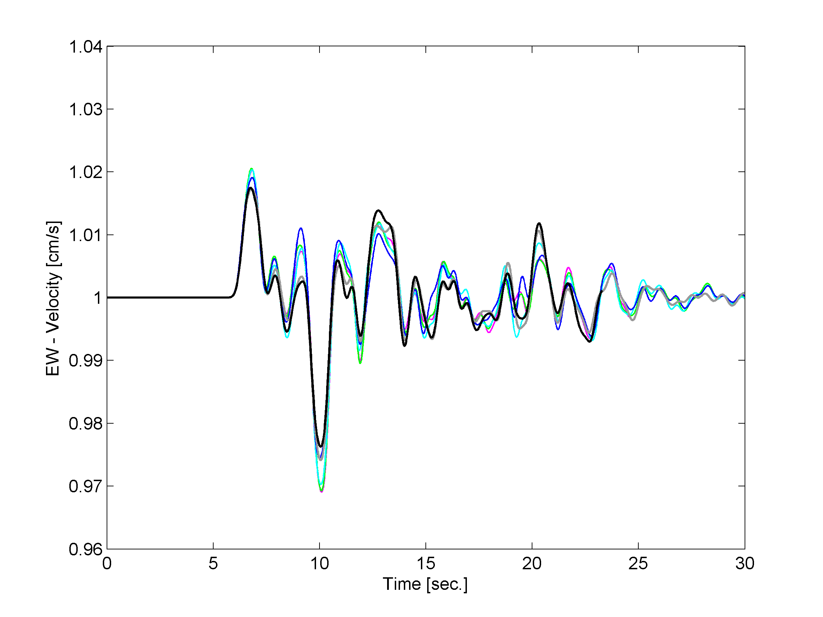
Figure 17. Receivers 38 (BEDROCK). Synthetics of EW components obtained by the 3D numerical modelling with:
- “Honoring” strategy (SD3) GeoELSE (grey line)
- “Honoring” strategy (SD4) GeoELSE (black line)
- “NOT Honoring” strategy DEPTH 3 (SD3) GeoELSE (blue line)
- “NOT Honoring” strategy DEPTH 2 (SD3) GeoELSE (cyan line)
- “NOT Honoring” strategy DEPTH 1 (SD4) GeoELSE (green line)
- “NOT Honoring” strategy DEPTH 1 (SD3) GeoELSE (green line)
excited by fault “strong 1” (M_{W} = 6).

Figure 18. Receivers 2 (SOFT SOIL MIDDLE OF THE BASIN). Synthetics of EW components obtained by the 3D numerical modelling with:
- “Honoring” strategy (SD3) GeoELSE (grey line)
- “Honoring” strategy (SD4) GeoELSE (black line)
- “NOT Honoring” strategy DEPTH 3 (SD3) GeoELSE (blue line)
- “NOT Honoring” strategy DEPTH 2 (SD3) GeoELSE (cyan line)
- “NOT Honoring” strategy DEPTH 1 (SD4) GeoELSE (green line)
- “NOT Honoring” strategy DEPTH 1 (SD3) GeoELSE (green line)
excited by fault “strong 1” (M_{W} = 6).

3.2. Source model

The simulations refer to the following cases:
- Strong Case number 1: a M_{W}=6.0 right-lateral strike-slip event on the Eastern Part of the Belledonne Border Fault;
- Strong Case number 2: a M_{W}=6.0 left-lateral strike-slip event on the Southern Tip of the Belledonne Border Fault.
The source model adopted (implemented like in Eq. 5) is a rectangular fault (9 km X 4.5 km) with a circular crack propagating from the center of the rectangle with a rupture velocity of 2800 m/s. The source time function adopted is an approximate Heaviside function:

, (7)

where the rise time τ = 1.116 s. These values are chosen to define a slip velocity of approximately 1 m/s. The total number of spectral nodes, involved in the simulation of the extended fault, is 749 for the case “strong 1” and a similar value in case “strong 2”.

3.3. Discussion of the results

XXX.

Figure XX. Synthetics of EW, NS and UD components obtained by the 3D numerical modelling with ADER-DG (black line) and GeoELSE (grey line)) excited by fault “strong 1” (M_{W} = 6). Receivers are recorded along the 2D Profile (R25, R26, R27, R28, R06, R29, R30, R31, R32 and 36).

3.4. XXX

XXX

4. Conclusions

XXX.

5. References
Abramowitz, M., Stegun I.A. (1966), Handbook of Mathematical Functions, Dover, New York.
Aki K. and Richards P. (1980), Quantitative Seismology. Theory and Methods, Freeman, San Francisco.
Bielak, J., Loukakis K., Hisada Y., Yoshimura C. (2003), Domain reduction method for three-dimensional earthquake modeling in localized regions. Part I: Theory, Bull. Seism. Soc. Am. 93 (2), 817-824.
Bielak, J., Loukakis K., Hisada Y., Yoshimura C. (2003), Domain reduction method for three-dimensional earthquake modeling in localized regions. Part II:Verification and applications Bull. Seism. Soc. Am. 93 (2), 825-840.
Casadei, F., Fotia G, Gabellino E., Maggio F., Quarteroni A., (2000). A mortar spectral/finite element method for complex 2D and 3D elastodynamic problems, Computer methods in applied mechanics and engineering 191, 5119-5148.
Faccioli, E., Maggio F., Quarteroni A., Tagliani A. (1996), Spectral-domain decomposition methods for the solution of acoustic and elastic wave equation, Geophysics 61, 1160-1174.
Faccioli E., Maggio F., Paolucci R., Quarteroni, A. (1997), 2D and 3D elastic wave propagation by a pseudo-spectral domain decomposition method, Journal of Seismology, 1, 237-251.
Faccioli, E., Vanini M., Paolucci R., Stupazzini M. (2005), Comment on "Domain reduction method for three-dimensional earthquake modelling in localized regions, Part I: Theroy" by J. Bielak, K. Loukakis, Y. Hisada, C. Yoshimura, and "Part II: Verification and applications", by C. Yoshimura, J. Bielak, Y. Hisada, A. Fernández, Bulletin of the Seismological Society of America 95 (2), 763-769.
Maggio, F., and Quarteroni A. (1994), Acoustic wave simulation by spectral methods, East-west J. Num. Math 2, 129-150.
Maggio, F., Massidda L., Sabadell J., Siddi G. (2001), A parallel spectral element method for applications to computational mechanics, Internal Report CRS4-TECH-REP-01/103, CRS4, Italy.
Maggio, F., Massidda L., Paolucci R., Stupazzini M. (2005), A parallel spectral element method for dynamic soil-structure interaction problems, Int. J. Num. Meth. Engng., submitted for publication.
Mercerat, E.D., Vilotte J.O., Sanchez Sesma F. (2005), Triangular Spectral Element simulation of elastic wave propagation using unstructured grids, Geophysical Journal International, in submitted.
Moczo, P., and Kristek J. (2003), Seismic wave propagation in viscoelastic media with material discontinuities: a 3D fourth-order staggered-grid finite-difference modelling, Bull. Seism. Soc. Am. 93 (5), 2273-2280.
Resemini S. (2003) Vulnerabilità sismica dei ponti ferroviari ad arco in muratura PhD Thesis, Università di Genova, Italy.
Sànchez-Sesma, F.J., and Luzon F. (1995), Seismic response of three-dimensional alluvial valleys for incident P, S, and Rayleigh waves, Bull. Seism. Soc. Am. 85, 890-899.
Stacey R. (1988) Improved transparent boundary formulations for the elastic-wave equation, Bulletin of the Seismological Society of America. 78 , 2089-2097.
Stupazzini, M. 2004, A spectral element approach for 3D dynamic soil-structure interaction problems, PhD. Thesis, Milan University of Technology, Italy.
Komatitsch, D., Tsuboi S., Ji C., Tromp J. (2003), A 14.6 billion degrees of freedom, 5 tetraflops, 2.5 tetrabyte earthquake simulation on the Earth Simulator, Proc. of the ACM/IEEE Supercomputing SC 2003 conference Phoenix, Arizona, 15-21 November 2003.
Komatitsch, D., Liu Q., Tromp J., Suss P., Stidham C., Shaw, J.H. (2004), Simulations of Ground Motion in the Los Angeles Basin Based upon the Spectral-Element Method, Bulletin of the Seismological Society of America 94 (1), 187-206.
Zienckiewicz, O., and R.L. Taylor, 1989. The finite element method. Vol.1, McGraw-Hill, London.

6. Acknowledgements
Computational resources: “homer”, “tethys”,
Project: Seismovalp e SPICE

