Third International Symposium on the Effects of Surface Geology on Seismic Motion
Grenoble, France, 30 August - 1 September 2006
Paper Number: xxx

3D Ground Motion Simulation of the Grenoble valley by GeoELSE

Marco STUPAZZINI¹
Ludwig-Maximilians-Universitaet, Theresienstrasse 41, 80333, Muenchen, Germany

ABSTRACT - The spectral element method (SEM) is a powerful numerical technique naturally suited for seismic wave propagation analyses. A class of SEM has been widely used in the seismological field thanks to its capability of providing high accuracy and allowing the implementation of optimized parallel algorithms. In this contribution, the capabilities of SEM based GeoELSE code are illustrated, to deal with the seismic response of a 3D model of the sedimentary basin of Grenoble (French Alps). The simulations take simultaneously into account the 3D topography of the area, the alluvial basin structure and the variation of mechanical properties throughout the valley, following the prescription of the ESG06 benchmark. The model is excited by seismic waves originated by a strong motion scenario earthquake of M_{W} ≈ 6; the fault and the distribution of the slip is kept constant while the location of the hypocenter is changed along the fault in order to take into account the influence of the directivity effect. The PGV map obtained are here presented and discussed. Finally the results are briefly compared with another set of numerical simulation and with a new empirical attenuation relationship recently proposed.

1. Introduction

Wave propagation phenomena can be studied nowadays thanks to powerful numerical techniques stemming from finite differences [FD, see e.g. Moczo 2003], to finite elements [FE, e.g. Bielak 1999, 2003], boundary elements [BE, e.g. Sanchez-Sesma 1995], spectral elements [SE, e.g. Faccioli 1997; Komatisch 2003, 2004] and ADER-DG [Kaeser et al XXXX] Spurred by the computational power made available by parallel computers, these techniques have embraced the area of three-dimensional wave propagation.
Recently a new 3D native parallel Fortran code for the study of seismic wave propagation through complex heterogeneous domains has been developed. GeoELSE (Geo ELasticity with Spectral Element) [Stupazzini 2004], [Maggio 2005] consists of a new generation parallel code, based on a Spectral Element spatial discretization and a 2nd order finite difference scheme for time advancing. The numerical domains are fully unstructured in order to follow complex geometrical (topographical, tectonical and geotechnical) and mechanical heterogeneities. The efforts were focused on three specific features (i) CPU time computation reduction of the program, (ii) large scale problems (number of grid points > 10^{6}) and (iii) capabilities of handling into a single model both soil and structures, in order to simulate dynamic soil-structure interaction.
To confirm the performance and the capabilities of GeoELSE it was decided to participate to the numerical benchmark of 3D ground motion simulation in the valley of Grenoble (French Alps). A paragraph is dedicated to the creation of the mesh that seems a reasonable strategy to overcome, at least for the case of sedimentary basin, the issue of creating a fully unstructured 3D mesh capable to honor the given geometries. The model is then excited by seismic waves originated by a strong motion scenario earthquake of M_{W} ≈ 6. The results obtained are here briefly presented and discussed, comparing them with the one produced by another applicants to the numerical benchmark of Grenoble (ESG06) with an ADER-DG method.
Finally the fault size and the distribution of the slip is kept constant while the location of the hypocenter is changed along the fault in order to take into account the influence of the directivity effect. The PGV map obtained are here presented and discussed. Furthermore the computed PGD are compared with the result obtained by a new empirical attenuation relationship recently proposed.

2. SEM NUMERICAL TOOL: GeoELSE

The SE approach developed by Faccioli [1997] has been implemented in the computational code GeoELSE (GeoELasticity by Spectral Elements [Maggio 2001], [Stupazzini 2004], [Maggio 2005]), for 2D/3D wave propagation analyses. The most recent version of the code includes: (i) the capability of dealing with fully unstructured computational domains and (ii) the parallel architecture. While the former feature allows to treat problems involving complex geometries, the second is the natural approach for large scale applications. The spectral element method (SEM) is usually regarded as a generalization of the finite element method (FEM) based on the use of high order piecewise polynomial functions. The crucial aspect of the method is the capability of providing an arbitrary increase in accuracy simply enhancing the algebraic degree of these functions (the spectral degree SD). On practical ground, this operation is completely transparent for the users, who limit themselves to choose the spectral degree at runtime, leaving to the computational code the task of building up suitable quadrature points and new degrees of freedom. Obviously, the increasing spectral degree implies the raise the computational effort of the problem.
On the other hand, one can also play on the grid refinement to improve the accuracy of the numerical solution, thus following the standard finite element approach. Spectral elements are therefore a so-called "h-p" method [Faccioli 1996], where "h" refers to the grid size and "p" to the degree of polynomials.
Referring to Faccioli [1997] for further details, we briefly remind in the sequel the key features of the spectral element method adopted. We start from the wave equation:

(1)

where is the time, the material density, a known body force distribution and the stress tensor. Introducing the Hooke's law:

(2)

where

(3)

is the small strain tensor, and are the Lamé elastic coefficients, and is the Kronecker symbol, i.e. if and , otherwise.

As in the FEM approach, the dynamic equilibrium problem for the medium can be stated in the weak, or variational form, through the principle of virtual work (Zienckiewicz 1989), and, through a suitable discretization procedure that depends on the numerical approach adopted, can be written as an ordinary differential equations system with respect to time:

(4)

where matrices and , respectively the mass and the stiffness matrix, vectors and are due to the contributions of external forces and tractions conditions, respectively. In our SE approach, denotes the displacement vector at the Legendre-Gauss-Lobatto (LGL) nodes, that correspond to the zeroes of the first derivatives of Legendre polynomial of degree N [Abramowitz 1966]. The advancement of numerical solution in time is provided by the explicit 2nd order leap-frog scheme (LF2-LF2) [Maggio 1994].

This scheme is conditionally stable and must satisfy the well known Courant-Friedrichs-Levy (CFL) condition:

(5)

The key features of the SE discretization are the following:

1. Like in the FEM standard technique, (i) the computational domain may be split into quadrilaterals in 2D or hexahedras in 3D, (ii) both the local distribution of grid points within the single element and the global mesh of all the grid points in the domain must be assigned, (iii) many of these latter are shared amongst several spectral elements, (iv) each spectral element is obtained by a mapping of a master element through a suitable transformation and all computations are performed on the master element (Figure 1). Research is in progress regarding the introduction of triangular spectral elements [Mercerat 2005].

2. The nodes within the element where (i) displacements and spatial derivatives are computed, (ii) on which volume integrals are evaluated, are not necessarily equally spaced. An example of LGL nodes for spectral elements with different degree is shown in 2.

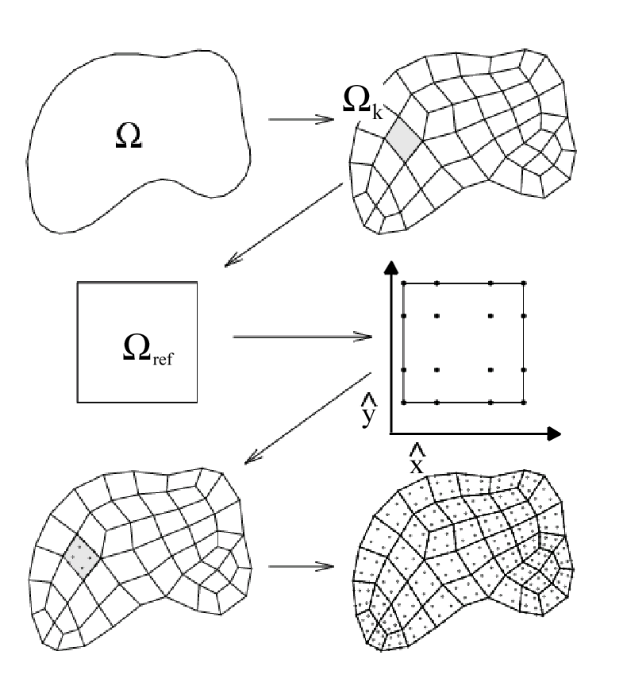

Figure 1. Computational domain is decomposed into a family of non overlapping quadrilaterals , obtained by a mapping of the master element through a suitable transformation (Casadei et al., 2000)

3. The interpolation of the solution within the element is done by Lagrange polynomials of suitable degree.

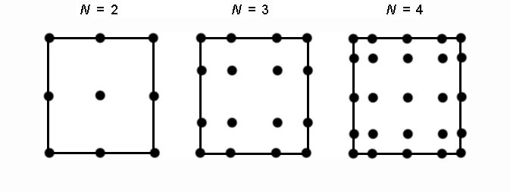

Figure 2. LGL points within SEM elements with different spectral degree N

4. The integration in space is done through Legendre-Gauss-Lobatto quadrature formula.
Thanks to this numerical strategy, the exponential accuracy of the method is ensured and the computational effort minimized, since the mass matrix results to be diagonal.

It is worth to briefly recall here the main features of the numerical code for seismic wave propagation:
- extended seismic source input through an appropriate distribution of seismic moment tensor density

(6)

where describes the time history of seismic moment release at position , V is the elementary volume of the source, and n and s denote the fault normal and the unit vector along the slip direction respectively (Aki and Richards, 1980);
- 1st order absorbing boundary conditions according to Stacey (1988);
- linear visco-elastic material with a frequency-dependent quality factor Q = Q₀/f₀·f.

3. The 3D numerical simulation

3.1. Numerical model

We first apply the GeoELSE code on a well-defined 3-D test problem, which was published in the final report of the LIFELINES PROGRAM TASK 1A01 (Day 2001) of the Pacific Earthquake Engineering Research Center. The test case is part of a multi-institutional code validation project of a series of different numerical methods employed in numerical modelling of earthquake ground motion in 3-D earth models.
The quasi-analytic solution of the problem is computed by the reflectivity method and is compared to all numerical solutions to evaluate their accuracy. The setup of the test problem LOH.1 (LayerOver Halfspace) is shown in Fig. 1(a), where the computational domain Ω = [-15000 m, 15000 m] × [-15000 m, 15000 m] × [0 m, 17000 m] is plotted. The material parameters of the layer (Medium 1) of the top 1000 m and the halfspace (Medium 2) are given in Fig.1.

In LOH1 the seismic source is a point dislocation, represented by a double couple source, where the only non-zero entries of the seismic moment tensor are M_{xy} =M_{yx} = M₀ = 1018 Nm. The location of the point source is (xs, ys, zs) = (0 m, 0m, 2000 m), that is, in the centre of the xy-plane of the domain Ω in 2000 m depth.
The moment-rate time history is given by the source time function:

Missing equation and mechanical properties parameters

where the smoothness parameter T, controlling the frequency content and amplitude of the source time function, is set to T = 0.1 s. In the LOH2 case the source is a vertical fault and hypocenter is located at (xs, ys, zs) = (0 m, 1000m, 4000 m). The signals are recorded up to a simulation time of 9 s by 10 receivers on the free surface, as indicated in Fig. XXX(a). The receiver locations (xi, yi, zi) = (i600 m, i800 m, 0 m), for i = 1, . . . , 10. We remark that, for all shown seismograms, the original source was deconvolved and replaced by a Gaussian of spread 0.05 as described in Day (2001).

The mesh adopted for the two cases is depicted in Figure XXXXb. The receiver locations have not to coincide with nodes of the mesh, as the numerical solution is represented by polynomials within each element and therefore can be evaluated at any position within an element. In the following, we present the comparison of our results obtained by a GeoELSE with SD3 (O4) and SD4 (O5) scheme against the analytical solution. Analogous to the LOH.1 and LOH.2 test case in the LIFELINES PROGRAM TASK 1A01, the visual comparisons in Fig. XXX shows the radial, transversal and vertical components of the seismic velocity field recorded at receiver 10 at (x 10, y10, z10) = (6000 m, 8000 m, 0 m). Additionally, each plot gives the relative seismogram misfit

EQUATION

where nt is number of time-samples of the seismogram, sj is the numerical value of the particular seismogram at sample j and sa j is the corresponding analytical value. We remark that, for all shown seismograms, the original source was deconvolved and replaced by a Gaussian of spread 0.05 as described in Day (2001).

The comparison between the numerical solutions (thin line) and the analytical solution (thick line) shows that the discrepancies are extremely limited and “that largest amount of the error is mainly due to the absorbing boundary behavoiur” OR “the exponential convergency of the solution from O4 to O5 is achieved (SE FAI LE SIMULAZIONI O4!!!).”

FARE
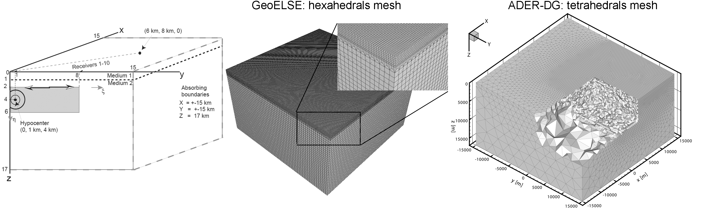

Figure XXX. (a) One of four symmetric quarters is shown for the LOH test case, where a layer of 1 km (Material 1) is lying on top of another layer (Material 2).For the LOH.1 the source is a point dislocation at 2000 km depth represented by a moment tensor with the only non-zero components M_{xy} =M_{yx}.In the LOH.2 case the source is a vertical finite fault. (b) Mesh adopted for the “LOH1” and “LOH2” cases: GeoELSE mesh (elem.: 352 800, nodes: 22 970 073 (order (O) 5, polynomial degree (N) 4), model size [-15km,15km]x[-15km,15km]x[0km,-17km], dt = 5.23e-4 sec (15% dt_CFL), first layer Δx =166.67m, bedrock Δx =500.00m).

FARE

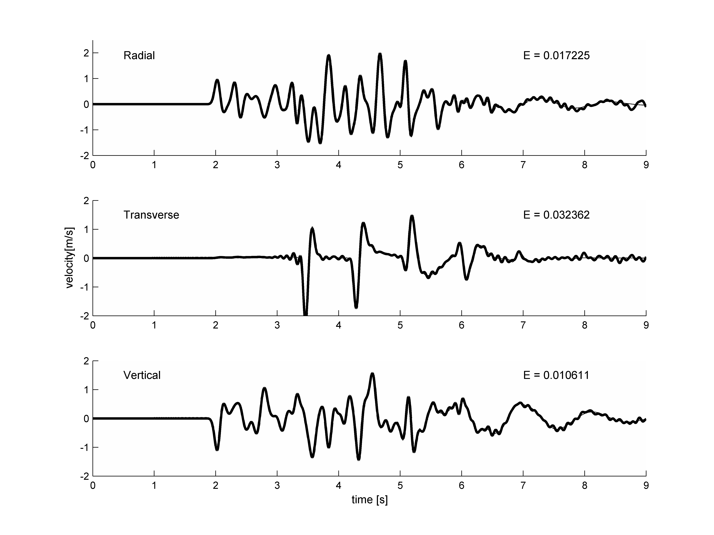

Figure 5. Comparison of the radial, transverse and vertical velocity components for the LOH.1 and LOH.2 test case on receiver 10. The analytical solution (thick line) is plotted against the numerical one (thin line) obtained by GeoELSE SD4 (O5). The relative seismogram misfit E from eq. (XXX) is given for each trace.
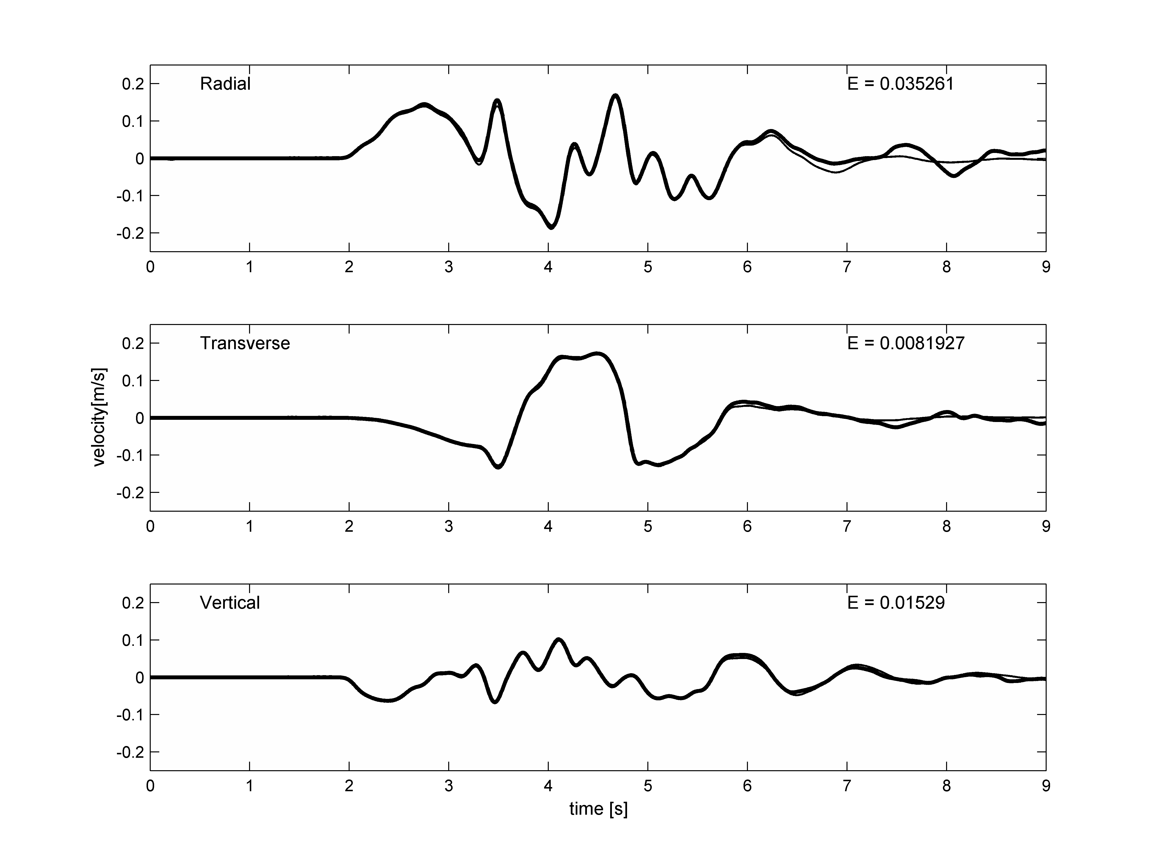

3.3. Numerical model

The SEM has been formulated as proposed by Faccioli [1997] and Komatitsch [1998]. The computational domain is decomposed into a family of non overlapping hexahedrals in 3D. The aim of this work is the simulation of two strong motion earthquake (“strong1” and “strong2”) in the frame of the numerical benchmark of 3D ground motion simulation in the valley of Grenoble (French Alps). The discretization of the area under study should be capable to reproduce the topography of the Grenoble surroundings, the 3D shape of the alluvial basin and the mechanical properties of the different materials. In order to accurately and efficiently reproduce all these features, it is necessary to provide a 3D unstructured mesh. While 3D unstructured tetrahedral meshes can be achieved quite easily with commercial or non commercial software, the creation of a 3D non structured hexahedral mesh is still recognized as a challenging problem. The personal experience developed throughout the different study cases already analyzed [Stupazzini 2004] [Maggio et al., 2005] suggests that one of the most promising software capable of meshing complex 3D domain is the commercial software CUBIT (http://cubit.sandia.gov/) that incorporates a set of powerful and advanced meshing scheme developed to automatically handle the unstructured meshing problem.
Nevertheless, it is worth noting that the meshing of a large domain like the valley of Grenoble seems not to be feasible with just a "push-button" procedure, due to the complex shape of the basin and to the and to the elements size that range from 100m up to 1km.

The strategy here presented subdivides the computational domain in small (many kilometers) hexahedral chunks (Figure 3). Each sub-volume was meshed with a quite standard scheme (e.g.: “pave” mesh scheme is applied on one of the surface and then a sweeping is performed along the other direction). This technique obviously worsens the quality of the resulting mesh and increases the total number of elements but, on the other hand, allow to perform the splitting into hexahedras of the area under exams strictly honoring the given geometry
The final mesh is depicted in Figure 3 and Figure 4 and consists of 216972 elements that range from a minimum size of 21 m (alluvial area) up to 1000 m. The mesh is designed to propagate correctly up to 2.5 Hz with a spectral degree SD = 3, and up to around 3 Hz with SD = 4. The main characteristics of the numerical analyses are summarized in Table I. The computations have been performed with a Dell Linux cluster based on Intel Xeon, 3.06 GHz, 64 bit, Gigabit Ethernet connection (homer.stru.polimi.it) and with a Fujitsu siemens cluster (tethys.geophysik.uni-muenchen.de).
The partitioning of the global domain into subdomains is performed by the free METIS software (Karypis and Kumar 1998) and is completely independent from the kernel. In order to avoid confusion it is worth to underline the fact that the meshing and the partitioning of the domain are two completely independent issue; Figure 3 and 4 do not represent the partitioning of the domain but only the way to mesh the domain honoring the given geometry. Finally the communication between the processors is performed by the MPI (Message Passing Interface) libraries.

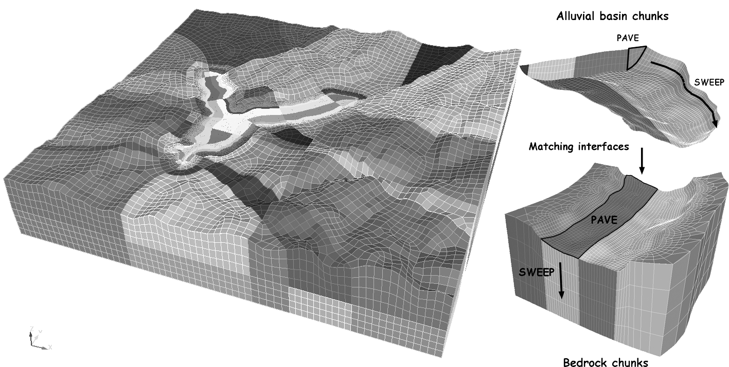

Figure 3. 3D numerical model used for the simulations. The computational domain is subdivided into small chunks and each one is meshed starting from the alluvial basin down to the bedrock.. For simplicity only the spectral elements are shown without LGL nodes.

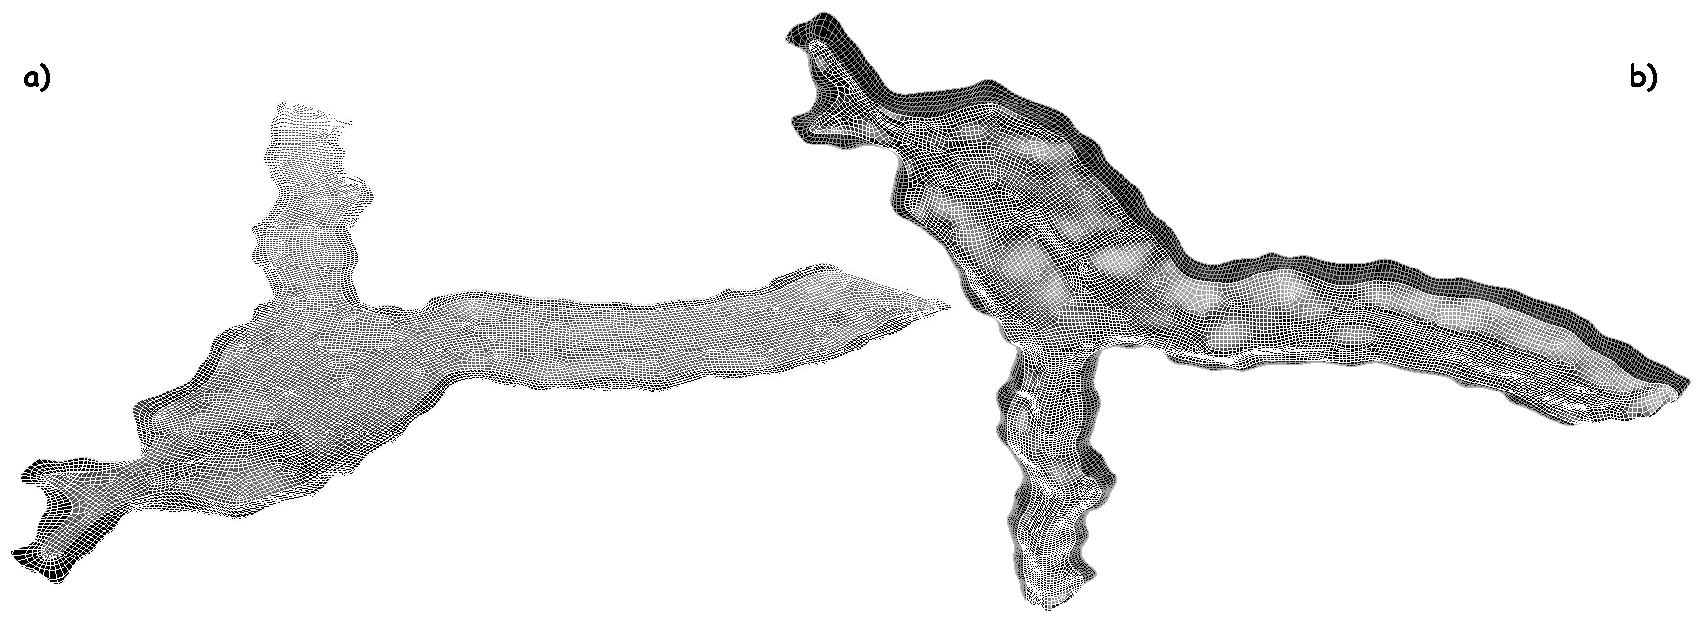

Figure 3. XXX

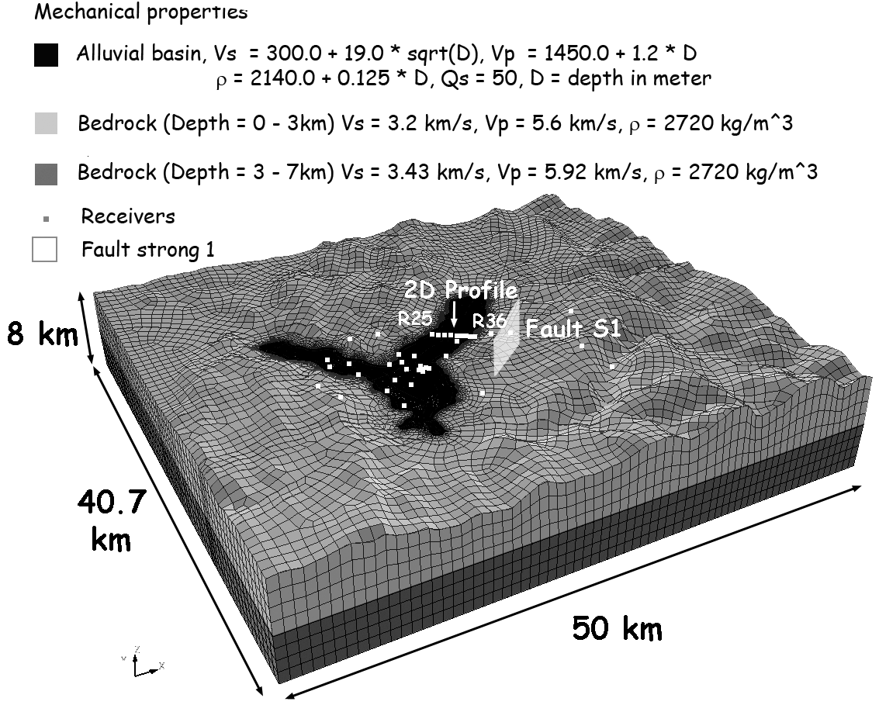

Figure 4. XXX

Table I. 3D numerical model size and computational time
SD | Elements  # | Nodes  # | Memory [Gb] | Δt_{simulation} [sec.] | time steps  # | Total time simulation [s.] | Total CPU time (10 CPUs) [min.]
3 | 202983 | XXX | ≈ 5 | XXX | XXX | 30 | 3070.45
4 | 202983 | XXX | ≈ 11 | XXX | XXX | 30 | 11177.35

3.2. Source model

The simulations refer to the following cases:
- Strong Case number 1: a M_{W}=6.0 right-lateral strike-slip event on the Eastern Part of the Belledonne Border Fault;
- Strong Case number 2: a M_{W}=6.0 left-lateral strike-slip event on the Southern Tip of the Belledonne Border Fault.
The source model adopted (implemented like in Eq. 5) is a rectangular fault (9 km X 4.5 km) with a circular crack propagating from the center of the rectangle with a rupture velocity of 2800 m/s. The source time function adopted is an approximate Heaviside function:

, (7)

where the rise time τ = 1.116 s. These values are chosen to define a slip velocity of approximately 1 m/s. The total number of spectral nodes, involved in the simulation of the extended fault, is 749 for the case “strong 1” and a similar value in case “strong 2”.

3.3. Discussion of the results

Figure 5 shows the synthetic velocity waveforms of receivers recorded along the 2D profile (see Figure 4). The dark line corresponds to the GeoELSE results while the grey line corresponds to the results obtained through an ADER-DG code [referecens]; the latter is a completely different numerical technique and it is worth noting that the two groups were totally independent in the creation of the mesh and the run of the numerical benchmark.
All the presented stations are located on the alluvial deposit except for receiver called R36 positioned on outcropping bedrock. The stations on the sediments show a clear amplification induced by the soft alluvial deposit and the waveforms tend to grow in complexity. Even if the pattern is quite complex the two numerical methods highlight a remarkable agreement both in the amplitude and phase information. A more detailed outlook including all the results produced by the participants of the 3D modellization of the valley of Grenoble will be presented in future.

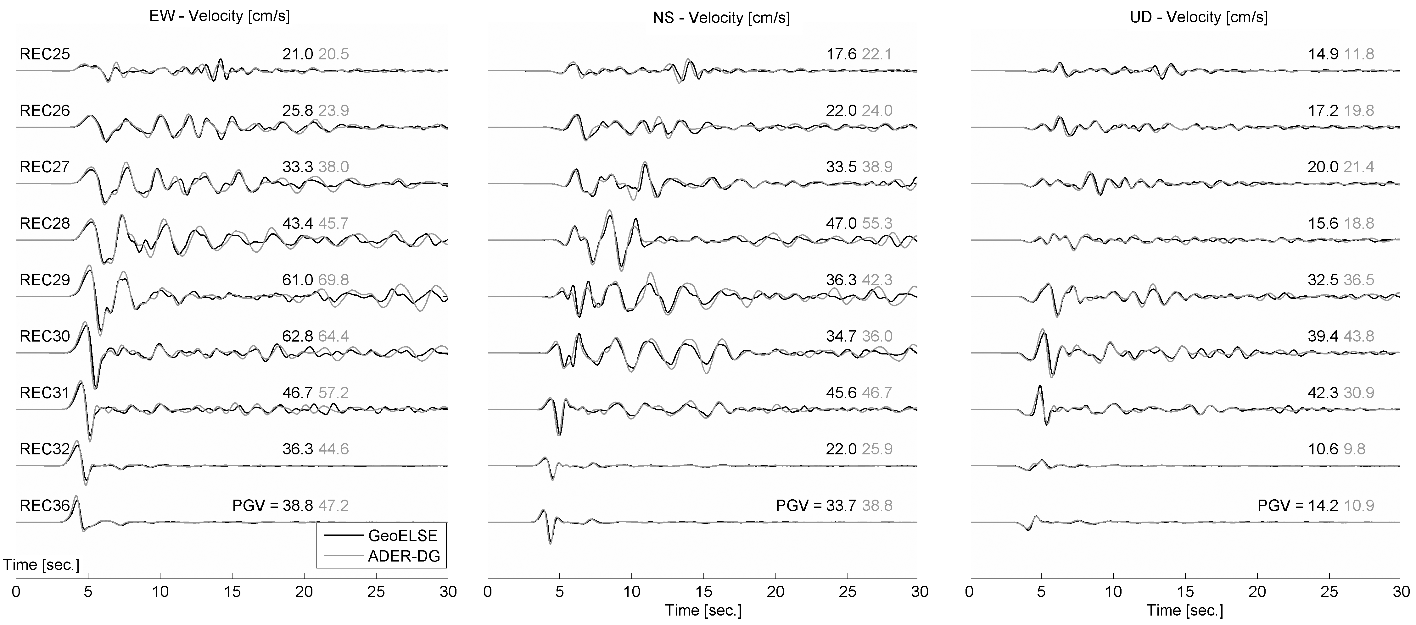
Figure XX. Synthetics of EW, NS and UD components obtained by the 3D numerical modelling with ADER-DG (black line) and GeoELSE (grey line)) excited by fault “strong 1” (M_{W} = 6). Receivers are recorded along the 2D Profile (R25, R26, R27, R28, R06, R29, R30, R31, R32 and 36).

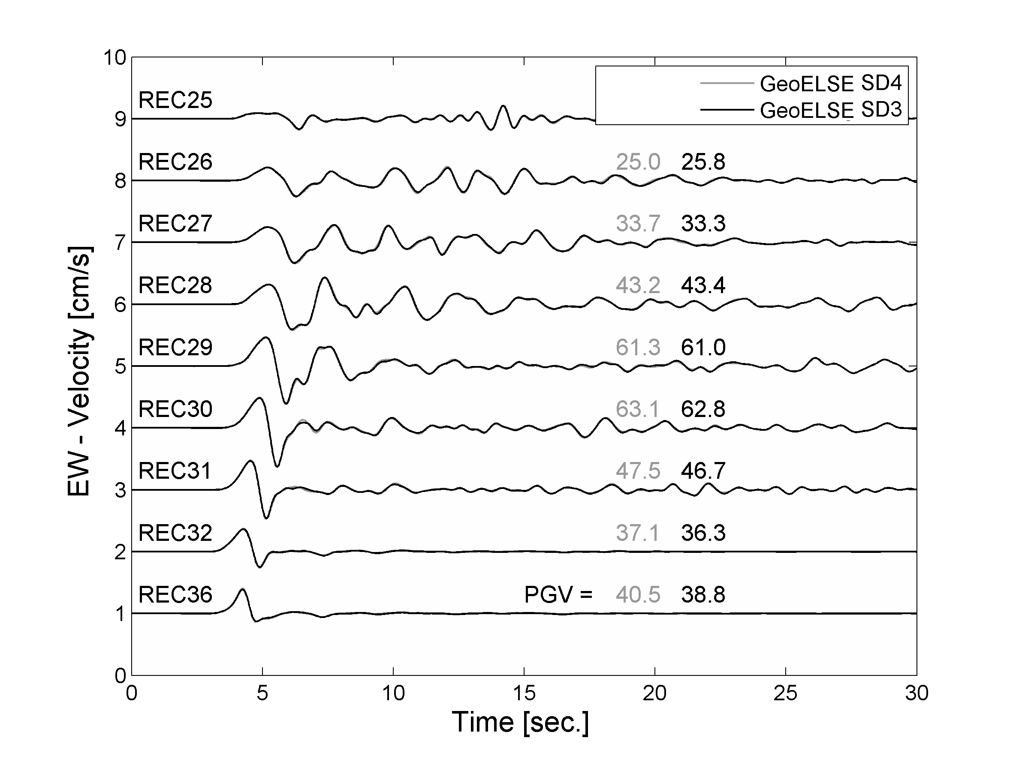
CONVERGENZA SD3 ed SD4
Figure XX

Figure XX.

3.4. Scenario simulation

We decided to adopt the framework of the Grenoble benchmark and to improve it introducing the variability strictly related to the hypocenter location of the earquake. This is usually a parameter that can be hardly taken into account on hazard-scenario simulation based on empirical attenuation relationship and that seems deeply to affect the distribution of the peak ground velocity (PGV) distribution on the area (citation Heiner et al., XXXX). The shape of the two original faults is maintained while the location of the hypocenter is changed as shown in the figure below.

Figure XXX – position of the hypocenter along the S1 and S2 fault.

The results obtained are adopted to plot the PGV map. The maximum of the observed velocity is considered as the maximum between the full set of 18 simulation produced. The map here computed is then compared with the one obtained with the original S1 case prescribed by the Grenoble benchmark committee. COMMENT ON THAT!!!
Furthermore we decided to keep the entire dataset of numerical time histories obtained and to plot them together with the attenuation relationship recently developed in the frame of an DPC-INGV project leaded by E. Faccioli et al. COMMENT ON THAT!!!

E. Faccioli and A. Rovelli: Project S5 of “DPC-INGV” "Definizione dell’input sismico sulla base degli spostamenti attesi" (1 giugno 2005 - 30 giugno 2006)

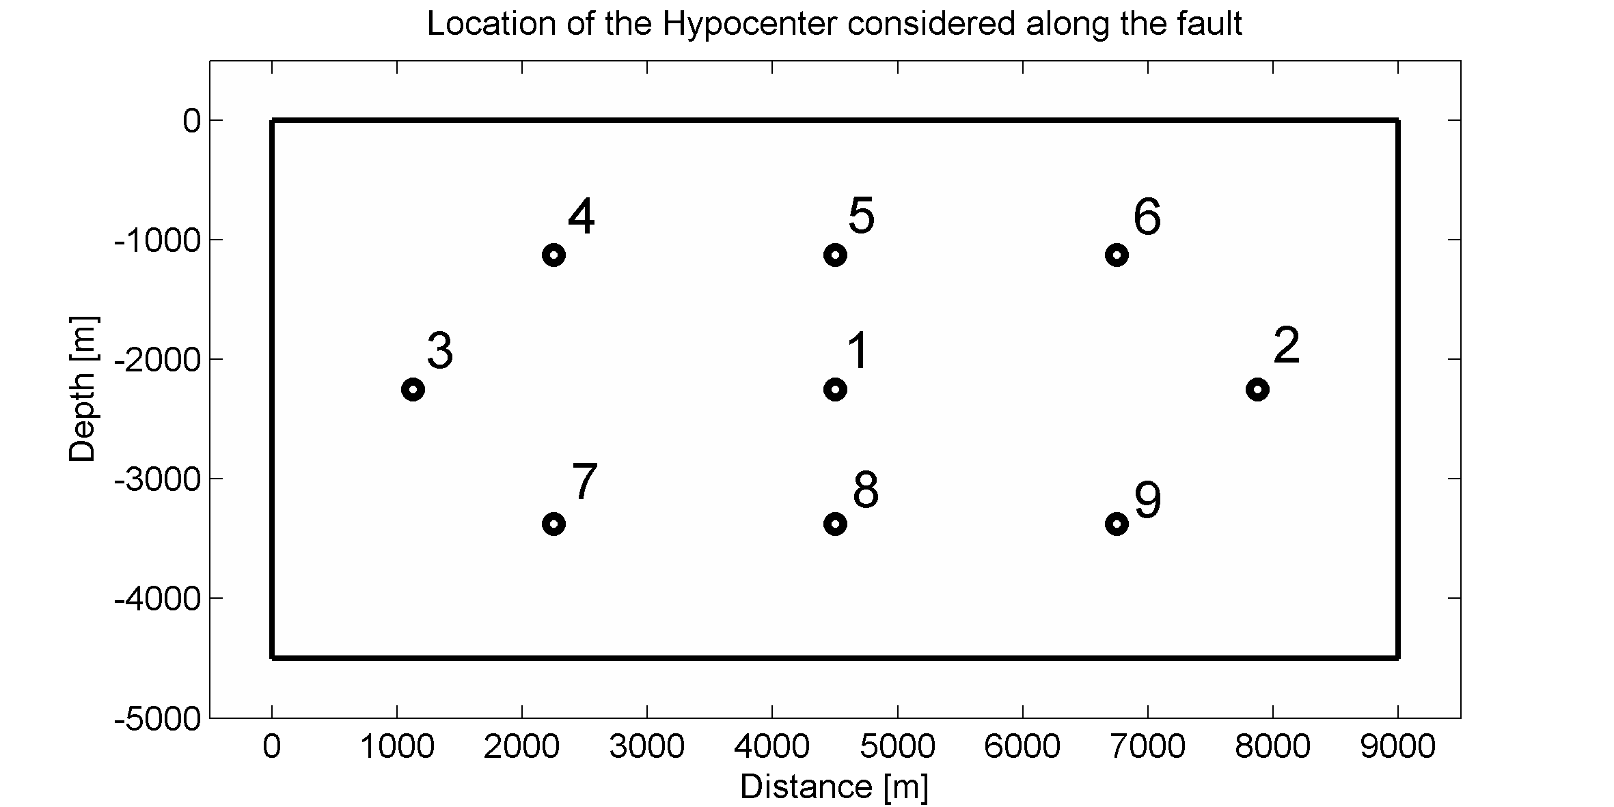
Location of the hypocenter examined

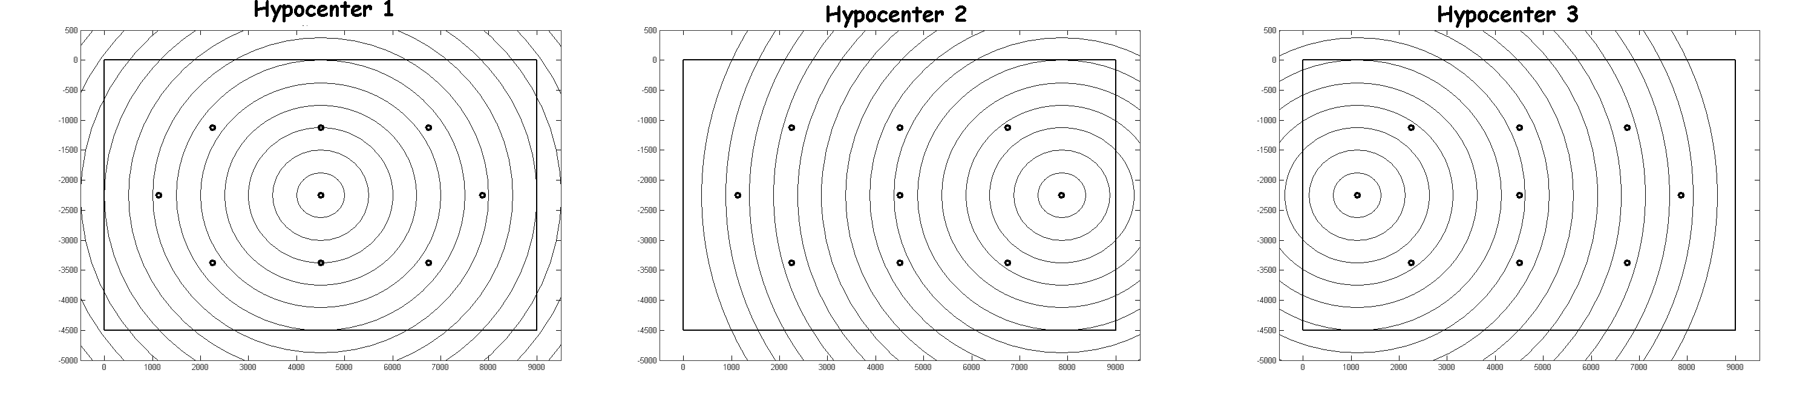
Isochrones of the triggered slip (left) Hypocenter 1, (center) Hypocenter 2 and (right) Hypocenter 3.
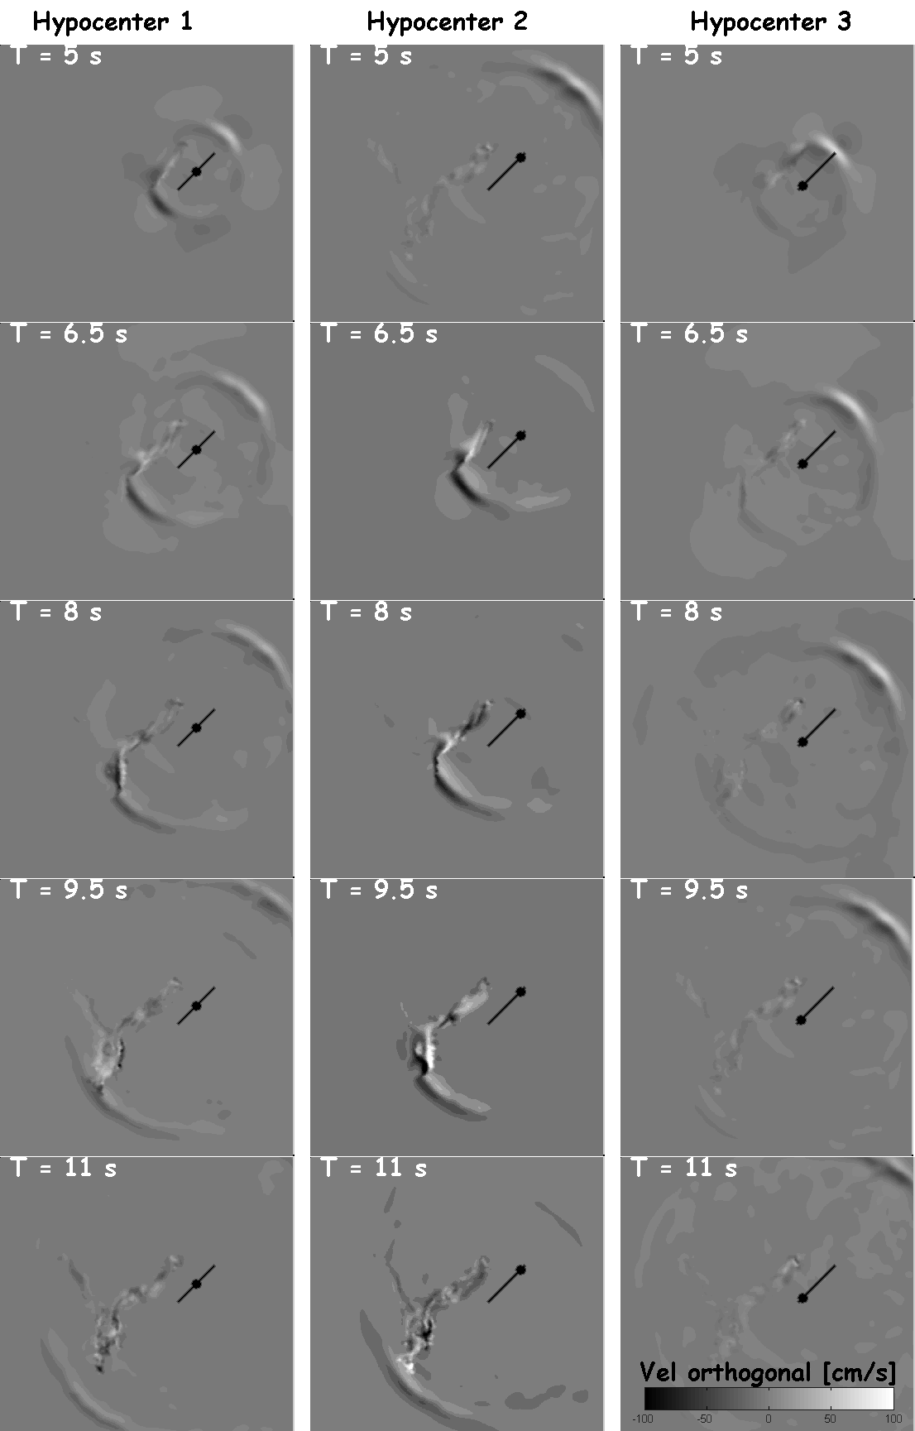
Velocity snapshots (component orthogonal to the fault) in the 3 cases: (left) Hypocenter 1, (center) Hypocenter 2 and (right) Hypocenter 3.

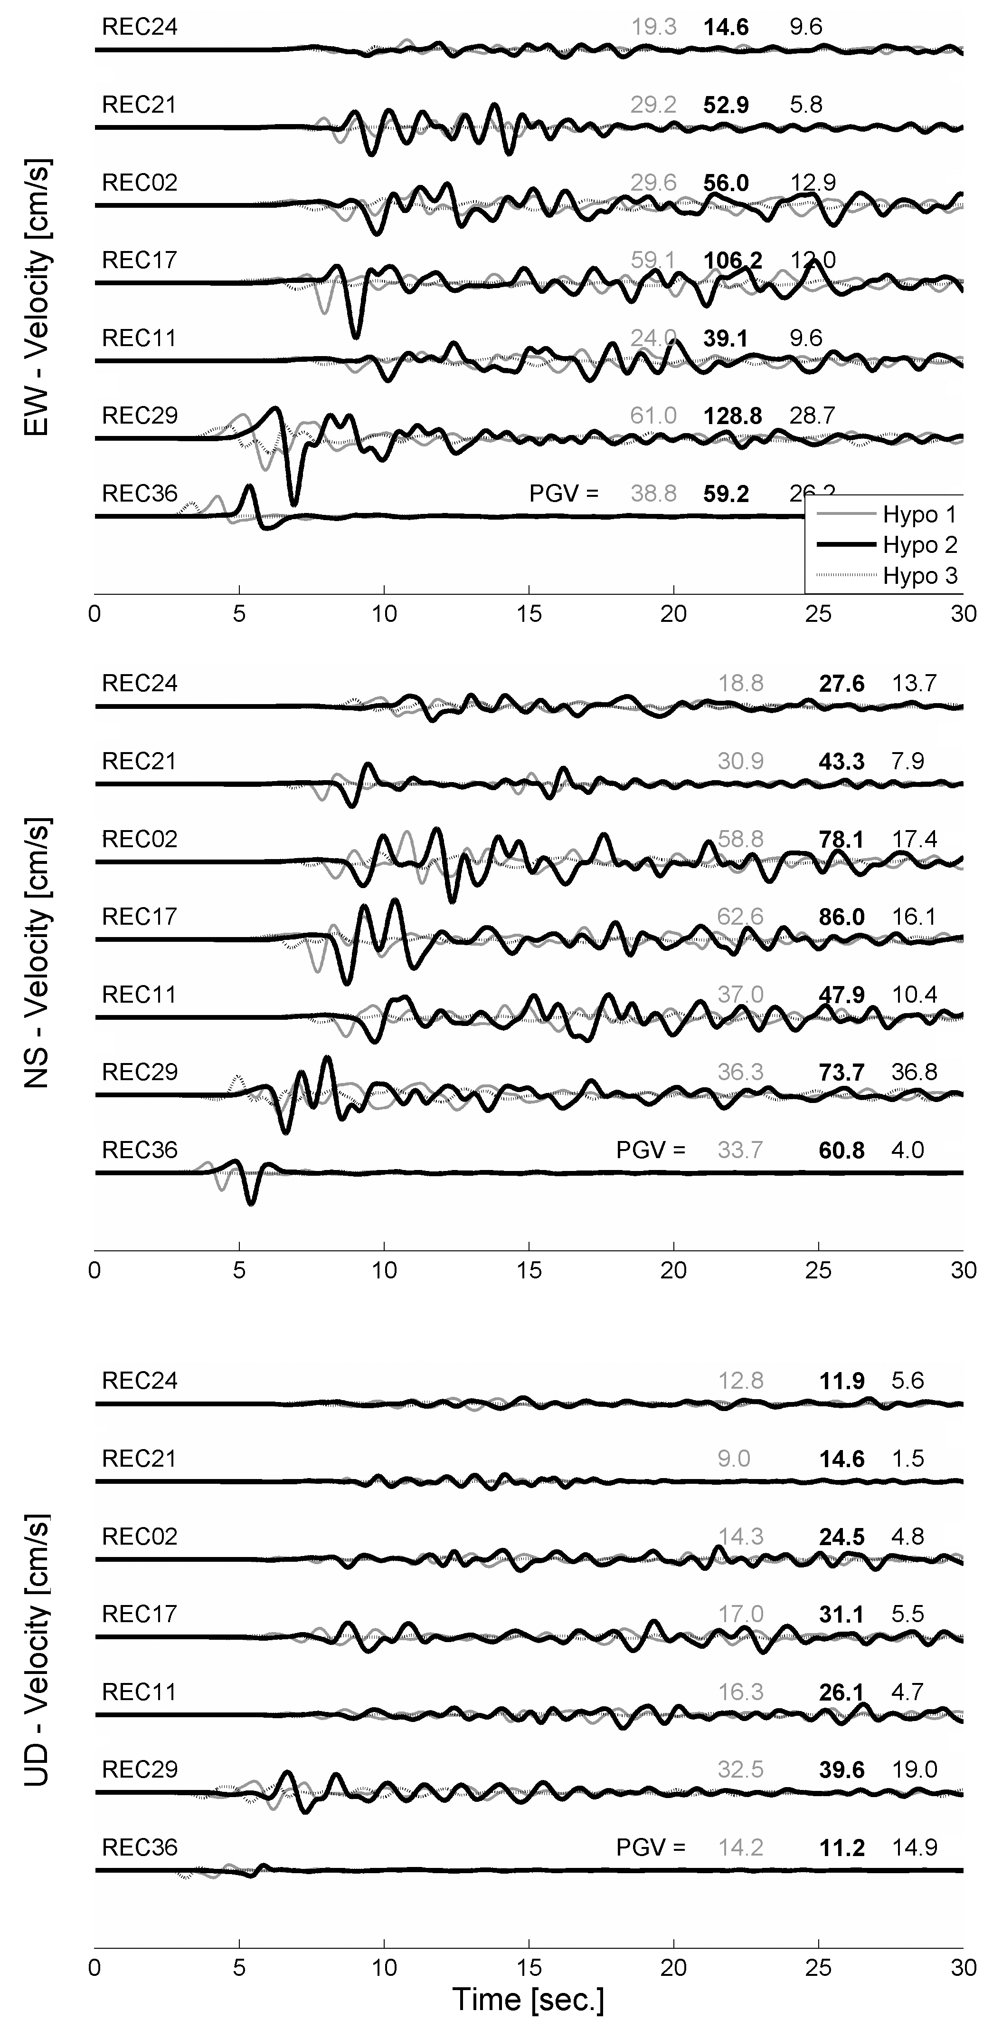
Velocity time histories in the 3 cases: (gray line) Hypocenter 1, (dark line) Hypocenter 2 and (dotted line) Hypocenter 3.

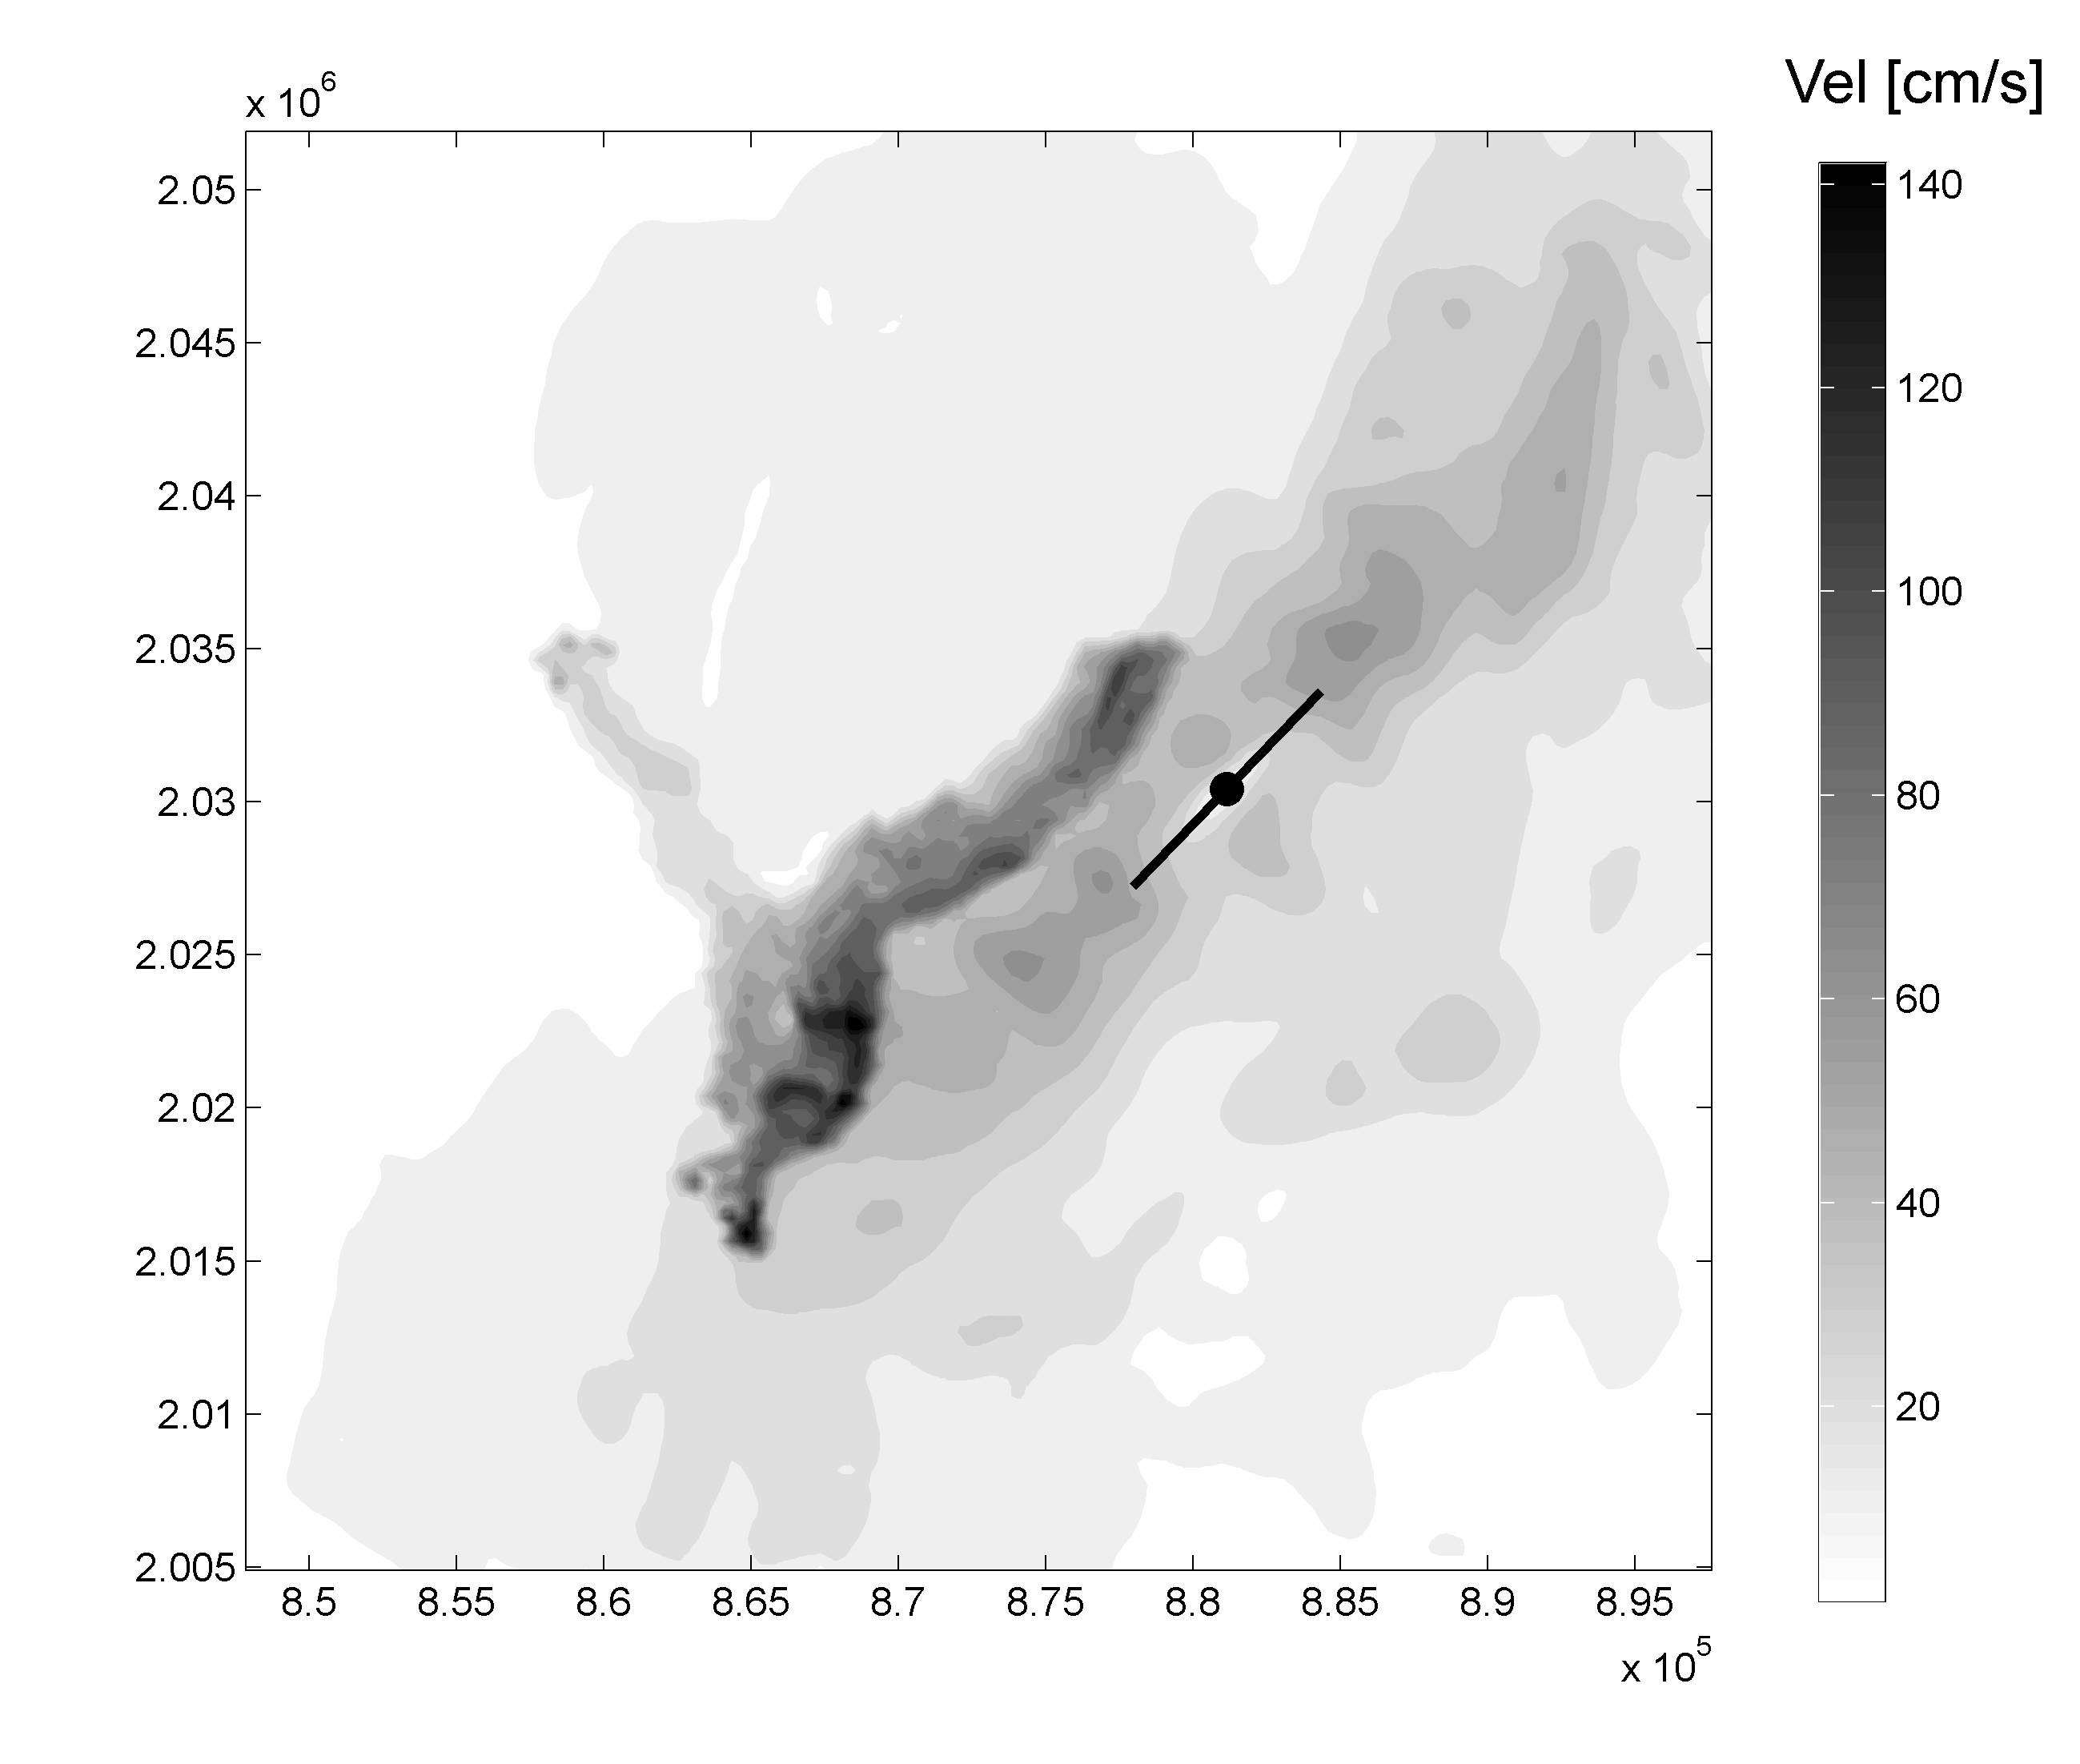
PGV map CASE HYPOCENTER 1

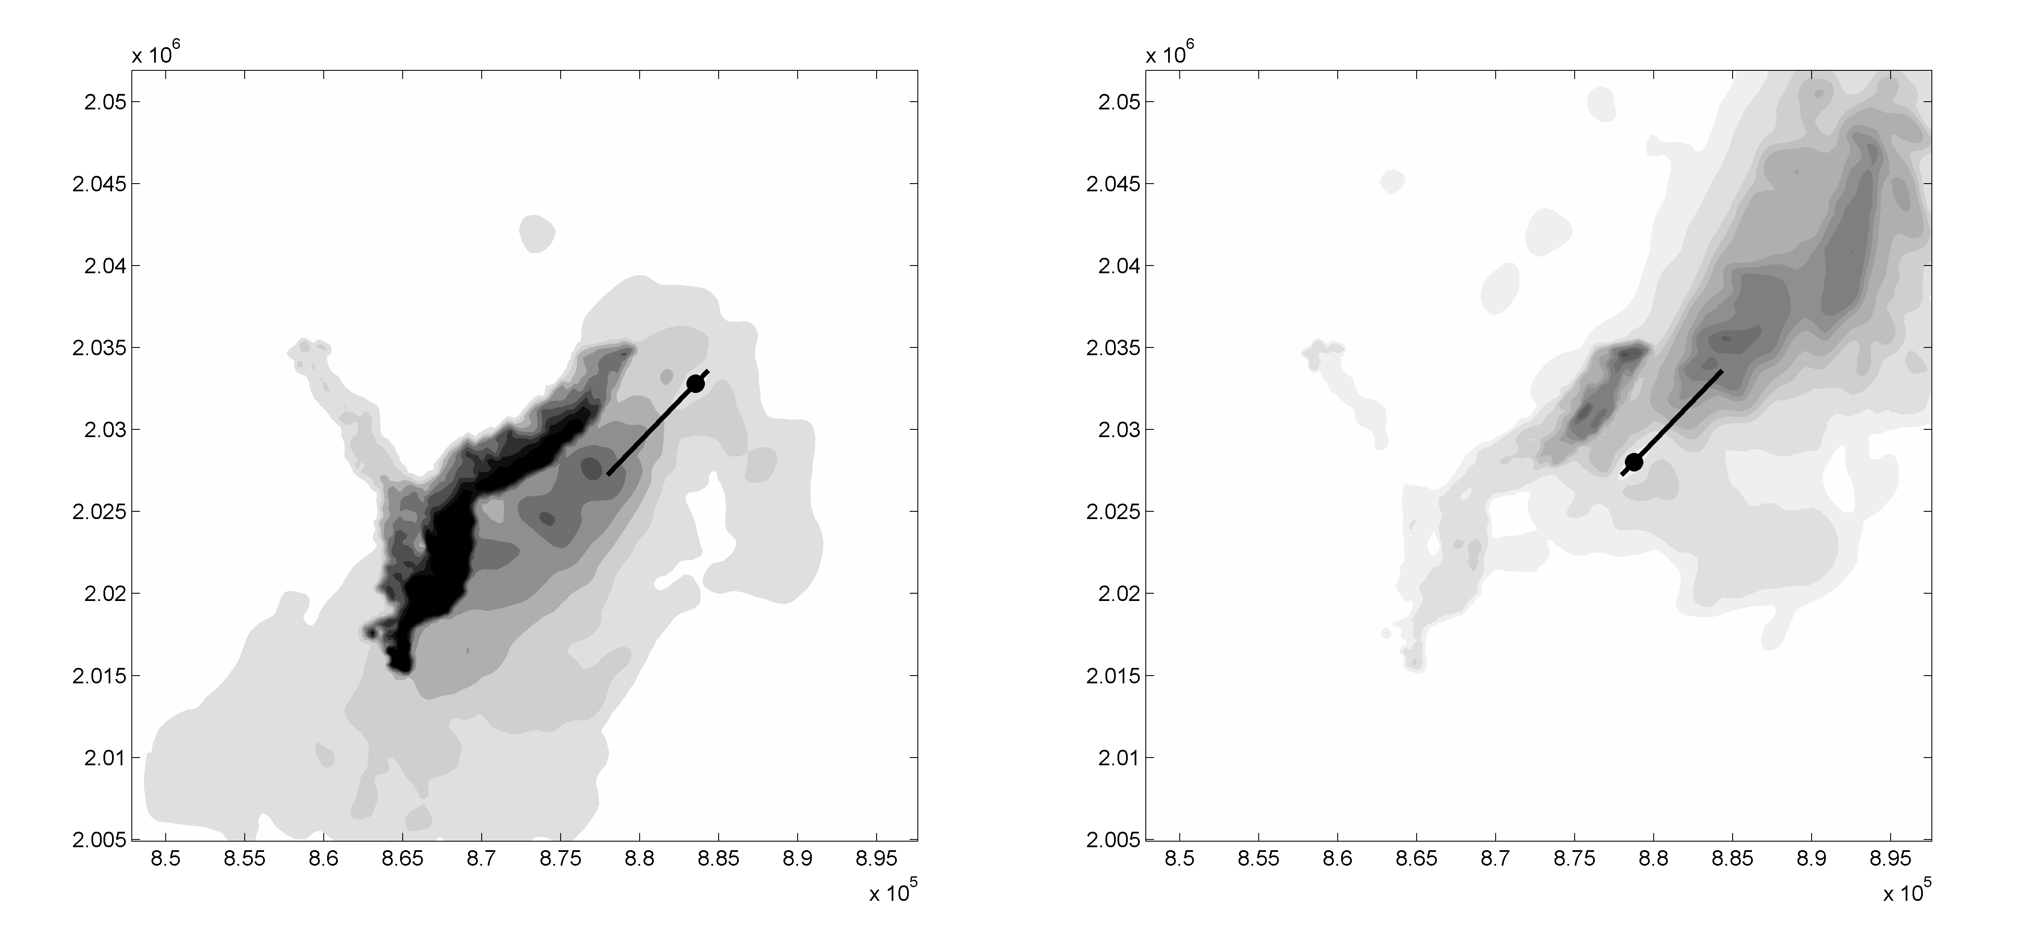

PGV map with HYPOCENTER 2 (left) and 3 (right)

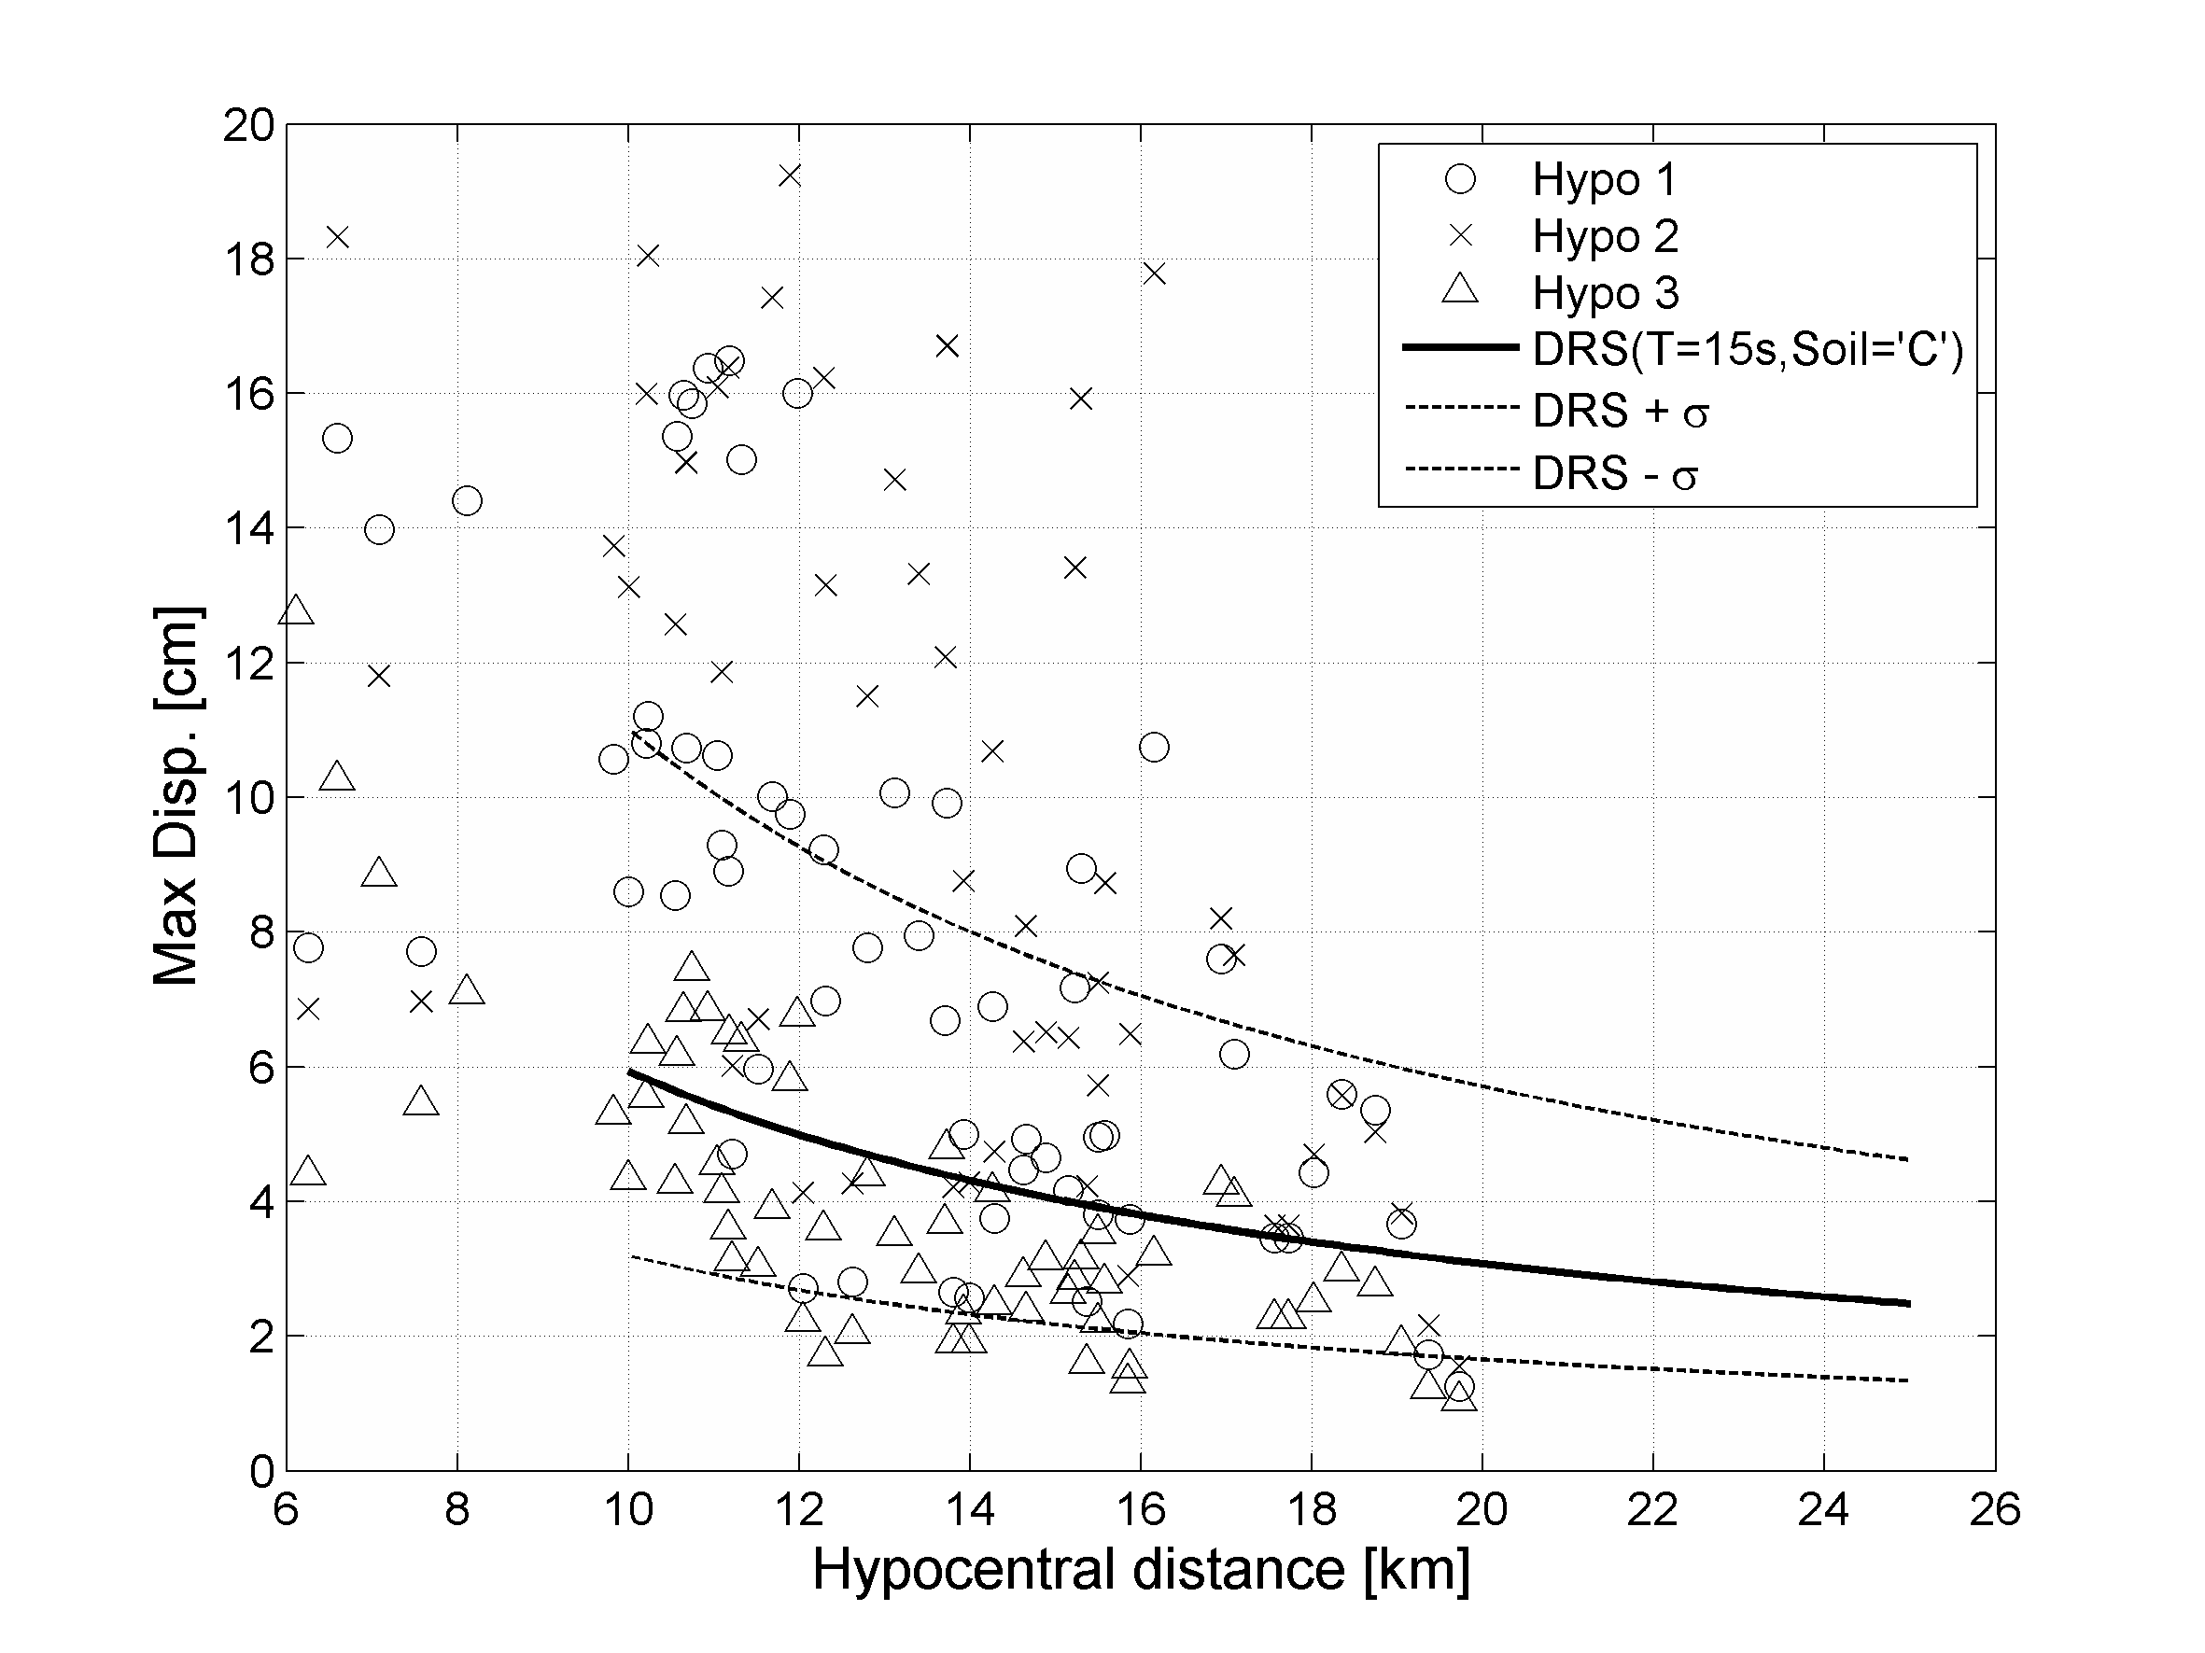
SOFT SOIL - E. Faccioli and A. Rovelli: Project S5 of “DPC-INGV”
"Definizione dell’input sismico sulla base degli spostamenti attesi"
(1 giugno 2005 - 30 giugno 2006)

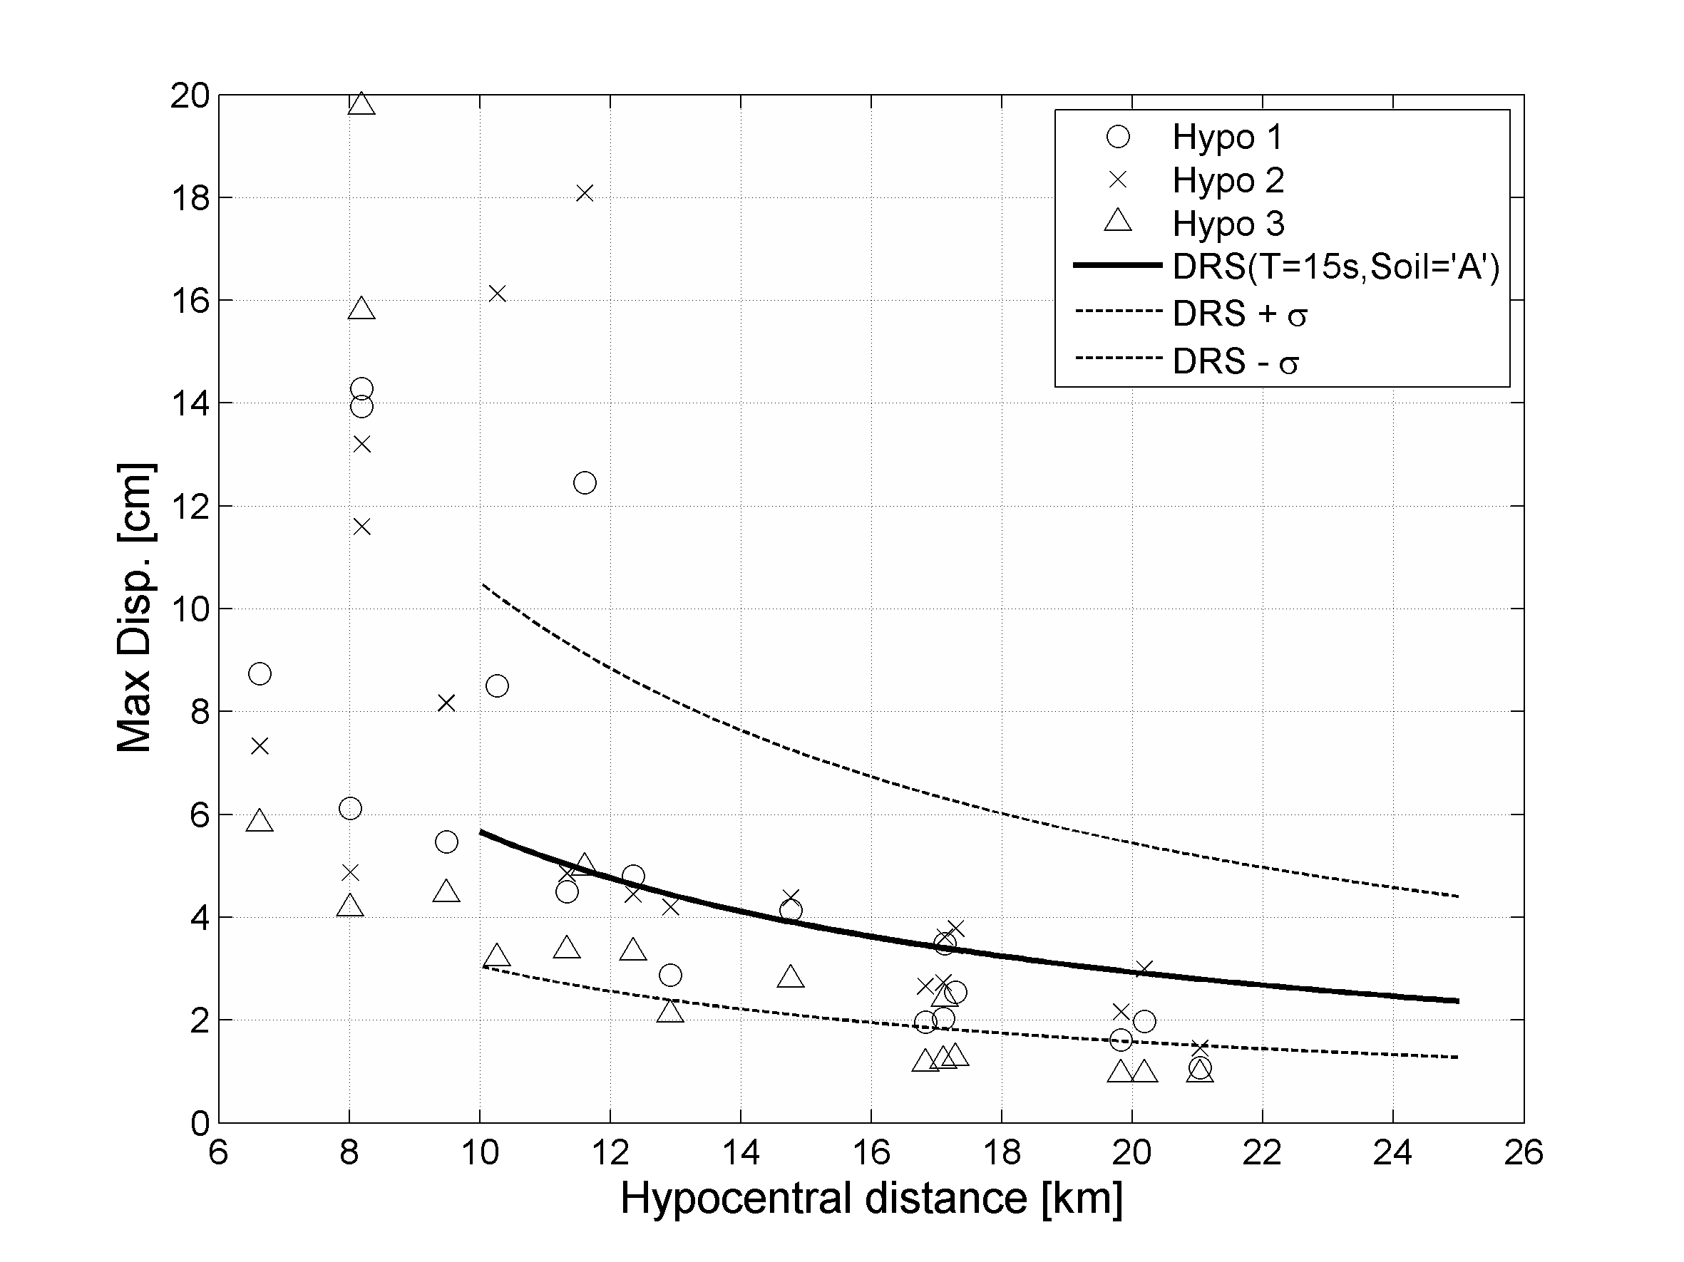

BEDROCK SOIL - E. Faccioli and A. Rovelli: Project S5 of “DPC-INGV”
"Definizione dell’input sismico sulla base degli spostamenti attesi"
(1 giugno 2005 - 30 giugno 2006)

4. Conclusions

The GeoELSE code, based on SEM, has been briefly presented. The parallel approach adopted and the capabilities to deal with unstructured computational domain allow to simulate the 3D model of the sedimentary basin of Grenoble (French Alps), excited by a strong motion scenario earthquake of M_{W} = 6. A set of synthetic ground motions, aligned along a particular 2D profile, has been shown and the results seem to capture important features like amplification effects induced by the soft alluvial deposit and waveforms complexity growth. The results could be potentially adopted to improve an hazard scenario for the examined region and provide a starting point for comprehensive comparisons with simpler 2D or 1D approaches to seismic wave propagation.

5. References
Abramowitz, M., Stegun I.A. (1966), Handbook of Mathematical Functions, Dover, New York.
Aki K. and Richards P. (1980), Quantitative Seismology. Theory and Methods, Freeman, San Francisco.
Bielak, J., Loukakis K., Hisada Y., Yoshimura C. (2003), Domain reduction method for three-dimensional earthquake modeling in localized regions. Part I: Theory, Bull. Seism. Soc. Am. 93 (2), 817-824.
Bielak, J., Loukakis K., Hisada Y., Yoshimura C. (2003), Domain reduction method for three-dimensional earthquake modeling in localized regions. Part II:Verification and applications Bull. Seism. Soc. Am. 93 (2), 825-840.
Casadei, F., Fotia G, Gabellino E., Maggio F., Quarteroni A., (2000). A mortar spectral/finite element method for complex 2D and 3D elastodynamic problems, Computer methods in applied mechanics and engineering 191, 5119-5148.
Faccioli, E., Maggio F., Quarteroni A., Tagliani A. (1996), Spectral-domain decomposition methods for the solution of acoustic and elastic wave equation, Geophysics 61, 1160-1174.
Faccioli E., Maggio F., Paolucci R., Quarteroni, A. (1997), 2D and 3D elastic wave propagation by a pseudo-spectral domain decomposition method, Journal of Seismology, 1, 237-251.
Faccioli, E., Vanini M., Paolucci R., Stupazzini M. (2005), Comment on "Domain reduction method for three-dimensional earthquake modelling in localized regions, Part I: Theroy" by J. Bielak, K. Loukakis, Y. Hisada, C. Yoshimura, and "Part II: Verification and applications", by C. Yoshimura, J. Bielak, Y. Hisada, A. Fernández, Bulletin of the Seismological Society of America 95 (2), 763-769.
Maggio, F., and Quarteroni A. (1994), Acoustic wave simulation by spectral methods, East-west J. Num. Math 2, 129-150.
Maggio, F., Massidda L., Sabadell J., Siddi G. (2001), A parallel spectral element method for applications to computational mechanics, Internal Report CRS4-TECH-REP-01/103, CRS4, Italy.
Maggio, F., Massidda L., Paolucci R., Stupazzini M. (2005), A parallel spectral element method for dynamic soil-structure interaction problems, Int. J. Num. Meth. Engng., submitted for publication.
Mercerat, E.D., Vilotte J.O., Sanchez Sesma F. (2005), Triangular Spectral Element simulation of elastic wave propagation using unstructured grids, Geophysical Journal International, in submitted.
Moczo, P., and Kristek J. (2003), Seismic wave propagation in viscoelastic media with material discontinuities: a 3D fourth-order staggered-grid finite-difference modelling, Bull. Seism. Soc. Am. 93 (5), 2273-2280.
Resemini S. (2003) Vulnerabilità sismica dei ponti ferroviari ad arco in muratura PhD Thesis, Università di Genova, Italy.
Sànchez-Sesma, F.J., and Luzon F. (1995), Seismic response of three-dimensional alluvial valleys for incident P, S, and Rayleigh waves, Bull. Seism. Soc. Am. 85, 890-899.
Stacey R. (1988) Improved transparent boundary formulations for the elastic-wave equation, Bulletin of the Seismological Society of America. 78 , 2089-2097.
Stupazzini, M. 2004, A spectral element approach for 3D dynamic soil-structure interaction problems, PhD. Thesis, Milan University of Technology, Italy.
Komatitsch, D., Tsuboi S., Ji C., Tromp J. (2003), A 14.6 billion degrees of freedom, 5 tetraflops, 2.5 tetrabyte earthquake simulation on the Earth Simulator, Proc. of the ACM/IEEE Supercomputing SC 2003 conference Phoenix, Arizona, 15-21 November 2003.
Komatitsch, D., Liu Q., Tromp J., Suss P., Stidham C., Shaw, J.H. (2004), Simulations of Ground Motion in the Los Angeles Basin Based upon the Spectral-Element Method, Bulletin of the Seismological Society of America 94 (1), 187-206.
Zienckiewicz, O., and R.L. Taylor, 1989. The finite element method. Vol.1, McGraw-Hill, London.

6. Acknowledgements
Computational resources: “homer”, “tethys”,
Project: Seismovalp e SPICE

